INFRARED CALIBRATION

Subcourse MM0487

Edition A

United States Army Combined Arms Support Command
Fort Lee, Virginia 23801-1809

16 CREDIT HOURS

REVIEWED: 2007

The military applications of infrared principles in the past few years have made possible the development of several small, highly efficient weapons systems. The addition of weapons utilizing the infrared principles into the Army inventory of weapons has greatly increased the first round hit probability and firepower of individual soldiers, light armored vehicles and aircraft.

You can use infrared devices for weapon guidance, detection of enemy equipment and personnel, navigation, recognition, aircraft proximity warning, and communications. You can use these principles for either passive or active applications. The active method employs both infrared transmitter and receiver equipment, whereas the passive method requires only receiver equipment.

That infrared systems work has been convincingly demonstrated, but they work well only when properly maintained. The efficiency and reliability of any weapons system is dependent upon the maintenance personnel and their test and measuring equipment used to service it. The Army calibration personnel are responsible for the accuracy and serviceability of the test and measuring equipment used to maintain the infrared system. A general knowledge of what infrared is and how it works is required to properly calibrate and maintain your infrared standards.

This subcourse will provide you with principles of infrared and a working knowledge of the characteristics and operation of infrared calibration standards as used to calibrate select secondary transfer standards, secondary reference standards and TMDE.

This subcourse consists of six lessons and an examination organized as follows:

Lesson 1 - Introduction to Infrared Calibration

Lesson 2 - General Radiometer Test Set

Lesson 3 - Infrared Transfer Set

Lesson 4 - Infrared Reference Set

Lesson 5 - Irradiance and Light Meter Test Sets

Lesson 6 - Infrared Calibration

ACKNOWLEDGEMENTS

Information and illustrations used to support the material in this subcourse were adopted from numerous sources. Specific credit is given to the following publications:

 | TM 9-1400-425-35, | Maintenance Manual (REDEYE Air Defense Guided Missile System)
 | TM 9-4931-387-15, | Infrared Test Set 4931-895-3894 (Secondary Reference)
 | TM 9-4931-388-15, | Infrared Text Set 4931-895-3886 (Secondary Reference)
 | TB 9-4931-411-50, | Calibration Procedure for Infrared Test Set (Model 460-1)
 | TB 9-4931-454-50, | Calibration Procedure for Radiometer, DBA Systems Model 302
 | Manufacturer's Manual; | Radiometer Model 302, DBA Systems, Inc.

SOLDIER'S TASKS

This subcourse supports the following MOS 35H tasks as identified in FM 9-35H-CM:

 | TASK NUMBER | TITLE
 | 093-435-3311 | Calibrate Infrared Secondary Transfer Test Set
 | 093-435-3312 | Calibrate Generalized Radiometer
 | 093-435-3015 | Calibrate Light Meter
 | 093-435-3711 | Repair Infrared Secondary Transfer Test Set

SUBCOURSE PHILOSOPHY

This subcourse is not intended as instruction in basic electronics. For example, when discussing a Schmitt trigger or Darlington amplifier, it will be assumed the student knows how a Schmitt trigger or Darlington amplifier operates. The subcourse is technically written only to the depth necessary to tie the circuit to the overall operation of the instrument. Unusual circuits will be explained in greater detail. When the equipment is covered in other correspondence subcourses, subcourse numbers will be referenced and only a brief narrative will be used.

GENERAL INFORMATION

This subcourse consists of one or more lessons and an examination. Each of the lessons is divided into two parts; the text and the lesson exercises. For one lesson subcourses the lesson exercises serve as the examination. A heading at the beginning of each lesson gives the title, the hours of credit, and the objectives of the lesson. The final examination consists of questions covering the entire subcourse.

If a change sheet is included, be sure to post the changes before starting the subcourse.

THE TEXT

All the text material required for this subcourse is provided in the packet. The text is the information you must study. Read this very carefully. You may keep the text.

THE LESSON EXERCISES

Following the text of each lesson are the lesson exercises. After you have studied the text of each lesson, answer the lesson exercises. After you have answered all the questions, go back to the text and check your answers. Remember your answers should be based on what is in the text and not on your own experience or pinions. If there is a conflict, use the text in answering the question.

When you are satisfied with your answers, check them against the approved solution in back of this text. Re-study those areas where you have given an incorrect answer by checking the reference given after each answer.

LESSON 1: INTRODUCTION TO INFRARED CALIBRATION

Lesson Objective: | After studying this lesson you will be able to state the principles and characteristics pertaining to infrared, radiometry, calibration standards, devices, and technology by answering the exercise questions with no mistakes.
Credit Hours: | Two
Materials Required: | None
1. Introduction

a. Many years ago the Air Force National Guard proved that infrared systems worked. They shot down an Air Force bomber with a sidewinder missile. This missile used an infrared system to locate, track, and hit its target. Today, various basic types of infrared systems are used in conjunction with tactical weapons in military arsenals throughout the world.

b. Calibration technicians are required to calibrate infrared equipment. To calibrate and maintain infrared equipment properly, you need a general knowledge of what infrared is and how it works.

c. At the conclusion of this lesson you should be able to explain or state the principles of infrared sources, blackbodies, graybodies, emissivity, planckian distribution, detectors, the effects of various atmospheric conditions on infrared detectors, collection devices, infrared systems and some of the uses of infrared.

2. General

a. Infrared (IR) radiation is electromagnetic radiation within the frequency range of approximately 300,000 to 500,000,000 Megahertz (1000 microns to 0.75 micron in wavelength, where 1 micron is 1 x 10⁻⁶ meters). The infrared spectrum lies between the lower extremity of the visible light spectrum and the extremely high frequency microwave region. This rather wide spectrum is often divided into three bands (regions) as follows:

Band* | Wavelength in Microns(um)
Near infrared | 0.72 to 1.5
Middle infrared | 1.5 to 5.6
Far infrared | 5.6 to 1000
* These divisions are arbitrary and not absolute.

b. A characteristic of the infrared portion of the electromagnetic spectrum permits its waves to be readily absorbed and converted into heat energy. Infrared radiations, however, are not heat waves. A hot object, such as a lamp filament, emits infrared radiation because of its temperature. This radiant energy is mainly the result of molecular agitation on the surface of the heated object and atomic excitation.

c. Infrared radiations, having the same nature as radio waves or light waves, are also transmitted the same way through air, vacuum, or space. The fact that infrared radiations are readily converted into thermal energy when they strike an object distinguishes them from other types of radiation. Any object that has a temperature above absolute zero (0 degrees Kelvin) gives off electromagnetic radiations with wavelengths in the infrared region. The degree of absolute temperature determines the quantity of the infrared radiations, that is, the hotter an object becomes, the more infrared it emits.

d. These electromagnetic radiations transmitted through space may be absorbed by an object and then converted into heat. Thus, it is common to think of infrared as heat radiation. However, infrared is not the transfer of thermal energy by the commonly known means of conduction or convection. In these methods, heat transfer depends upon a physical medium. Such a transfer is always a thermal transfer of energy and not electromagnetic radiation.

3. History of Infrared

a. Research in infrared

(1) Although military interest in infrared has been recent, infrared investigations extend well over the last hundred years. In 1800, Sir William Herschel discovered infrared radiation while he was studying the heating effect of various portions of the solar spectrum. Employing only a sensitive mercury thermometer as a heat detector, he found that the heating power of the visible spectrum increased toward the red or low frequency end and that maximum heating power was not reached until the thermometer had been moved beyond the visible spectrum. He, thus, proved the existence of a form of invisible, radiant energy that could be refracted and reflected according to the laws of optics. Herschel theorized that this radiation was of the same nature as light and labeled it invisible light.

(2) Actually, some credit for the discovery of infrared must be given to scientists as far back as Galileo and Sir Isaac Newton who are credited with discovering the science of optics and spectroscopy.

b. Early detection techniques

(1) Research on Herschel's discovery was handicapped by the lack of a detector superior to the mercury thermometer. The second type of detector was the thermocouple, which was an improvement over the thermometer. Eventually a detector more sensitive than the first two types of detectors was developed. It was called a thermopile and consisted essentially of a series of thermocouples. Thermopiles were used for detection and measurement of infrared for the next half century.

(2) A breakthrough in detection techniques occurred in 1880 when S. P. Langley invented the bolometer, a device much more sensitive to temperature changes than any previous IR detector. Its operation is based on small changes in the resistance of a thin wire when heated by infrared radiation. With the boost in sensitivity, Langley was able to detect heat from infrared radiation which previously had been too faint to be detected. Before the bolometer (heat sensing power meter) was invented various investigators became occupied with establishing the maximum wavelength of infrared. Conclusions as to the lower limit of the infrared succeed one another, but each conclusion grossly underestimated the limit. The following years saw the limit extended with each investigation. In 1897 the infrared spectrum was extended to 20 microns. Within a year infrared wavelengths of 135 microns were measured and within a few years, wavelengths all the way to 300 microns were observed. Today, with our more sensitive detectors, it is possible to measure infrared wavelengths up to 1000 microns. The gap between infrared and the high edge of the Hertzian electromagnetic (microwave) region had been bridged. The frequency and wavelengths of the infrared and microwave portions of the electromagnetic spectrum can be seen in figure 1.

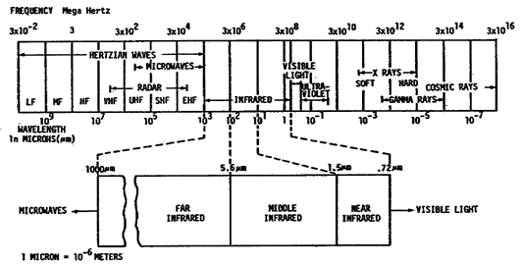

Figure 1. Electromagnetic Wave Spectrum.

(3) The electromagnetic spectrum consists of the following kinds of electromagnetic radiation: gamma rays, x-rays, ultraviolet radiation, visible light, infrared rays, radar, television signals, and radio waves. All electromagnetic waves travel at the same speed, which is the speed of light. The different parts of the electromagnetic spectrum are determined by the frequency (or wavelength) of the electromagnetic wave.

The retina of the human eye is sensitive to electromagnetic waves with frequencies between 4.3 x 10¹⁴ Hertz and 7.5 x 10¹⁴ Hertz. This band of frequencies is called the visible region of the electromagnetic spectrum. If the electromagnetic waves have a frequency higher than 7.5 x l0¹⁴ Hertz, the eye doesn't respond to them. Such waves, beyond the violet edge of the spectrum, are called ultraviolet light. If the waves have a frequency lower than 4.3 x l0¹⁴ Hertz, the eye again does not respond to them. Those waves, whose frequency is lower than visible light at the red end of the spectrum, are called infrared light or infrared radiation.

(4) The twentieth century has seen a great expansion of knowledge of the entire infrared spectrum. This is a direct result of the more precise techniques made possible by the bolometer and by improved thermopiles. The development of precision diffraction gratings and prisms for use in the IR region of the spectrum has also contributed to this progress. In addition, the use of photoelectric device as a means of IR detection has been developed. Presently, one of the goals of research is to increase the sensitivity of detectors to still longer wavelengths, where the measurable intensity of radiation from IR sources becomes quite small.

c. Advantage of infrared systems

(1) A major advantage of infrared over radar lies in the fact that radar is always an active device; that is, it must generate and transmit electromagnetic waves in order to function. Infrared operations may be based on the fact that all warm bodies radiate energy in the infrared region. Because it cannot function without transmitting detectable energy, radar always presents a security problem. Also, the difficulty of detecting and tracking targets by radar has been increasing because of the elimination of aircraft propellers and the trend toward a smaller, more streamlined aircraft with higher speeds indirectly reduces radar range. On the other hand the more powerful engines used to produce the higher speeds are better heat sources and hence better infrared targets. Also, jets and rockets spew out gases of high temperature. This makes operation easier for infrared equipment, which depends primarily on total radiation rather than on target size.

(2) In its present state of development, infrared can perform some radar functions more effectively, more cheaply, and with less complex equipment. As a supplement to radar, infrared equipment improves the performance of the entire detection system.

(3) This optimism is not only based upon infrared's inherent advantages, but also upon the increasing effect of the law of diminishing returns upon radar research and the latter's susceptibility to countermeasures. Another item that favors infrared is the possibility that at least a portion of tomorrow's battlefields will be in the upper atmosphere and at the fringe of space. In these areas, infrared systems are at their best because here they are unhampered by the limiting effects of atmospheric vapors and particles. At the upper limits of the atmosphere, targets will have no chance whatsoever against infrared detection.

(4) Currently, it is the passive infrared system (those systems that function through sensing radiation emitted by targets) that presents the best possibilities for tracking, fire control, missile guidance, and reconnaissance. Passive infrared imaging has been demonstrated to have an information content almost equal to that of images formed by visible light. There is, however, some development of active systems that function more like radar, generating and transmitting pulses of infrared energy; these systems, like radar, operate by detecting the infrared that is reflected by the targets.

d. Infrared drawbacks

It is not to be assumed that infrared systems present no disadvantages. If this were the case, radar would be obsolete tomorrow. In both the design and the operation of infrared equipment, there are obstacles. Infrared systems are often severely limited by atmospheric conditions; they generally have short detection ranges; as yet, no simple and direct means has been found to measure distances to targets. As for designing infrared systems, the lack of wholly suitable detectors and optical components is a critical problem hampering infrared equipment engineers.

4. Principles of Infrared

a. Infrared Radiation and Molecular Structure

(1) The surface of the sun at a temperature of 6000°K emits a continuous band of wavelengths in the infrared region. As this radiation passes through the cooler gas layers of the solar atmosphere, certain wavelengths are absorbed. Because the absorbing medium is in a gaseous state, its atoms and molecules do not absorb all wavelengths equally. They absorb principally those wavelengths that they would emit if heated to a high temperature. Thus, the atoms of one chemical element will absorb certain wavelengths, while the atoms of another element will absorb other wavelengths.

(2) Before the radiations from the sun reach the earth's surface, they must pass through the absorbing gases which comprise the earth's atmosphere. Here again, the molecules of the atmosphere absorb principally those wavelengths they would emit if heated to a high temperature. Each atom and molecule then absorbs and emits radiation of a definite wavelength, the exact wavelength depending on the physical structure of the atom or molecule.

(3) To have molecular motion we must have a body temperature above absolute zero. The simplest type of atomic motion is the rotation of electrons. Rotation causes generation of infrared energy generation at the lowest levels and longest wavelength. The next order of energy or power output is caused by rotation and mod molecular vibration. The highest power output is caused by combined rotation, vibration and changes in the energy levels of electrons. This causes high output power at the short wavelength. The heat generated is incidental to the production of infrared energy. Heat is primarily being caused by the friction of particle collisions.

(4) A theory states that the electrons of a given atom may travel in one of many possible orbits. When an electron is caused to move from one orbit to another, the atom either gains or loses energy. Thus, for example, when the atom is heated, the emission of a definite wavelength of energy is caused by the movement of an electron from one orbit (energy state) to another. Also, when an atom is excited by energy of a definite wavelength, an electron will again change orbits and the energy will be absorbed. This theory can also be applied to molecules and combinations of molecules, and explains why every substance emits or absorbs energy in the form of electromagnetic radiations.

(5) Electromagnetic radiation from a heated object

(a) A star, or any other hot object, radiates electromagnetic waves stretching across the entire spectrum from infinitely short wavelengths to infinitely long ones. However, the waves emitted at various wavelengths do not have equal intensities. The intensity is always weak at very short and very long wavelengths, and it is strongest at some wavelength in between.

(b) Suppose that you place a bar of iron in a furnace and steadily raise its temperature. At first, the iron feels hot and sends out heat but does not glow visibly; at this point the peak of its radiation is in the infrared region. As the temperature of the iron increases, it begins to emit radiation in the visible region; first turning dull red in color, then cherry-red, then yellow, and finally at the highest temperature, becoming white hot.

(c) This simple thought - experiment which has its counterpart in many experiences of everyday life involving kitchen stoves, soldering irons and so on - shows that the temperature of an object determines the wavelength at which it radiates most of its energy. As the temperature of the object increases, the radiation emitted by it moves toward shorter wavelengths - from the infrared to the red, then to the yellow, to the blue and eventually, if the temperature mounts high enough, presumably past the blue and the violet into the ultraviolet.

b. Electromagnetic Radiation

(1) Perhaps everyone has thrown a stone into a quiet pool of water and watched the ripples move away in all directions. These ripples are a good example of wave motion, and were produced by the energy of the stone striking the water. In this case, the wavelength of the ripples is the distance between the crests of the waves. Electromagnetic waves all move with a similar motion and thus produce waves whose lengths can be measured. The electromagnetic spectrum is customarily divided, in the order of decreasing wavelength, into radio waves, infrared waves, visible light waves, ultraviolet waves, x-rays, gamma rays and cosmic rays. This spectrum is illustrated in figure 2.

(2) The actual units used to describe wavelength depend upon the portion of the spectrum in which the waves are located. The simplest method uses the metric system of units. Starting at the left of the spectrum shown in figure 2 (in the radio wave region), wavelengths are measured in meters. In microwave portion of the spectrum, where the waves are shorter than one meter, they are measured in centimeters. Similarly, in the upper microwave and far-infrared regions, wavelengths are measured in millimeters; and as the wavelengths become still shorter, they are measured in tenths and hundredths of a millimeter. However, in the range of wavelengths known as the near infrared, the visible, and the ultraviolet, measurements are usually made in microns (um) or thousandths of a millimeter. The infrared region, therefore, is shown in figure 2 to extend from approximately one millimeter (1000 u) in wavelength to .75 microns, where the boundary between the visible region and the infrared is determined solely by the spectral sensitivity of the eye.
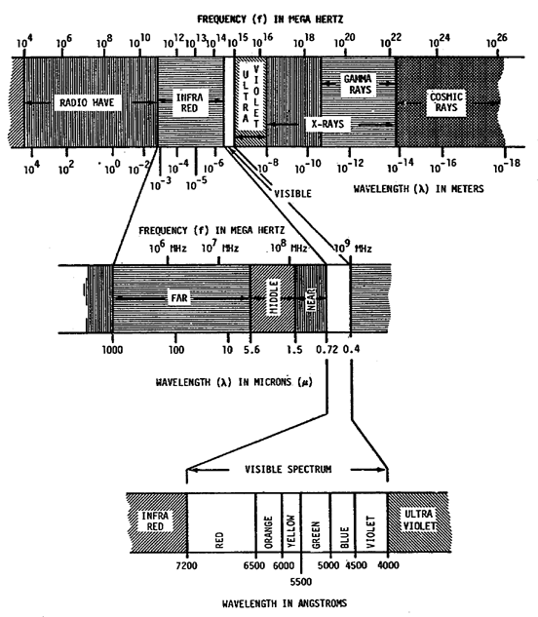
FREQUENCY ( f ) IN HERTZ

Figure 2. Electromagnetic Spectrum (Infrared and Visible Light Region).

(3) Another commonly used term for expressing wavelengths in the region of the visible spectrum is known as the angstrom unit. One angstrom unit is equal to 0.0001 micron, or one ten-thousandth of a micron. For example, the beginning of the visible spectrum is shown in figure 2 to be 0.72 microns, which can also be represented as 7200 angstrom units (abbreviated 7200 ). Table 1 shows the relationship of the various units of the metric system of measurement. Micron units are normally used to express wavelengths in the infrared region. Micron is preferred over angstrom as a unit of measure.

Table 1. Metric Units
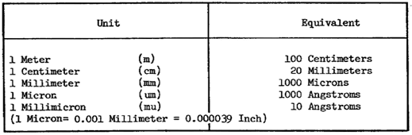

(4) In spite of the tremendous expanse of wavelengths ranging from the longest radio waves several kilometers in length to gamma and cosmic rays one millionth of a micron in length, all electromagnetic waves travel with the same velocity in a vacuum (and for our purposes in the atmosphere), 300,000,000 meters per second. As shown in figure 2, only one very narrow band of waves is visible to the eye, all the rest are invisible. With the exception of the band of waves known as the extreme ultraviolet, the air is fairly transparent to all electromagnetic waves. To waves of the extreme ultraviolet, the air is quite opaque. In contrast, fog is generally opaque to all but radio waves.

c. The Infrared Spectrum

(1) The infrared region of electromagnetic radiation consists of that portion of the spectrum located between the longest visible wavelengths and the shortest microwave wavelengths. The infrared band is many times as broad as the visible optical spectrum which ranges from 0.3 to 0.72 micron. It is generally accepted that the infrared spectrum lies between 0.72 and 1,000 microns on the electromagnetic spectrum. A conversion from wavelength to frequency is as follows:

Since the range of the infrared spectrum is so large it is conveniently divided into smaller ranges. This has been determined by the techniques employed for detection and measurement of the radiation. The infrared band is, therefore, divided somewhat arbitrarily into three regions, and as illustrated in figure 2.

(a) The near-infrared between 0.72 and 1.5 microns

(b) The intermediate-infrared between 1.5 and 5.6 microns

(c) The far-infrared between 5.6 and 1000 microns

The devices used in the near and middle bands are employed for ranging, recognition, and communications. The usable distance range of near infrared equipment is normally between 6.5 and 10 miles. Equipment which operates in the far infrared band is used for ranging, missile guidance, detection and location of personnel, tanks, aircraft, and ships. The present usable distance range is between 100 yards and 12 miles. The bulk of target radiation is at the lower wavelengths, but present infrared detectors and optical components do not operate efficiently in the far infrared region.

5. Source of Infrared Radiation
Everything with a temperature above "0" degrees Kelvin is considered as an infrared source. Therefore, the sun, atmosphere, clouds, earth, trees, etc., radiate infrared energy. Sources are classified into two main types, one which is provided by nature and one which is more or less artificial.

a. Natural sources

Since all objects with a temperature above absolute zero emit infrared energy, everything is a natural source. The special characteristics of the emitted radiation, depends on the source temperature, surface characteristics, and emissivity. We also have to consider the reflectivity of an object to radiation emitted from other sources.

(1) Celestial sources. Our sun, on which all life processes depend, is an intense source of radiation. The most important celestial body, for vicinities close to the earth, is the moon. The greater part of radiation from the moon is solar radiation. The planets and stars are weak sources of infrared and can be disregarded except for certain astronomical applications.

(2) Terrestrial sources. Sources on earth such as trees, rocks and water are classified as terrestrial sources. Metal, sand, and rocks also reflect solar radiation. The average emissivity of terrestrial objects is about 0.35 and the temperature will be the ambient temperature. Both the emissivity and the temperature of specific objects will vary depending on the nature of the object. Various surfaces come to different temperature because each have a different emissivity that varies differently with wavelength. Each surface increases in temperature until it is radiating as much power at long wavelengths as it is absorbing at the shorter wavelengths of the solar radiation. Thus, infrared systems can distinguish between such terrestrial features as water, trees, and roads when scanning the terrain.

(3) Atmospheric sources. Atmospheric sources include those surrounding the earth such as dust, clouds, and atmospheric gases. The transmission of infrared radiation through the atmosphere depends on the concentration and distribution of the numerous gases. Meteorological conditions and the transmission of IR varies with weather conditions and with altitude.

b. Artificial sources

Artificial sources are subdivided into the active sources and the controlled sources.

(1) Active in the sense that artificial sources are high power sources of infrared, but the generation of IR is not their purpose. As a result, they are not controlled with regard to temperature and spectral response. A flare, missile or an aircraft for example generate much infrared energy, but that is incidental to their purpose.

(2) The controlled sources are primarily designed to be sources of infrared at a particular wavelength and we have built in the ability to control mainly the temperature and possibly even the spectral response. Blackbody standard sources, for example, very closely approach the performance of an ideal blackbody. These sources are used in laboratories as standards and background simulating devices.

c. Background sources

Under the heading of both natural and artificial sources we find a subgroup called background sources. The reason being, background source can be either natural or artificial. A background source is an unwanted source of infrared. Depending on what a particular infrared system is designed for will determine whether an object is a target or background. A missile tracking system will regard the missile as the target and all other radiations and reflections as background, while an infrared mapping system will see the missile, and clouds as background and the terrain as the target. To have a good infrared system we should be able to distinguish between the target and background. The infrared system has the ability to distinguish between the two by tuning the detectors to a particular wavelength.

d. Emitters and Absorbers

When we speak of infrared sources we talk about emitters and absorbers of infrared energy. All objects above absolute zero are continuously absorbing and emitting radiation. A commercial blackbody is illustrated in figure 3. These bodies emit radiation in a continuous spectrum; however, the peak energy level is dependent on temperature. Consider a solid object within an evacuated cavity which is maintained at a uniform temperature as in figure 3. Regardless of what material the object is made of or what its initial temperature is, the object will eventually be at the same temperature as the cavity. This state is known as thermal equilibrium, and in this state the exchange of energy between the object and the cavity will be the same in both directions.

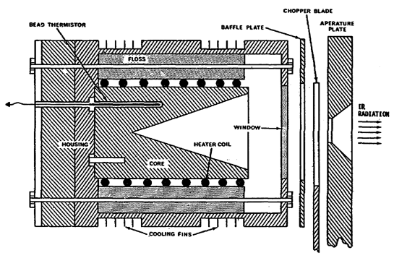

Figure 3. A Commercial Blackbody.

(1) Blackbody

(a) Definition. A material that absorbs all radiation falling upon it, and when it reaches a uniform stable temperature, emits an equal amount of radiation. Such a theoretical material is named a blackbody. A number of different devices have been developed which closely approximate the theoretical. These devices are used as laboratory standards. A blackbody is a perfect radiator and absorber of radiation at all temperatures and for all wavelengths.

(b) Radiance emittance. Radiance emittance is expressed as the power per unit area of a source. The unit of measure most commonly used to express this is watts/cm². The power incident is the power received on a unit area of surface. The power reflected is also expressed in watts/cm² and represents lost or wasted power because it is not absorbed by the object. The power transmitted is that portion of the radiation that passes right thru the body without affecting it. The power emitted per unit area, which is the radiant emittance, will equal the power absorbed by the object.

1 The radiant emittance of a blackbody will be the area bounded by the curve, as shown in figure 4 for the temperature of the blackbody. The curve for a graybody at 1500°K with an emissivity of .8 is depicted, and it can be seen that the entire curve lies under the blackbody curve for the same temperature. Note that the curves do not intersect and that no object can have a higher radiant emittance than a blackbody at a given temperature. This family of curves also shows that it is difficult to obtain any appreciable power at the longer wavelengths.

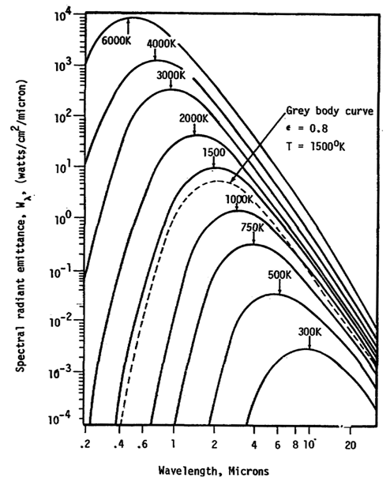

Figure 4. Spectral Radiant Emittance Curves for Blackbodies at Several Absolute Temperatures.

2 To be a perfect blackbody several other requirements must be filled. It must:

Have a perfect planckian distribution.

Be able to maintain a constant temperature.

Have a constant spectral response.

Have an emissivity factor of 1.

No object can really fulfill all of these requirements but laboratory blackbodies come close. They are close enough to being perfect, that they can be used for scientific measurement purposes.

(2) Graybody sources. Most objects do not even come close to behaving like blackbodies. What is not a blackbody is called a graybody. A graybody does not absorb all incident radiation; a portion is reflected and a portion is transmitted. The radiation reflected is effectively wasted. For example, 1 watt/cm² incident, 0.2 watt/cm² was reflected; 0.1 watt/cm² was transmitted and only 0.7 watts was absorbed. 0.7 watts is the amount to be emitted as radiant emittance. In reality all objects are graybodies.

6. Emissivity Factor

a. Emissivity factors. Blackbodies emit radiation in a continuous spectrum with the peak emission dependent on the temperature of the source. A perfect blackbody has an emissivity of one (unity). All other surfaces have an emissivity which is less than one. The emissivity of graybodies is dependent on their temperature and emissivity. Emissivity factors of various materials are listed in figure 5.

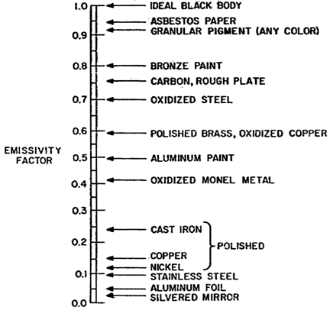

Figure 5. Emissivity Factors of Various Materials.

b. Factors affecting emissivity. The emissivity of actual sources varies with the material, the surface finish, the temperature, and the wavelength of the radiation as can be seen in the Tables 2A, B and C. Metals generally have a low emissivity and ceramics have a high emissivity. A rough surface will have a higher emissivity than a polished surface. The emissivity for most materials increase with an increase in temperature. Emissivity varies inversely with wavelength and the incremental change of emissivity also varies inversely with wavelength.

Table 2. Factors Affecting Emissivity
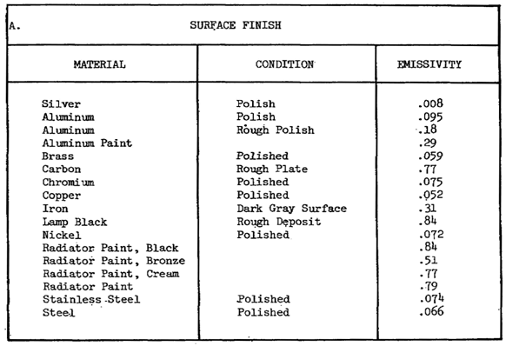

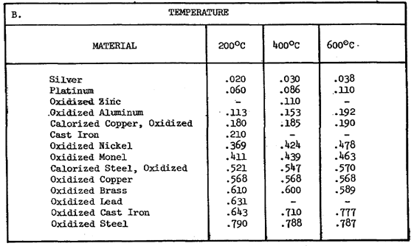
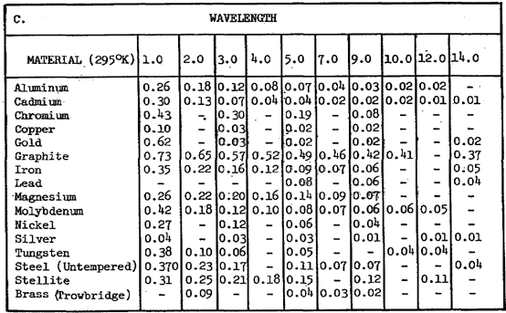

Emissivity Factor (E) = | Total radiant emittance of a graybody
 | Total emittance of a blackbody at the same absolute temperature

Using the example in (b)(2) above where E of the graybody 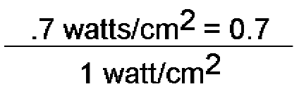 was equal to 0.7, the ratio

c. Several factors affect emissivity, the most important is surface since IR is primarily a surface function. Temperature, of course, has a great affect and in general as the temperature goes up, so does E. The type of material in general makes little difference as long as the material can withstand the temperatures being generated. Blackbodies, for example, are made of many types of metal including stainless steel, aluminum, copper and even from ceramic material. As stated before, surface finish is the main factor affecting emissivity.

7. Planckian Distribution

a. Planckian distribution is the name given to a characteristic curve when the power output of some sources is plotted against the wavelengths on a graph. As you can see in figure 6, radiation is present at all wavelengths and the power output increases as the wavelength gets shorter. As the temperature of the source is increased, the point of maximum power output shifts to an even shorter wavelength. As a rule of thumb, we can say that when we double the absolute temperature, expressed in Kelvin, the wavelength is cut in half.

b. The curve of a graybody with planckian distribution would be very similar to the curves in figure 6. They would peak at the same wavelength but with less power.

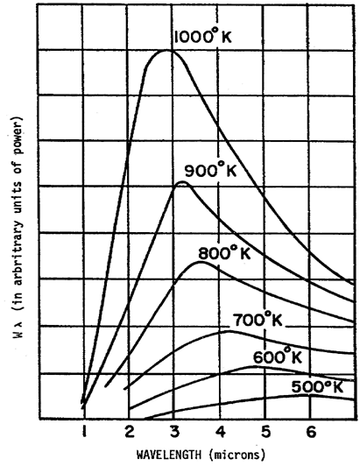

Figure 6. Planckian Spectral Distribution.

8. Attenuation of IR radiation. There are two basic causes of attenuation of infrared radiation. The two factors involved are the distance between source and detector (called geometry), and the atmosphere.

a. Geometry (see figure 7). As a ray of radiation leaves a source, it begins to spread. This fact causes a decrease in power density. The same loss occurs in radio transmission. This attenuation rate is constant and follows an algebraic rule called the inverse square law.

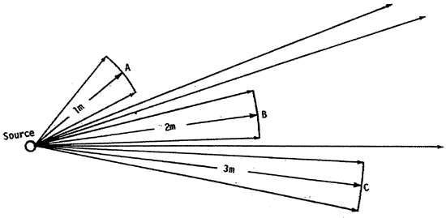

Figure 7. Geometry.

If the reference point (Point A) is one meter from the source, then at two meters from the source (Point B) the source power will only be 1/4th of that at reference point A; at three meters (Point C), 1/9th and so on. The power measures at any point varies as the inverse square of the distance from a source reference point to the point of measurement.

b. Atmosphere. Attenuation by the atmosphere across the infrared region is not a constant. In infrared theory, attenuation is used to express the reduction of infrared radiation density (power per unit area) with the relationship being the distance from the infrared source. This reduction is due mostly to absorption and scattering. The amount of attenuation due to these factors is going to differ from day to day with the changing atmospheric conditions and altitude. In other words, the molecular density of the atmosphere has an important affect on IR transmission.

(1) Absorption. Infrared is absorbed in the atmosphere mainly by water vapor and carbon dioxide. Absorption by the permanent gases and the rare gases of the atmosphere is negligible. Water vapor is the most important absorber of infrared. As can be seen in figure 8, water vapor absorbs strongly at wavelengths between 5 and 7 microns, and at greater wavelengths. It absorbs moderately at 3 to 5 microns and 7 to 8 microns. Note that water vapor is nearly transparent between 8 and 12 microns, the portion of the spectrum where the peak of the earth's emissive power lies. Energy emitted by the earth between these wavelengths passes virtually unimpeded into outer space. Absorption by carbon dioxide and ozone in the atmosphere is relatively unimportant. Ozone has a strong absorption band between 9 and 10 microns, but the percentage of ozone present in the atmosphere is very small. Carbon dioxide absorbs effectively at the same wavelengths as water vapor, but it is only when the atmosphere is exceptionally dry that carbon dioxide absorption becomes important.

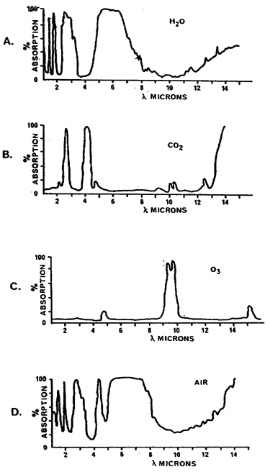

Figure 8. Absorption of IR by Atmospheric Components.

(2) Scattering. When infrared enters the atmosphere (or any body of matter), part of it is reflected diffusely or scattered in all directions. This is due to the interposition in the infrared beam of particles of varying size (such as dust and water droplets) and the resulting deflections caused by encounters with these particles. More specifically, the term denotes the changes in direction of infrared owing to collision with these particles.

c. Windows

Those wavelength bands of the infrared spectrum having little or no atmospheric attenuation losses are called windows. At higher altitudes, where the densities of absorbing and scattering agents decrease, the attenuation of infrared is considerably reduced.

9. Infrared Collecting Devices. The increased use of infrared and ultraviolet light has led to the development of a new scientific field known as electro-optics. The fact that infrared radiation has characteristics of both microwave and visible light leads us to use both optics and electronics in the detection and propagation of infrared radiation. Lenses and mirrors are used to collect, focus, filter and project infrared, while electronic instruments are used for detection and display. The principles of optics must be considered when using and testing infrared optical components. Infrared radiation which reaches the surface of a material may be reflected, refracted, or absorbed. In addition, the material may diffract, disperse, or polarize the radiation.

10. Infrared Detectors. To use of infrared radiation, we must have some means to detect and measure the radiation. The first detectors employed for investigation of the infrared spectrum were thermal detectors, thermometers, thermocouples, thermopiles, and bolometers. During the post World War II years there has been increasing development of solid state devices for detectors. Infrared detectors come in many varieties but they can be broken down into two main types, the photo type and thermal type. Figure 9 shows the types of detectors used for the three divisions of the infrared spectrum.

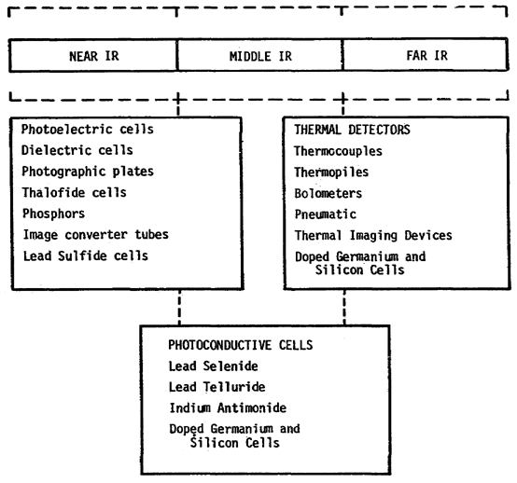
Figure 9. Useful Spectral Regions of IR Detectors.

a. Photo detectors.

When you think in terms of image-forming detectors, you are thinking in terms of photo detectors. Photo detector efficiency varies with the frequency or wavelength of the incident radiation. In the near and middle infrared regions, the photo type detector finds general application while at the longer wavelengths the thermal types are used. The photo type detector works through the excitation of atomic and molecular particles which changes its current carrying capability. The electrical change is amplified and processed for an indication of the level of activity. This type is sensitive to wavelength change rather than heat. The photo detectors are also selective devices. Their wavelength sensitivity is a specific band pass and inherent low-frequency cutoffs. The output of most detector falls off rapidly at wavelengths longer than eight or nine microns and shorter than 1 micron, as indicated in Figure 10.

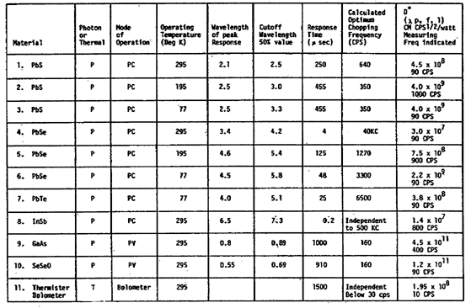

Figure 10. Detector Characteristics.

(1) The most significant class of photo detector is made up of those devices which employ photoelectric effects; that is, the detecting device undergoes changes in electrical characteristics when exposed to radiant energy. These include photoemissive, photoconductive, and photovoltaic detectors. Detectors which depend upon luminescent properties may also be considered photoelectric devices.

(2) Photographic detectors, such as the camera and film used in infrared photography, may be considered as latent image forming devices. There is also a group of detecting devices which produce instantaneous images, in the manner of television picture tubes. These devices work on photoemissive or photoconductive principles. Figure 11 illustrates an output circuit for a photoemissive cell. In a practical circuit, a photocathode (mode of material with the proper photosensitivity) is exposed to incident infrared radiation. The photocathode emits electrons in quantities proportional to the intensity of radiation. The photoelectric effect by which photoconductive detectors operate depends upon the fact that some materials exhibit a marked increase in electrical conductivity as a result of infrared illumination.

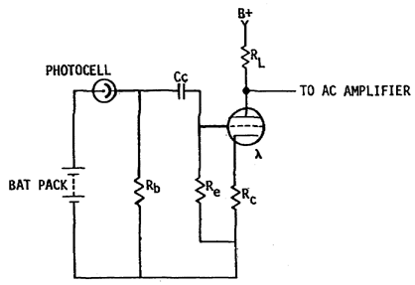

Figure 11. Photoemissive Cell.

b. Thermal detectors.

A thermal detector works on the heating ability of infrared and has a long time constant because it must actually warm up before it produces an electronic signal. Any temperature change, caused by incident radiation, can be made to produce the following effects in the detecting device:

(l) Generation of an electromotive force (thermocouple). The thermocouple is a type of thermal device whose basic principle of operation is based on the seebeck effect. This effect is present in a circuit using two dissimilar metal conductors; when the two junctions are at different temperatures, an electromotive force is generated, and current flows in the circuit. When a thermocouple is used as an infrared detector, the incident radiation produces the needed temperature difference at the junctions. A simple type of thermocouple is shown in Figure 12.
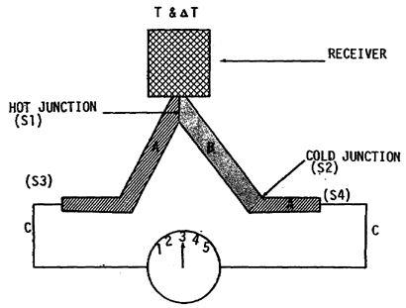

Figure 12. Two Junction Thermocouple.

(2) Resistance change (bolometer). The thermoelectric effect which is used in the bolometer involved a change in electrical resistance of the detector material when it is subject to temperature changes. The bolometer is operated in a circuit with a small current passing through it constantly, so these changes produce a variation in the circuit current. Thus, variations in incident infrared radiation, which cause changes in temperature, are indicated indirectly when the circuit current is measured or used to activate an indicating device of some type. To this extent, the bolometer type of detector is not a transducer since it does not convert energy from one form to another but simply functions as a modulator. Bolometer detectors are of three basic types - the metal strip, the thermistor, and the superconductor. Whichever type is used its operation is essentially the same - it is part of the thermal resistive arm in a balanced bridge circuit. Figure 13 illustrates the Langley bolometer circuit.

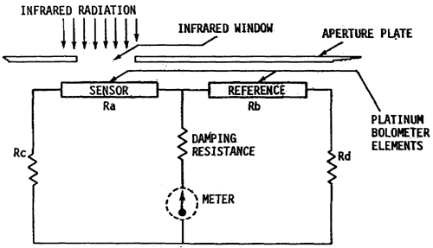

Figure 13. The Langley Bolometer.

(3) Gas volume change (Golay cell pneumatic detector). The Golay cell operates on the principle that the volume of a gas changes as a result of a change in temperature. The change in temperature is accomplished indirectly by the exposure of another cell element to incident infrared radiation. Incident infrared radiation enters the Golay cell through the rock salt window, shown in Figure 14, and heats the absorbing tiny aluminum membrane. The heating of this membrane causes an increase of pressure of the gas agent in contact with it, which then expands. This expansion, by means of a capillary tube, distorts the diaphragm; this causes a reflection on a certain portion of the adjacent photocell, with the spot on the cell depending on the distribution of the detecting diaphragm. Then, when the reflecting diaphragm is distorted, the optical setting will be displaced, and light will fall on the photocell proportional to the amount of incident radiation. The electrical output from the photocell can then be amplified and passed onto the indicating device.

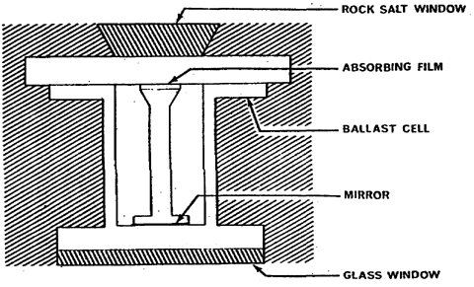

Figure 14. The Golay Cell.

11. Classification of Systems

a. Infrared systems are generally divided into two major classifications according to their basic operating principles. One of these groups is composed of passive systems, which do not employ any transmission of infrared radiation. These systems operate by detecting the radiation which is emitted by virtue of the target temperature. The basic elements of a passive system are the optical components, the filters which are used to eliminate undesirable radiations and the detector. Figure 15 is an illustration of the basic components of a passive infrared system.
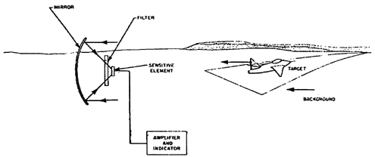

Figure 15. Passive IR System.

(1) A missile system using a passive infrared seeding device (internal to the missile) could be constructed as shown in Figure 16. The detector would be multielement so that as the radiant energy reflected by the mirror on to it would be balanced when looking directly at the target. As the target moved the energy received would apparently move on the detectors. The detectors being part of a bridge then would show an imbalance. This condition can then be amplified and the error signal sent to the guidance control section of the missile.

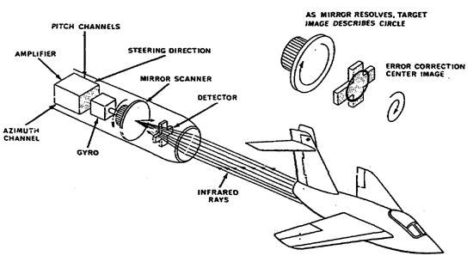

Figure 16. Theoretical Passive System.

(2) Passive systems have several major advantages. They provide a higher degree of security than active systems and they are not as vulnerable to active countermeasures. For these reasons, passive systems have been much preferred for military applications.

b. The other group of systems, as mentioned above, is referred to as active, meaning that the systems include an infrared radiating source which is directed toward a target. Figure 17 illustrates a typical active system. In an active system, a portion of the transmitted energy is reflected by the target and is returned to the detector. Image forming detectors are generally used in active systems in order to identify the target. The active system has two major disadvantages. The radiation intensity at the receiver suffers a 4-power attenuation in energy level (geometry loss based on distance from source to target and target to receiver). Unless a very highly collimated narrow illuminating beam is used, range is severely limited by the inefficiency of the system due to this excessive radiation loss. The system, being active, is more easily detected and countermeasures are achieved in much the same manner as with RF transmitting systems. However, for short range purpose, it is highly desirable.

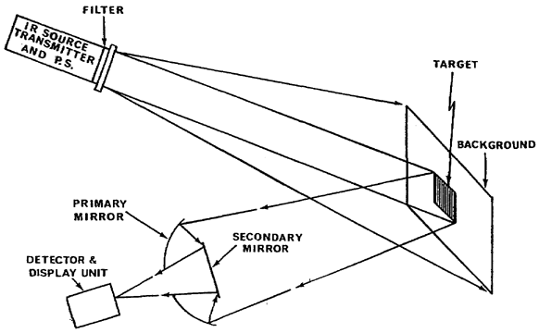

Figure 17. Simplified Active System.

12. Summary. An active system with blackbody source is extremely effective as a calibration standard. However, in order to understand IR calibration requirements, you must understand how the user's equipment functions and what the calibration parameters are. A glossary of IR terms is included at the end of this subcourse for your use as a reference to technical terms.

SUBCOURSE MM0487, INFRARED CALIBRATION

EXERCISES FOR LESSON 1

1. Which statement best describes infrared?

a. Electromagnetic radiation outside the visible spectrum at its red end

b. Heat waves at wavelength between 0.72 and 1000 microns

c. Ultrahigh frequency waves between .4 and .72 microns

2. The emissivity of a graybody depends on

a. Wavelength, temperature, and area.

b. Temperature, wavelength, and surface finish.

c. Area, surface finish, and color.

3. The amount of atmospheric absorption depends on

a. Altitude, emissivity factor, temperature.

b. Temperature, wavelength, and type of material.

c. Atmospheric conditions and the altitude.

4. A perfect blackbody source will

a. emit parallel rays.

b. have an emissivity factor of 1.

c. usually be a good reflector.

5. During transmission of IR radiation, how does the factor of geometry affect attenuation?

a. Inversely proportional to the square of the path length

b. Proportional to the fourth power of the wavelength

c. Wavelength independent for short wavelengths

6. If the temperature of an IR source is increased, what happens to the wavelength with respect to peak energy level?

a. Wavelength decrease

b. Wavelength increase

c. No change in wavelength

7. What type IR system does not have its own transmitting source?

a. Artificial

b. Active

c. Passive

8. How does the atmosphere attenuate infrared?

a. By radiation, absorption, heating affect

b. By absorption, scattering and reflection

c. By radiance energy, and absorption

9. What is the basic concept of infrared radiation?

a. Infrared is always based upon the transmission of energy

b. Infrared is based on the fact that all warm bodies radiate infrared

c. Infrared can easily overcome most environmental conditions

10. What is one disadvantage of a passive infrared system?

a. They generally have a short detection range

b. Presents a security problem

c. More expensive than radar

11. What is the comparison of the velocity of wavelengths in the electromagnetic spectrum in vacuum?

a. The same for all wavelengths

b. Longer for the long wavelengths than the short

c. Shorter for the long wavelengths than the short

12. At higher altitudes the quantities of absorbed and scattered infrared radiation

a. Increase.

b. Decrease.

c. Remain the same at all altitudes.

13. Which was the first type of detector used for experiments in the infrared spectrum?

a. Thermal detectors

b. Photoconductive cells

c. Pielectric cells

14. Which type thermal detector does not convert energy from one form to another, but functions as a modulator?

a. Thermocouple

b. Bolometer

c. Thermal imaging devices

15. Which classification of the infrared system is most desired by the military?

a. Active system

b. Transmitting system

c. Passive system

SUBCOURSE NUMBER MM0487, INFRARED CALIBRATION.

APPROVED SOLUTION

Lesson 1 Introduction to Infrared Calibration

1. a para 2a 9. b para 3c
2. b para 6b 10. a para 3c
3. c para 8b 11. a para 4b(4)
4. b para 5d(1) 12. b para 8c
5. a para 8 13. a para 10
6. a para 7a 14. b para 10b
7. c para 11a 15. c para 11(2)
8. b para 8

LESSON 2: GENERAL RADIOMETER TEST SET

Lesson Objective: | After studying this lesson, you should be able to state the purpose, characteristics, operation and circuit analysis of the general purpose radiometer test set and answer all response exercise questions correctly.
Credit Hours: | Three
1. INTRODUCTION.

a. It was the intention of lesson one to give general information, rather than any specified type or types of infrared systems. The present mission of the calibration program is to support two infrared systems: the REDEYE and Land Combat Support System (LCSS). The REDEYE missile was the Army's first infrared system and is supported by a secondary transfer radiometer. The LCSS is a diversified system which supports a variety of missiles. The support provided for this system is also a transfer radiometer.

b. The DBA 302A Radiometer is used to calibrate a tungsten ribbon filament infrared source in the LCSS and another radiometer which converts infrared light to an analogous AC signal. It is used as a comparative device, using a known standard as a reference to measure an unknown radiance.

c. Calibration technicians are required to calibrate the secondary transfer radiometer and to use the radiometer to calibrate other infrared sources.

d. During this lesson, study the purpose, characteristics and circuit analysis of the general purpose radiometer test set.

2. DESCRIPTION.

a. General (Figure 1). The DBA systems model 302A Radiometer is a small, lightweight, portable, secondary transfer standard designed to evaluate and calibrate instruments and equipment in the field. The instrument has two assemblies - one optical electronic and the other purely electronic with a non-critical length connecting cable. The spectrum over which the 302A operates is a portion of the near infrared. This radiometer covers the range from 0.7 to 1.1 microns. In principal, the radiometer absorbs some of the radiant energy from a source and then converts it or transduces it to electrical energy. The converter is a photon detector and is made of a PN junction which is formed from a silicon slab. The detector in this system measures the radiant flux incident on a surface of unit area. This is termed irradiance and the units in which it is measured are Watts per centimeter squared.

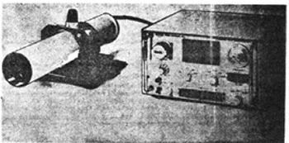

Figure 1. Model 302A Radiometer

b. Basic Radiometer Elements. The first element of this radiometer is the optics section which collects the radiant flux from a source and focuses the flux onto a detector. Figure 2 illustrates the basic radiometer elements.

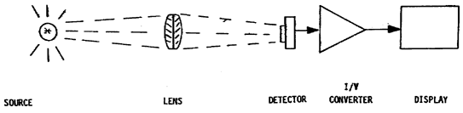

Figure 2. Basic Radiometer Element.

(1) Optics. The 302A Radiometer is used with collimated radiant sources because the lens system is focused at infinity. The field stops are located in the focal plane. An image that occurs in any other plan causes measurement errors in terms of absolute responsivity in the unit. This results in less energy falling on the detector surface than would normally be the case if the image were in focus.

(2) Detector Package

(a) The heart of the 302A Radiometer is the detector. The detector supplied with the 302A Radiometer is a silicon PN diode. The unit is mounted on gold plated adapter rings which mate to a 3-pin connector. The connector is very sturdy and very precisely machined so that mechanical and optical alignment errors are reduced to negligible quantities. Try to keep dirt, dust, fingerprints or any other extraneous material from contaminating the detector surface or the connecting pin. A small circular Corning 2-64 Filter is mounted in the detector window aperture. To remove the filter, for cleaning or replacement, use a small ring compressor to remove the retaining ring. If you attempt to remove or replace this ring without using a ring compressor, a extremely difficult task, you may damage the detector.

(b) The 302A Radiometer uses a detector in the photovoltaic mode, thus the diode is zero biased. The high silicon diode equivalent circuit is shown in Figure 3 (note the photo detector symbol). The diode's sensitivity, or high quantum efficiency, allows the unit to be used at a very low radiant flux level. The design used in the photovoltaic mode allows a fast response time which enables the instrument to be used at a relatively high frequency with sufficient bandwidth to measure accurately the incoming radiant flux. Since this instrument is used as a transfer standard, long term stability is an important factor. The detector is sufficiently stable to be a negligible contributor to the drift over a long period of time. Used in the photovoltaic mode, temperature has little effect on the response of the cell. This is quite beneficial for a transfer standard. Also in this mode the output is linear over a range of 8 to 9 decades. There is no significant effect on detector cell performance due to humidity, surface deterioration or aging. Silicon is an inert substance and surface deterioration, at the low temperatures at which this cell is used, is insignificant. The silicon cell used in the detector is a diffused junction type with the P/N junction very near to the light sensitive surface. The incident radiation penetrates the P/N layer of the cell and protons which have sufficient energy per wavelength produce hole-electron pairs within the cell. Hole-electron pairs formed near the P/N junction are separated by the junction's electrostatic field and current can then flow through an external load. This is the basic mechanism which causes the cell to respond to IR radiation.

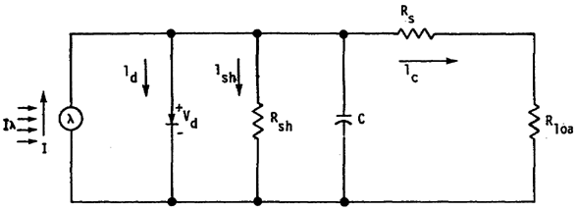

Figure 3. Silicon Diode Equivalent Circuit.

(c) Radiometer Response. The spectral intervals over which radiometric measurements are made, are controlled by the spectral response of the detector and optics. The detector responds equally to all wave lengths and the optics transfer all wave lengths within its spectral range without absorption. This the output indication is proportional to the total radiance at the optics. The spectral response of the radiometer is controlled and limits are placed on its response.

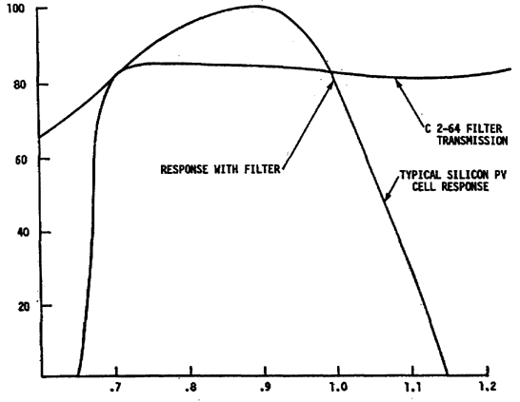

Figure 4. Typical Spectral Response of a Silicon Cell.

(d) Silicon Detector Response. Figure 4 illustrates the response of the silicon detector and the response of the optics with the Corning 2-64 Filter. The intended use of the radiometer dictates the particular spectral interval accepted by the radiometer. The wavelength is given in nanometers and the magnitude in percentage of transmission. Transmission refers to the transfer of energy through the optics. The radiometer measures the total irradiance within a spectral band and does not measure the spectral distribution of radiance flux. That is, it does not measure the variation in flux as a function of wavelength. The possibility of rejecting irradiance within the spectral band to which the radiometer responds is possible through the use of notch filters in a filtering system within the reflex sight of the radiometer. The use of filters for spectral selectivity is a special function dictated by the particular and special requirements of the system under test. In a normal application of this radiometer, the source is considered to be a heated solid and/or liquid and its spectral distribution curve is continuous, showing a single maximum at a wavelength which varies with the temperature of the source. Such a source is called a thermal radiator.

(e) Thermal Radiator Spectral Response. Figure 5 shows an ideal-normalized spectral response from a thermal radiator. The wavelength is given in nanometers and the magnitude in relative irradiance. The shortest wavelength is to the left of the diagram. The two irradiance sources are the standard daylight fluorescent and the tungsten filament. Shown with the two sources is the relative response of the silicon photovoltaic cell. The detection of the quantity of irradiance flux between the spectral limits as defined by the optical system in the radiometer is the primary function of the radiometer. A variety of other functions are available to the operator in order to give the instrument its widest possible utility. The versatility of these functions allows the radiometer to be used in a variety of applications. The fundamental function, however, is to measure irradiance flux incident upon the detector surface.

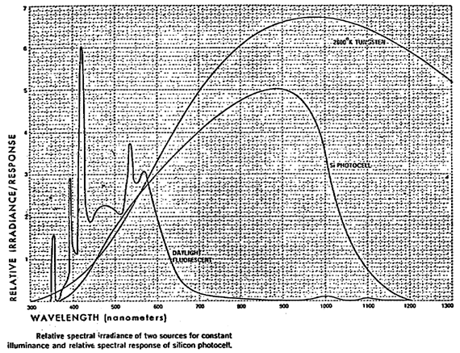

Figure 5. Thermal Radiator Spectral Distribution.

The output of the detector is applied to a current-to-voltage converter. This electrical signal is then transmitted to a processing and display device. The density of the flux per unit area at its optical input (irradiance) is the fundamental quantity involved in all radiometric measurements.

c. Components.

(1) Optical Unit. (Figure 6) The optical head is composed of three subassemblies. The first is the objective lens and its mounting tube, second is the reflex sight assembly, and the third is the amplifier detector head package.

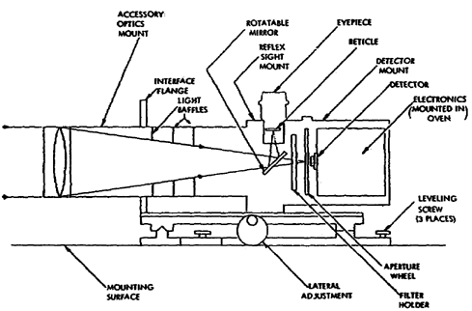
Figure 6. Optical Unit Block Diagram.

(a) The objective lens is mounted in a removable lens tube and focused for columnated targets. The lens tube contains two baffles which reduce the incidence of reflected diffused light to the detector. The lens tube mates to the reflex sight assembly in a single grooved thread which causes the lens tube to be aligned in precisely the same position each time it is mounted to the reflex sight assembly. This eliminates the wedge effect of the lens and removes any error it might cause. The focus of the system is on an image plane which coincides precisely with the plane in which the field stops are located. The field stops cannot be seen in the reflex sight. The instantaneous field of view, determined by the field stop, is normally expressed in radians.

(b) The reflex sight, when it is in the view position, places a mirror in the optical path of the incoming radiance flux and diverts the flux to an eyepiece which is located on the top side of the reflex sight assembly. The radiance flux passes through a calibrated reticle at the focal plane in the eyepieces. The reflex sight enables the operator to position and align the optical head on the selected target. Focus the eyepiece to suit the individual operator's eyes. The image formed by the target is at the focal point which is also the plane of the calibrated reticle. If the object that is being viewed is truly collimated or at infinity, then the image coincided with the sharpest image of the reticle at the image plane. When a measurement is made, place the reflex lever in the operate position. This removes the mirror from intercepting the radiance flux beam and seals the eyepiece so that external radiation cannot enter the reflex assembly through the eyepiece and also switches off the back lighted reticle lamp. Now the incoming radiant beam is focused on the field stop aperture.

(c) The system is normally equipped with a Corning 7-69 Filter. A variety of neutral density filters or notch filters may be used to shape the incoming radiance to allow only certain spectral ranges to be admitted to the radiometer detector. Since the known transmission and spectral characteristics across a given transmission band for neutral density filters are not normally highly accurate, the filters must be calibrated in terms of transmission percentage if the accuracy of the total system is to be maintained.

(d) The detector is located immediately behind the field stop aperture and is larger than the aperture. This unit uses a photon detector made of a PN junction, which is formed from a silicon slab. The detector in this system measures the radiant flux incident on a surface of unit area. This is termed irradiance and the units in which irradiance is measured are Watts per centimeter squared. Neutral density or spectral filters may be inserted in the radiant beam path by placing the selected filter into the 2" x 2" filter holder located in the ride of the reflex housing compartment.

(e) Preamplifier. The detector is mounted in a preamplifier assembly which is mated to the rear of the reflex sight assembly. The preamplifier is in a temperature controlled oven which maintains stability of the electronics which interfaces with the silicon detector cell. The preamplifier electronics (you will study these later) is composed of current-to-voltage amplifiers. The output of the preamplifier is connected to the electronics chassis by a cable. The preamplifier electronics is divided into two parts. One is the DC system and the other is the AC system. The electronic preamplifier assembly contains its own power regulators plus the temperature regulator which keeps the oven at 50° C. Calibration adjustment for the amplifier is contained within the housing and is accessible through the rear panel of the housing. A calibration input jack is also located on the rear panel. The jack is used to provide electronic calibration of the system independently of the silicon detector.

(2) The interconnecting connector is labeled on the rear panel of the control chassis. Only one multipin connector is found on the rear of the optical head. The interconnecting cable only mates one way.

3. CONTROLS AND INDICATORS. A description of the controls and indicators for the control and display chassis follows. Use Figure 7, during the description of the controls and indicators, as an aid in finding switch, control and display locations.

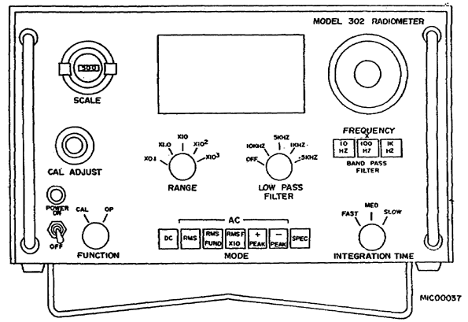

Figure 7. Model 302A Front Panel Controls.

a. AC ON/OFF switch - The unit's primary power is controlled by this switch which is located on the lower left side of the front panel. Directly above the switch is an indicating pilot lamp.

b. SCALE Control - The scale control is a linear overall scale factor adjustment which enables the operator to normalize all types of measurements. This allows for individual detector variation and/or filter transmission loss compensation. The nominal setting of this control is 500.

c. CAL Adjust Control - The cal adjust is a precision 10-turn dial used to null the offset of the first amplifier in the preamplifier assembly. Use this control to eliminate small range-to-range offset errors.

d. FUNCTION Selector - The selector switch gives the operator a choice of inputs to the current-to-voltage converter in the preamplifier. In the OP position, the preamplifier is connected to the detector output. In the CAL position, the preamplifier is connected to the CAL input connector on the rear panel of the optical unit. In this position, direct electrical inputs can be made to the preamplifier.

e. RANGE Selector - The RANGE control provides five decades steps of amplification in units of nanoamperes from 1 x 10⁻¹¹ to 1 x 10⁻⁴. With the 3-1/2 digit panel meter, over seven decades of range totals are available.

f. MODE Selector - The mode selector switch, through a series of push button switches, controls all amplifier and processing electronics. The various functions are relay controlled on individual circuit boards. The mode switch controls the relays.

(1) DC - The DC mode provides DC coupling of the detector through the entire system. This allows high precision measurements to be made over long periods of time with non-varying irradiance sources.

(2) RMS - The RMS mode is an AC function and yields the effective value of a cyclic waveform. The RMS function is obtained by squaring all frequency component terms within the bandwidth of the instrument, integrating these over the entire bandwidth and then taking the square root of the result.

(3) RMS FUND - RMS of the Fundamental is a processing technique which differs significantly from wideband RMS. When the RMS Fund push button is depressed, the band pass filter is switched into the signal path. The frequency at which the filter is tuned passes unattenuated.

(4) RMS FUND X10 - RMS of the Fundamental X10 yields an additional decade of amplification. This function takes advantage of the nominally low noise content of the RMS Fundamental.

(5) Plus (+) PEAK - The plus (+) PEAK measurement uses a peak ride hold and sample technique. The peak rider follows the input signal unilaterally in the peak detect mode. That is, it tracks in a positive amplitude direction so long as the signal is increasing. It then samples and displays the voltage.

(6) Minus (-) PEAK - The function performs in an identical manner as that of Plus PEAK except that it peak detects the negative excursions of the incoming wave forms. Peak-to-peak measurements are made by adding algebraically the plus (+) peak and the minus (-) peak.

(7) SPEC - This switch position provides for selection of an expansion option. A spare circuit board is left unused in the electronic chassis to facilitate the inclusion of a customer - required special function.

g. INTEGRATION TIME - The INTEGRATION Time selector switch enables the operator to vary the bandwidth of the amplifiers in the DC mode only. The time constants are:

(1) FAST - 1 millisecond
(2) MED - 60 millisecond
(3) SLOW - 30 seconds

h. LOW PASS FILTER - The Low Pass Filter is used in the AC mode only and places a 3 dB attenuation point at the frequencies indicated on the control panel, 10 kHz, 5 kHz, 1 kHz and 0.5 kHz. This filter is normally used only with relatively slow time varying waveforms.

i. BAND PASS FILTER - The filter is a constant gain high Q tunable filter. The gain is 0 dB ± 1% over its entire range. The Q is about 50, and results in sharp dial tuning characteristics.

j. DIGITAL PANEL METER - This meter is a 3-1/2 digit meter with a full-scale reading of 199.9. If an input is higher than maximum level, the three right-hand digits turn off and the meter is blank. When this overrange indication is observed, set the range switch to a higher scale. The 1/2 digit is simply a 1 or no number (0) at all and is referred to as + 1. The comparator circuit determines if the last bit will or will not be allowed to the counter. If the ramp capacitor is charged to 4/10 of a single quantizing bit the system reads 0. If, however, the ramp capacitor is charged to 6/10 of a volt the system responds with a 1. The last bit in an analog-to-digital converter is not exact but is similar to the rounding off process in mathematics. The use of the instrument on a higher gain range is one way to overcome some of the problems with quantizing error. That is, it is better to read 100 on the scale than 10. This allows quantizing error to be reduced to 1/10 of the indication; therefore, as a simple rule, the highest gain range possible for all readings must be used.

k. Specifications.

(1) The optical specifications begin by stating that the objective lens is an acromatic double lens 2.80 inches in diameter with a focal length of 11.48 inches. The front and rear surfaces are coated for a peak transmission at 0.9 microns. The detector is a circular, photovoltaic silicon cell, 10 millimeters in diameter. The spectral response of the cell peaks between 0.8 and 0.9 microns. Its responsivity is greater than or equal to 0.35 amps per watt at peak spectral response and zero-biased voltage. The detector uniformity is within ±2% across 80% of the detector surface, symmetrically located about the center. The total spectral range of this detector is between .35 microns to 1.1 microns.

(2) The sensitivity of the system is 1.2 x 10⁻¹¹ watts per centimeter squared at the peak frequency of response. The system has provision for either neutral density or spectral filters. The unit has a dynamic range of 8 decades. Three decades are obtained without switching ranges due to the three-digit meter. The remaining four decades are obtained by the range switch. The eighth decade (range) is obtainable in the RMS of the fundamental times 10 range only. The sensitivity of the instrument is basically 10 picoamperes which may be extended to one picoamperes by using the RMS of the fundamental time 10 mode.

(3) The resolution of the system is one part in two thousand. The DC amplifier noise is less than five picoamperes. In the AC mode the noise is dependent upon the frequency and the bandwidth in use, and is not specified.

(4) The linearity of the system in either AC or DC is ±0.1% of full scale, with full scale represented by 199.9 on the output display device. The zero offset of the system with the input short circuited to ground through a one meg ohm resistor is .000.0 ± one digit. Calibration accuracy of the system is ±0.3% of full scale plus 10 picoamperes in DC mode, and in the AC mode is ±2% of full scale. The long term stability is 0.5% for six months and the thermal stability is ±0.015% per degree centigrade from +5° C to 40° C. The response time of the DC system is about 16 microseconds, while that of the AC is 1.6 microseconds. The power requirements for the system are 115V ±10 volts AC from 50 to 400 Hz.

4. GENERAL OPERATING INSTRUCTIONS.

a. Assembly.

(1) The Model 302A Radiometer is packed in a padded, fitted case as shown in Figure 8. To assembly the radiometer it must be removed from the carrying case. When you open the case, remove the mounting table if the system will not be used on an optical bench. This provides a way to hold the optical head during assembly. Next, remove the reflex sight/optical head from the carrying case. This is the center most tube and is located directly in front of the radiometer display and control chassis.

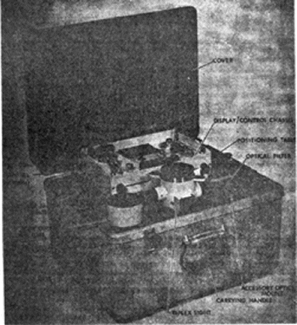

Figure 8. Radiometer Packed in Carrying Case.

(2) Position the reflex sight/optical head in the mounting table and secure it to the mounting flange with the one-fourth inch screws provided with the unit. Be sure when you mate the flange of the reflex sight to the mounting table that the flanges pull up snugly and securely at the same time. Once this unit is firmly mounted, attach the lens tube to it. Attach the lens tube at the forward end of the reflex sight optical head assembly. Remove the lens tube dust caps and the dust cap from the optical head. Now, the lens tube can be connected to the reflex sight. Remove the electronic display and control chassis from the case. Be careful because a power cable is attached to the back of chassis. Also, do not allow the unit to catch on any other items in the case when it is removed. Remove the interconnecting cable from the case and connect it to the electronic display control chassis and the optical head. This cable mates to the control chassis and optical head only one-way. When the interconnecting cable is securely connected, connect the primary power cable to the power source, and on the display and control chassis turn the power switch on.

b. Operation.

(1) Alignment of the lens with the Reflex Sight Assembly. Align the instrument on the collimated source which is to be measured. The reticle in the eyepiece is quite useful in aligning the target and making sure that the image or target which is to be measured is properly centered in the radiometer with good focus. If angular displacement of targets in milliradians is desired, the reticle is a very convenient way to make these measurements; it is calibrated directly in milliradians. When a measurement is to be made, place the reflex sight in the OP position. When this is done the reflex mirror is seated very tightly against the O ring at the base of the eyepiece which effectively seals out the light from the eyepiece. Focusing the eyepiece to the operator's eye requires that the eyepiece be turned or rotated for the best focus, but this does not affect the focusing on the detectors. If the target is truly at infinity or if the radiant energy from the target collimated (all rays in the radiant beam are perfectly parallel), then the image produced coincides with the sharpest image of the reticle. If the sharpest reticle image to the operator's eye does not equal the sharpness of the target image, then under normal operating conditions the target is not at infinity; its rays are not collimated or the optical head is improperly oriented. Next field stop selections must be made. This selection process is determined by considering the intensity of the source and the exact measurement to be made.

(2) If a filter is to be used to shape spectrally the incoming radiant energy, certain precautions are recommended. First, to maintain consistent and accurate measurement, the operator must insert the filter into the filter holder so that a tight, snug fit is obtained. Also insert the filter perpendicular to the optical axis of the unit. The plush lining of the filter holder and the loading spring at one edge generally keeps most standard filters tightly and perpendicularly mounted in the filter holder. When the filter holder is inserted into the reflex sight assembly, take care to make certain that it is properly seated and secured in the recess provided. This assures light tightness and accuracy in the measurements. The front panel controls of the display and control chassis are set according to the type of measurement to be made.

5. BLOCK DIAGRAM OPERATION.

a. The simplified block diagram of the total system is illustrated in Figure 9. It shows the relationship of the optics, detector and preamplifier to the total system. We will relate the diagram to the operation of 302A Radiometer.

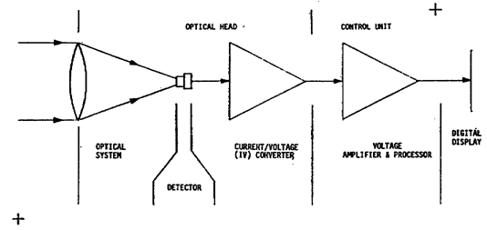

Figure 9. Model 302A Radiometer Simplified Block Diagram.

(1) A radiometer is a device which gathers an incoming beam of photon energy called radiant flux and converts this energy into an electrical current. This unit then converts the energy of photons to an electric current and then it converts that current into a precise voltage, then it amplifies and processes the voltage for display on a digital panel meter (DPM). An examination of this block diagram illustrates the major components of the system and the general signal flow. First, there is the optical system which focuses the radian beam on the detector; thus, it causes a greater concentration of photons on the detector surface than would be the case otherwise.

(2) There are two amplifiers in the optical head: one DC and the one AC (Figure 10). The amplifiers are designed to offer the maximum stability possible. The amplifier gains are fixed and are calibrated periodically to maintain accuracy. However, additional circuitry is provided to produce an AC signal from what is essentially a fluctuating DC input from the detector. The functions are provided by means of an inverting and summing amplifier driven by an integrator. The current produced by the detector is converted by an external circuit to a voltage. The current to voltage converter maintains a linear relationship to the transducer output and because the transducer has a linear relationship to the incoming radiant beam, linear relationship is possible and an accurate measurement of the incoming radiant flux can be made.

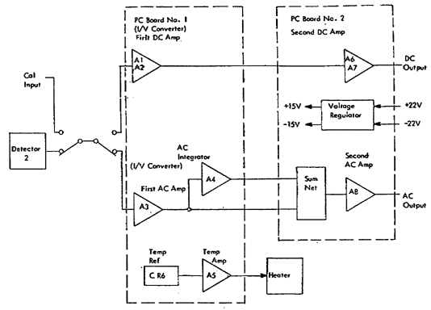

Figure 10. Preamplifier Electronics Block Diagram.

(3) The voltage generated by the current-to-voltage converter is then processed, amplified and applied to the DPM. Processing involves such functions as bandwidth limiting, peak riding or RMS calculation.

The DPM is nothing more than a digital display voltmeter with a full scale readout of 199.9 millivolts. The overall system is calibrated in nanoamperes, and the general scale factor is 1 millivolt per nanoampere input.

b. Detailed Block Diagram.

(1) See Figure 11 for the detailed block diagram of the 302A Radiometer. Signal flow in the block diagram begins at the left-hand side and proceeds in either the upper or lower path depending upon whether an AC or DC signal is selected. At the far left margin of the block diagram, a calibrate input and a detector input are shown. One of the two may be selected by a relay which is controlled from the front panel of the display and control chassis, CAL/OP control. The detector output is applied when the OP position is selected. When CAL is selected, the input to the amplifiers is from the Calibrate Input Jack located on the rear panel of the optical head. The second series switch selects either the AC or the DC mode. This selection reroutes the input (from either the detector or the CAL input) to the DC or the AC preamplifier. In each case the input amplifier is a current-to-voltage converter. Each has a gain of, or a conversion scale factor of 1 x 10⁶ or 1 x 10⁴.

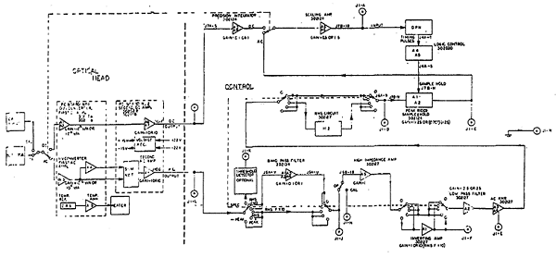

Figure 11. Model 302 Detailed Block Diagram

(2) The voltage output of the first stage is proportional to the current input times the scale factor which is selected from the front panel by the RANGE switch. The only real difference between the first stage of the AC preamplifier and that of the DC preamplifier is that the AC preamplifier has a considerably wider bandwidth than the DC preamplifier. The DC preamplifier is extremely stable and maintains this stability over long periods of time with practically no drift. The AC amplifier does not have the drift problem that the DC amplifier has; however, it is required to have a frequency response which is essentially flat up to 10,000 Hz with no more than a .1% deviation from flatness. The gain factor, or scaling conversion factor, for the AC and DC is the same. In the DC amplifier the second amplifier performs two functions: A selectable gain amplifier with two fixes voltage gains 10 or 1, and isolation of the preamplifier current to voltage converter (first amplifier) from the control unit. Additional circuitry produces an AC signal from what is essentially a fluctuating DC input from the detector. These functions are provided by means of an inverting and summing amplifier driven by an integrator. Also both second (output) amplifiers provide line drive from a very low output impedance. The low output impedance minimizes the noise pickup on the line. Any noise that develops on the line is fairly easily swamped in the extremely low output impedance of the amplifier.

(3) The DC signal path is shown in the upper portion of the block diagram. The DC output of the preamplifier is applied to the precision integrator in the control chassis. The signal is bandwidth limited by the precision integrator. A voltage gain of either times 1 or time 1/10 is available at this stage. This allows for part of the ranging that is controlled from the front panel to be used to limit or amplify the incoming signal. The integrator has selectable time constants on the control chassis front panel: FAST, which is one milliseconds; MEDIUM, which is 60 milliseconds; and SLOW, which is 30 seconds. The input to the precision integrator is available at test point J1-M on the rear panel of the display and control chassis. The output of the precision integrator is supplied to the scaling amplifier. The scaling amplifier provides an adjustable linear scale variation up to ±50% of signal amplitude. The scaling amplifier is also used in the AC mode.

(4) The output of the scaling amplifier is available at test point J1-A. When the system is in the DC mode, this output is useful for driving analog chart recorders or other analog devices. In the AC mode the output is also available, but it must be synchronized with the DPM for valid operation. The output of the scaling amplifier is applied to the DPM which, four times a second, reads the input voltage at its input terminal and displays that quantity on the nixie tube readout.

(5) The output of the preamplifier is available at test point J1-L. The signal path routing is selectable and a number of functions are available to the operator. These various functions are described next. The function used is dependent upon the type of measurement desired.

c. Theory of Operation. Efficient corrective maintenance requires a complete understanding of the detailed functions performed within the radiometer. To obtain an overall concept of the system, refer to the block diagram (Figure 11) as each circuit is described.

(1) DC, Signal Flow and Processing (Figure 12). The selection between the detector and the calibrate input is achieved by using K1 which is controlled from the control and display chassis. The selection between the DC and AC mode is accomplished by using the K2 relay which is controlled from the control and display chassis. When the DC mode is selected the output of the detector is applied to the DC current-to-voltage converter on printed circuit board number 1. The DC current-to-voltage converter is illustrated on the upper half of the schematic and the AC on the lower half.

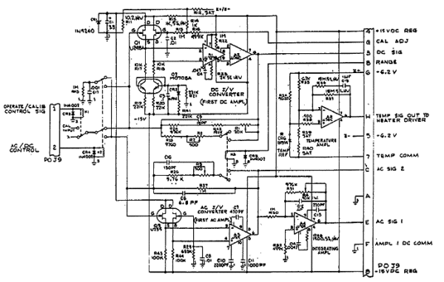
Figure 12. Radiometer Preamplifier PCB 1 Schematic.

(a) Q1 is a matched pair of FETs on a single chip with closely regulated matched drain to source current. Amplifier Al is internally thermally stabilized by a substrate heater and a sensing device constructed on the chip. The output from differential amplifier Al drives amplifier A2 differentially. The offset drift of A2 is reduced by the gain of Al and becomes nearly negligible. Amplifiers Al and A2 are used only in the DC mode.

(b) The second DC amplifier is located on printed circuit board number 2 (Figure 13) and consists of amplifiers A6 and A7 with associated components. This amplifier has relay switched gain control and isolates the DC I/V converter from the interconnecting cable. Gain is controlled in the X10 position by R51 and R8 while R52 and R7 are connected in parallel in the X1 position.

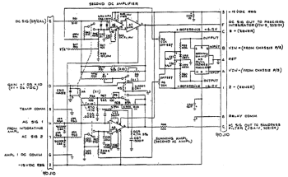

Figure 13. Ratiometer Preamplifier PCB 2 Schematic.

(c) HEATER CONTROL SENSING AMPLIFIER AND VOLTAGE REGULATOR. Amplifier A5 is a differential amplifier used to sense the voltage across a reference diode CR6 and controls the heater driver circuit. The heater drive circuit controls the temperature of the preamplifier oven. The positive 15 volts and negative 15 volt supply is generated by a single I.C., A9. Exact voltages are determined within the unit and are not externally adjustable. Caution should be observed if this unit is repaired to prevent short circuiting the unit's outputs, since they are not current limited. A short circuit causes the unit to destroy itself within a few milliseconds.

(d) The DC output from the preamplifier through the interconnecting cable is supplied to a precision integrator (Figure 14). The precision integrator is composed of A3 and A4, and integrating capacitors C8 and C9 selectable by relays K1 and K2. The precision integrator has selectable time constants, which are controlled by relays. The relays are controlled by the integration time switch on the front panel. Time constants of 1 and 60 milliseconds to a time constant approaching 30 seconds can be inserted into the signal path; This allows the system bandwidth to be severely limited which diminishes the noise to a great extent. With a high signal-to-noise ratio at the detector a faster time constant is used in the integrator. R49 is the resistive part of the time constant and limits the gain of the integrator to a precise value. R43 and R45 in series with the parallel combination of R44 and R46 provides for calibration offset nulling by adjusting the offset control R5D. R2 is used to provide an equal output impedance to drive the variable gain amplifier in either the AC or DC mode. The output of the integrator never exceeds the input, due to a feedback resistor, and the output is the opposite polarity of the input. The gain is either one (unity) or one tenth as determined by the front panel controls. Once the integration is performed and a relatively quiet signal output is developed, the signal is then supplied to a scaling amplifier.

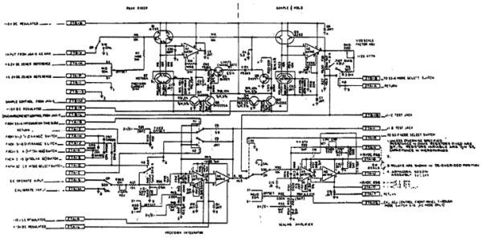

Figure 14. Integrator Peak Rider and Variable Gain Amplifier Schematic.

(e) The scaling amplifier shown in Figure 14 has a normal gain of 1 and consists of A5 and A6, with a single ended operational amplifier input. The gain of this stage is controlled by a panel mounted 5K variable resistor labeled SCALE on the front panel. This amplifier has a gain of unity when the scaling potentiometer on the front panel is set to 500. The gain of the amplifier can be increased linearly by means of this potentiometer to a gain of 1.5 or it can be diminished to a gain of 0.5. This feature allows the operator to scale the overall gain of the system to compensate for variations in detector responsivity or transmission losses due to various filters being used in the reflex sight assembly. Frequency response effects need to be compensated for by the use of the scaling potentiometer. R51 is the noninverting offset bias current balance resistor which references the scaling amplifier to signal ground. R64 connects the scaling amplifier offset control to the front panel CAL ADJ control when the system is operated in the AC mode. The output of the scaling amplifier is used to drive a digital panel meter.

(f) The DPM display is presented on three nixie tubes and a single neon tube which indicates polarity. The output voltage developed from the detector is displayed on this meter. This is a 3-1/2 digit meter. The 1/2 digit is simply a 1 or 0 (zero). The 3 designates the three nixie tubes which indicates the output number with digit 0 through 9.

1 Since the DPM displays the analog input in digits, the input must be converted using an analog-to-digital conversion process. This unit uses the ramp process coder, which is designated as such because at a particular time it takes a sample of the input voltage and starts the internal precision ramp voltage. During the period the ramp is charging at a linear rate, a clock frequency is supplied to a decade counter. The output from the counters is then displayed on the nixie readout.

2 Since a digital clock is being used to count the interval required by the precision ramp voltage to charge a capacitor to the input voltage the ±1 digit is ALWAYS an error. This is called a quantizing error and must be taken into account in all measurements that are made.

A decision must be made by the comparator circuit to distinguish between a one state and a zero state. If the ramp capacitor is charged to 4/0 of a single quantizing bit the system reads 0. If the ramp capacitor is charge to 6/10 of a volt the system responds with a 1.

3 The use of a higher gain range is one way to overcome some of the problems caused by quantizing error. That is, it is better to read 10.0 on the scale than 10. When the DPM encounters overvoltage, the DPM simply blanks all the digits. This tell the operator that there is an overvoltage situation and that the gain of the system must be reduced. When the gain of the system is reduced by one decade and the digits are again lighted, the operator then knows that this is the highest usable gain range. Depressing the DC function switch locks out all other functions.

(2) AC signal flow. The AC section is operational when any other function of the mode switch is depressed. The detector output is applied to the AC current-to-voltage converter (Figures 9 and 12). The converter, which is also the first AC amplifier, consists of amplifier A3 with associated components and is located on printed circuit board number 1.

(a) Amplifier A3 is frequency compensated for the detector and is the source drive. Because of its high performance characteristics and frequency compensation requirements, its input must not remain open circuited. If it remains open circuited, the amplifier tends to become unstable. When this amplifier is not in use (i.e., DC mode), the input returns to signal ground through R45 and C17. This same input load is used to stabilize the DC Amp when the system is in the AC mode.

1 To maintain high input impedance and very low bias current a source follower, Q3 is used to drive A3. With a gain of 1, Q3-A3 has a gain bandwidth product of 20 megaHertz. C7, C10 and C11 internally compensate this amplifier for unity gain, while C6 and C16 roll off the response enough to stabilize the unit in this configuration.

2 Resistor R27 provides the 1 x 10⁶ gain. R26 with R3 when switched into parallel with R27 provides the 1 x 10⁴ gain). The precise gain of A3 in the 1 x 10⁶ gain position is set by the following amplifier stage, while 1 x 10⁴ is adjusted by R3. R43 and R44 are the load resistors and R29 provides a DC return path, and reference to signal ground. C8 filters out high frequency noise. The output of this amplifier is routed to the second AC amplifier.

(b) The AC amplifier concept illustrated in Figure 15 is the DC subtraction method employed to produce an AC amplifier using the two operational amplifiers. The amplifier consists of an integrating amplifier and a summing amplifier. The integrating amplifier, which has a gain of minus one, responds only to slow changes. The input signals to A4 and A8 are applied to the inverting inputs. When DC is applied to the input of the circuit, opposite and equal voltages are applied to R1 and R2. Thus the two inputs to the summing amplifier cancel. When a change in the circuit input occurs, this change is immediately applied to R1 and R2. With a new voltage level applied to the input, the new level is immediately applied to R1 and R2. Due to C1, the output of A4 is delayed and is not immediately opposite and equal to the circuit input. During this time, the two inputs of A8 do not cancel, and A8 produces an output. Thus, A8 only produces an output when the input to the circuit changes, and corresponds to the operation of an AC amplifier.

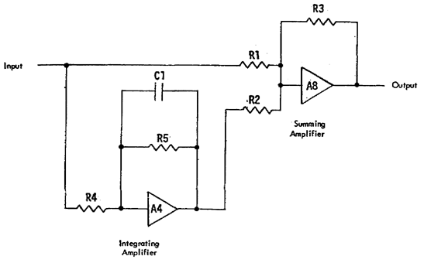

Figure 15. AC Amplifier Concept.

1 The second AC amplifier consist of a summing network (A8) and an integrator (A4) with associated components. A4 is an integrating amplifier with a long time constant and a gain of -1. The integrating amplifier is used in conjunction with the summing amplifier (A8) to produce an AC amplifier. Since the output of A4 is 180° out of phase with the input, it subtracts the DC component from the signal in the second AC amplifier leaving the pure AC component of the signal. From the second AC amplifier the signal is transmitted by interconnecting cable to the electronic chassis.

(c) When the AC signal reaches the control chassis a variety of functions become available to the operator. The operator presses the appropriate pushbutton to select the RMS function. If this is chosen, the signal is routed through the AC amplifier, which depending upon the range selected, amplifies the signal to such an amplitude as to be useful by the RMS module within the processor.

(d) The band pass filter is shown in Figure 16. Amplifier Al provides absolute gain correction and frequency dependent compensation to the filter. A different compensation is provided for each filter range. This is necessary because of the difficulty of exactly matching all of the electronic components, bandwidth limitations in the operational amplifiers, and lack of absolute physical balance in the PC board. Each range has a slight gain increase with respect to frequency. The gain of the system at center frequency is normally 1. This may not be exactly true in each range, therefore, the range adjust resistor is used to correct this deviation.

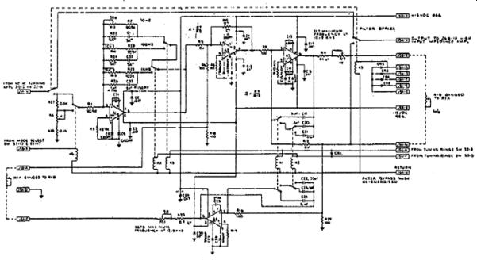

Figure 16. Band Pass Filter Schematic.

1 1 to 1/10 range change is provided in the voltage divider formed by R27, R4 and R28. The input impedance to the inverting amplifier input changes with the voltage division but is compensated for the divider. In the 10 Hz range R13 and R2 form the DC feedback resistance and R22 and C1 are the frequency dependent AC impedance elements. In the 100 Hz range R14 and R23 form the DC feedback resistance and R24 and C32 are the frequency dependent AC impedance elements. In the 1 kHz range, R15 and R25 form the DC feedback resistance and R26 and C33 are the frequency dependent AC impedance elements.

2 The three operational amplifiers which comprise the active filter have a number of common characteristics. All are used in the inverting mode, returning all noninverting inputs to signal ground through offset bias current balancing resistors (R8, R10, and R17). All are compensated with capacitors to signal ground. Since the gain of each amplifier differs, the values of these capacitors varies. These capacitors also establish the rolloff characteristics of the amplifier R19 and R21 when set to the maximum frequency within the highest range (12.5 kHz).

(e) The AC Amplifier in Figure 17 performs signal conditioning for the AC measuring circuitry in the system. The input amplifier A5, which is the high input impedance amplifier on the block diagram, provides high input impedance to the optical head and low output impedance to drive the other amplifiers. A5 also provides signal inversion for the minus peak mode. Al, labeled inverting amplifier on the block diagram, is a two range precision amplifier, X1 and X10, controlled by relay K5. It is switched in and out of the signal path by relay K2. The X10 gain is used only in the RMS FX10 mode. The second precision two-range AC amplifier (low pass filter), A2, is driven through a TEE filter composed of R3, C40, and R34. This filter removes only high frequency noise and does not attenuate the signal significantly, except in the low pass filter mode where additional capacitance is switched into the circuit paralleling C40. The X2.5 and X25 range of this amplifier is controlled-by relay K1. The high signal voltage output of this stage is used to minimize the effects of small residual errors in the peak rider and RMS circuits. The output of A2 drives the integrating amplifier A4, which generates a precise DC voltage for DC component subtraction in the summing amplifier, A3. Amplifiers A3 and A4 form an AC amplifier. Amplifiers Al, A3, A4 and A5 are compensated for unity gain. (A1 is used in a X10 gain configuration in RMS F X10 and is slightly overcompensated. This is the proper approach with the particular operational amplifier used.) The noninverting input resistor is R33. R31 and C1 are the feedback resistor and capacitor for unit gain which match the input resistance for offset bias balance. The noninverting signal ground return reference resistor is R1. The inverting input resistor is R32 and the X10 gain feedback resistor is R40 which is in series with the gain adjustment resistor, R39C. The unity gain feedback resistor is R2 which is in series with the gain adjustment resistor, R33C. A2 provides gains of 2.5 and 25. The inverting input resistance is the series resistance of R3 and R34. The feedback resistance in the X2.5 position is R4 in series with the gain adjustment resistor R5C. The X25 gain feedback resistance is R6 in series with the gain adjustment resistor R7C. The summing amplifier AC input is through resistors R12 and R35. These resistors with C45 form a TEE filter which, when additional capacitors are switched in parallel with C45, form a low pass filter. The DC summing voltage is applied through R36 and R13 from A4. C50 is placed at the junction of these two resistors and returned to signal ground to filter out high frequency noise. The feedback resistor for A3 is R14. Input offset voltage is nulled to zero at the noninverting input through the offset bias balance resistor, R17. The fixed offset nulling voltage is developed by the voltage division of R18 and R15 with R18 returned to either Z+ or Z-. R19 and R16 form the adjustable voltage divider and is controlled by the screwdriver adjustable potentiometer, R20C for offset nulling. C17, C19 and C20 compensate the amplifier for unity gain. Amplifier A4 is the integrating amplifier and is driven by the AC signal output of A2 through input resistor R9. The limiting feedback gain resistor composed of R10, R29 and adjustable resistor R11C sets the exact AC integrated voltage. The gain of this integrating amplifier is -1. The time constant of C23 and the feedback resistance is 1 second. This amplifier is compensated for unity gain by C24, C26 and C27. The fixed offset nulling voltage is developed by the voltage division of R24 and R25. R25 is returned to either Z+ or Z-. The adjustable offset nulling voltage from the screwdriver adjustable potentiometer R26C is developed at the junction between R22 and R23. The offset nulling voltage is supplied to the noninverting amplifier input through R21.

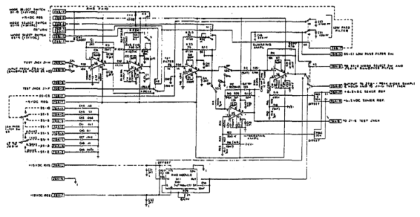

Figure 17. AC Amplifier RMS-AC.

(f) The RMS module, Figure 17, is a self-contained true RMS computing module, entitled M1. The offset of the module is nulled out by adjusting R27C. The absolute gain of the module is adjusted by R28. Capacitor C30 provides low frequency AC filtering in the DC output. The module acts on any cyclic AC wave form input and within a few cycles, outputs the effective DC value of the input signal. The RMS module is switched in and out of the circuit by relay K3. The RMS module accepts the AC signal and provides a DC output which is precisely the RMS value of the AC signal. This output voltage is sampled by the peak rider sample and hold circuitry.

(g) The peak rider in Figure 14 is a unilaterally connected high speed voltage comparator which charges a capacitor through a diode to a voltage equal to maximum positive voltage applied to the amplifier input. When the input voltage decreases the diode disconnects the drive circuit to the capacitor which then holds the maximum voltage until it is reset or discharged to zero.

1 With an AC signal such as a sinewave, the peak rider follows the sinewave until the sinewave reaches its peak amplitude and when the voltage of the sinewave begins to diminish (invert) the peak rider remains at the greatest amplitude.

2 The matched dual pair of FETs contained in Q1 are supplied equal currents to provide a zero temperature coefficient. The precision current sink is provided by Q2, a matched dual pair of 3NP transistors. The base voltage to the current sink is developed by the voltage division of power supply common and 15 v through R12 and R13. Q1 is configured as a source follower and drives Al. The drive voltage is developed across load resistors R8 and R9. Q1 provides a very high impedance to the input signal and the hold capacitor, eliminating droop effects (discharge of C4 caused by loading). A1 is a very fast voltage comparator with a short recovery time. This results in an error of no more than ±0.1% in the final voltage held on the hold, capacitor C4. Reverse leakage is minimized through the use of diodes CR2 and CR3. These diodes allow the capacitor to be charged in one direction only. Q5 acts as a charge line switch connecting Al to hold capacitor during charging and disconnects the hold capacitor during reset. R16 is used to discharge the gate of Q5 when commanded. CR14 is a disconnect isolation diode which allows Q5 to conduct when the diode becomes reverse biased. Q8 and Q5 gate control switch is driven by the level changer Q7. The gate of Q6 (the hold capacitor reset or discharge device) is returned to signal ground through R20 and is switched through the connect/disconnect diode CR5.

3 Q3 is used to prevent appreciable loading of C4 and thereby minimize droop. Q4 is a matched dual pair of transistors used as a precision current sink whose base voltage is developed at the junction between R28 and CR6. These currents provide a zero temperature coefficient in Q3 and are developed across R21 and R22

4 The voltage division chain composed of R26, R27 and R36D paralleled by R4D and R3 are used to scale the peak voltage by 1/25 and to introduce the scale correction needed to compensate for the gain of the AC amplifier. Switching to the RMS of the FUNDAMENTAL deenergizes K5, which introduces an additional factor of 0.707 to produce the RMS value of the signal. Resistor R36D sets the exact scale factor for the RMS determination and R4D sets the 1/25 scale factor.

5 The peak rider only operates on a positive polarity and the measurement of positive peaks is the only function of the peak rider. The minus peak function in the radiometer is possible by inverting the signal in the AC amplifier. If the signal is negative it becomes positive when inverted so the peak rider senses only a positive polarity. If plus peak mode is selected, negative peaks are not sensed and vice-versa.

(h) The scaling amplifier shown in Figure 14 is advantageous in those areas of the AC processing functions which are frequency sensitive. The use of neutral density filters, which have transmission losses that can be measured and known to a fairly high degree of accuracy, can be scaled to bring the gain of the radiometer back to a normalized calibration level by using the scaling amplifier potentiometer control. This provides a method of bringing the system to a normalized calibration when using filters or other detectors. The output of the scaling amplifier, such as that of the DC system, is used to drive the DPM.

(i) The basic timing and control of the sample and hold circuit (Figure 18) is developed from the logic of the DPM. The timing diagram is shown in Figure 18. The 5 millisecond astable is located at A4 and the output gating is implemented in A5. R17 and C12 determine the pulse width of A4, and R18 connects the positive input of A4 to Vcc. Pins 3 and 4 of A4 respond to a negative transition of the input timing signal from the DPM. The output produced at A4 pin 1 is negative going and the output produced at A5 pin 6 is positive going.

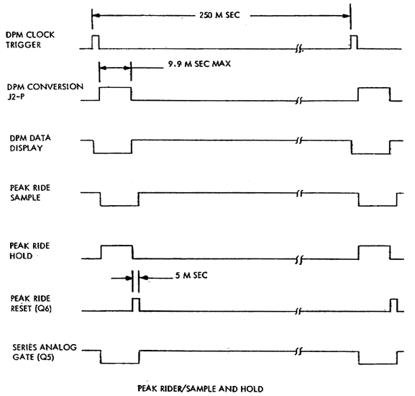

Figure 18. Timing Diagram

(3) POWER SUPPLY. The power supply is driven by an electrostatically shielded transformer (TI) shown in Figure 19 with two secondary windings. One of these windings is centered tapped which allows positive and negative voltages to be generated.

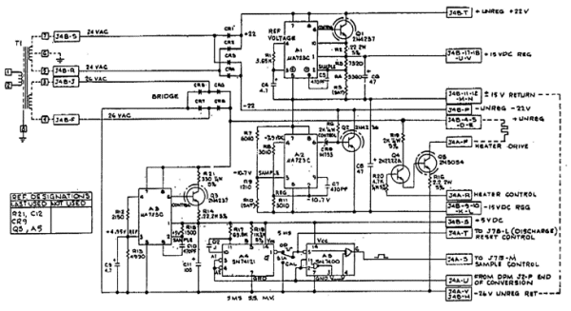

Figure 19. Radiometer Power Supply Schematic.

(a) The transformer output is rectified positively by CR1 and CR2 and filtered by a large chassis mounted capacitor. This filtered voltage supplies the +15 volt regulator (Al). This regulator drives the pass transistor Q1. C5 is the compensation capacitor for the regulator amplifier. The output of this regulator supplies positive power for the processing circuitry within the control chassis.

(b) Regulator A2 receives negative voltage from rectifiers CR3 and CR4, which is filtered by a large chassis mounted capacitor. In the negative voltage regulator configuration, the feedback voltage is applied to the noninverting regulator input. The reference voltage is applied to the inverting input, after being divided by R8 and R11. The output of pin 4 is about -7.9 volts with about -10.7 volts appearing at the function between R8 and R11. Voltage divides R7 and R9 in series with R10 provide the noninverting input with about 10.7 volts and yields an output voltage of -15. This output is series passed by Q2 which is driven by the regulator. C7 is the regulator compensation capacitor and provides high frequency and transient filtering.

(c) Regulator A3 is used to regulate the +24 volt relay/heater power source to +5 volts used by the system logic. About +4.95 volts are developed at the junction of R12 and R13 and ripple filtered by C9. C10 is the frequency compensation capacitor. R14 is the current limit sensing resistor which protects the pass transistor, Q3, from damage due to a short circuit on the output. R21 dissipates part of the power lost in the voltage reduction from the +24 volt unregulated supply to the regulated +5 volt output. This lessens the thermal stress on the regulator and limits the current surge during the initial power turn on. R14 is the current sensing resistor which is set to protect the regulator in the event that safe regulator current limits are exceeded.

(d) The heater element in the preamplifier assembly is driven from the Darlington pair, Q1 and Q5. Control of the heater winding is through the collector of Q5. Transistor Q4 is driven directly from the control operational amplifier in the preamplifier assembly through current limiting resistor R20. R16 limits the maximum current input to Q5 during warm-up when Q5 may be completely saturated to make heat control less cyclic.

6. SUMMARY. During this lesson you should have learned the purpose, characteristics, block diagram, circuit analysis, and theory of operation of the general purpose radiometer test set. From the information given in this lesson, you should be able to operate and make IR calibration measurements with the general purpose radiometer test set.

SUBCOURSE MM0487, INFRARED CALIBRATION

EXERCISES FOR LESSON 2

1. In which portion of the electromagnetic spectrum is the 302A Radiometer designed to operate?

a. Near infrared

b. Far infrared

c. Middle infrared

2. Which component of the radiometer converts electromagnetic energy into electrical energy?

a. Optical lens

b. Detector

c. Current to voltage converter

3. For a higher accuracy filters should be calibrated in

a. wavelengths.

b. relative irradiance.

c. percentage of transmission.

4. What is the advantage of photo diode in the detector being used in the photovoltaic mode?

a. Very fast response time

b. Allows the radiometer to be used at a very low frequency

c. Higher sensitivity to temperature

5. What is the full-scale readout of the DPM on the radiometer set?

a. 1.99 volts

b. 200.00 millivolts

c. 199.9 millivolts

6. When the CAL/OP control on the display and control chassis is in the CAL position, the source of the input to the preamplifiers is the

a. Detector assembly.

b. Calibrate input jack.

c. Internal power supply.

7. The integration time switch on the front panel is in what position if the integrator constant is 60 millisecond?

a. Slow

b. Fast

c. Medium

8. At what time interval does the DPM monitor the output of the scaling amplifier?

a. Four times per second

b. Once per second

c. Twice per second

9. What is the purpose of the scale control on the 302A Radiometer Set?

a. Zero adjust

b. Full scale adjust

c. Normalize radiometer for all types of measurement

10. When is the detector connected to the preamplifier?

a. Whenever a mode selector push button is pressed

b. When the scale control is set to 500

c. When the CAL-OP control is in the OP position

11. What is the gain of the scaling amplifier when the scale control on the front panel is set to 500?

a. .1

b. 1

c. 10

12. What is the indication on the DPM when it encounters overvoltage?

a. Asterisk

b. Blank

c. A 1 in left digit with zeros in remaining digits

13. See Figure 15 for the following two questions. When does the summing amplifier A2 have an output?

a. When opposite and equal voltages are applied to R1 and R2

b. When equal voltages are applied to R1 and R2

c. When the input to the circuit changes

14. What is the gain of integrating amplifier Al?

a. One

b. Minus one

c. One tenth

15. The reflex sight assembly is calibrated in

a. Milliradians

b. Radians

c. Microns

16. What does the output of integrating amplifier in Figure 11 represent?

a. Pure AC sinewave

b. DC component of the AC signal

c. The drive of the RMS module

17. The preamplifier assembly is temperature controlled. What components on printed circuit board number 1 establishes the temperature within the preamplifier?

a. Amplifier A5

b. Amplifier A4

c. 6.2V reference

18. How can an operator overcome the problem of quantizing error on the DPM panel?

a. By using the instrument on a lower gain range

b. By allowing more time for equipment to warmup

c. By using the instrument on a higher gain range

19. The gain of the operational amplifier in the band pass filter is normally 1; however, this changes from range to range. What must be adjusted to correct this deviation?

a. Range resistor R4

b. Scale adjust potentiometer

c. Frequency adjust R21

20. What is the function of amplifier A5 in the AC measuring circuit Figure 16?

a. To provide sufficient gain to allow the DPM to operate

b. Low input impedance to $he optical head and a high output impedance

c. High input impedance to the optical head and a low output impedance

SUBCOURSE NUMBER MM0487, INFRARED CALIBRATION.

APPROVED SOLUTION

Lesson 2 General Radiometer Test Set

1. a para 2a 6. b para 5b(1)
2. b para 2a. 7. c para 3g
3. c para 1c(1) 8. a para 5b(4)
4. a para 2(2) 9. c para 3b
5. c para 5a(3) 10. c para 3d
11. b para 5c(1)(e) 16. b para b(3)
12. b para 5c(f)3 17. a para 5c(1)(c)
13. c para 5c(2)(b) 18. c para 5c(1)(f)(3)
14. b para 5c(2)(b) 19. a para 5c(2)(d)
15. a para 4b(1) 20. c para 5c(2)(e)

LESSON 3: INFRARED TRANSFER SET

Lesson Objective: | After studying this lesson you should be able to explain the purpose, characteristics, and operation of the Infrared (Secondary Transfer) Test Set and applicable elements of the Guided Missile Test Set.
Credit Hours: | Three
1. INTRODUCTION.

In previous lessons you studied the principles of infrared and some of the basic components of infrared equipment. To support the REDEYE Missile System, special test equipment was developed. The two test sets you are interested in are Guided Missile Test Sets, AN/TSM-54 and the AN/TSM-82. As a calibration technician you are required to use infrared standards and associated equipment to calibrate infrared test equipment. In this lesson, study the purpose, characteristics, and operation of infrared transfer standards including the guided missile test set (GMTS).

2. DESCRIPTION.

a. General. The infrared (secondary transfer) test set (Figure 1) will be called the test set. This test set is a precision system used to measure infrared radiation. The test set and the infrared (secondary reference) test set comprise the calibration support system for the Guided Missile Test Sets, AN/TSM-54 and AN/TSM-82 (Figures 2 and 3). All components of the test set are housed in two portable, shockmounted combination cases (Figure 4).

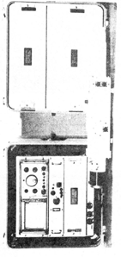

Figure 1. Infrared (Secondary Transfer) Test Set 4931-00-3886.

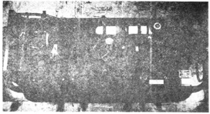

Figure 2. GMTS, AN/TSM-82.

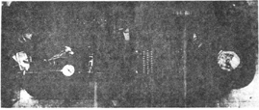

Figure 3. GMTS, AN/TSM-54.

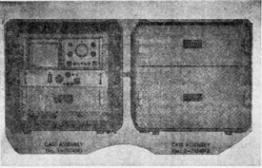

Figure 4. Infrared Secondary Transfer Test Set 4931-895-3886.

b. The test set combination cases are used for transportation and storage. The cases are constructed of an outer shell, an inner frame, and a suspension system which joins the outer shell to the inner frame. The inner frame assemblies are designed to accommodate the applicable test set units as shown in Figure 4. Case assembly No. 1-7924041, Figure 5, contains rack mounted electronic components that can be operated while mounted in the combination case or from a standard rack mounting. Located beneath the rack mounted components is an equipment storage drawer which houses specific test set items, Figure 6. Below the drawer are three power connectors. One power connector is for primary power input and two route voltages to the electronic components.

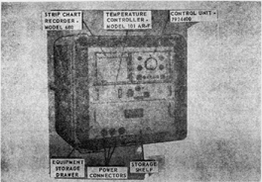

Figure 5. Case Assembly No. 1--7924041.

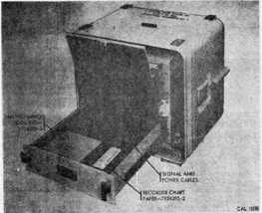

Figure 6. Case Assembly No. 1 APN 7924041 Equipment Storage Drawer Components.

Located beside the power connectors is a hinged door compartment which provides storage for the test set operating manual and handbooks. A primary power cable which can be plugged into a convenience outlet is mounted on the inside of the combination case cover, Figure 5. Case assembly Army Part Number (APN) No. 217924042, Figures 7 and 8, is a two-drawer compartment for housing specific test set components and related material components issued with the test set. The drawers have resilient cushions with formed cavities outlining the shape of the compartments that fit into each cavity. The inside of each drawer cover is lined with a cushioning material to assure a slight compression load on the components in the drawer.

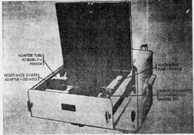

Figure 7. Case Assembly No. 2 APN 7924042 Top Drawer Components.

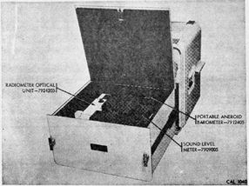
Figure 8. Case Assembly No. 2 Bottom Drawer Components.

c. Case assembly No. 1, Figure 5, contains the following test set components:

(1) Radiometer electronics unit. The radiometer electronics unit consists of a control unit APN-7924400 and a single-pen strip chart recorder, Model 680. These are housed side-by-side in a rack mounted case. The control unit contains the amplifiers and control circuitry needed for system operation. All controls, indicators, and a null meter are located on the front panel. Two receptacles on the front panel receive the preamplifier and chopper interconnecting signal and power cables from the radiometer optical unit. There is an attached power cable for the combining case power connector. A permanent record of calibration runs is kept by the strip chart recorder. The control unit supplies recorder input signals.

(2) Radiometer Blackbody Temperature Controller, Model 101AR-F. The blackbody temperature controller is slide-mounted in the combination case rack directly below the radiometer electronics unit. It accurately controls and maintains, to a preselected value, the operating temperature of a matched blackbody radiation reference source mounted within the radiometer optical unit. The front panel contains the necessary controls for system operation. A receptacle on the front panel receives the interconnecting cable from the radiometer blackbody source. A connector routes 117V ±10% 50-60 Hz power for unit operation.

(3) Preamplifier Signal Cable, APN 792437. The preamplifier signal cable, Figure 9, routes supply voltages from the control unit to the radiometer optical unit preamplifier and detector. It also routes the amplified detector signal to the control unit for processing and readout on the output meter and strip chart recorder. The cable is stored in the equipment storage drawer.

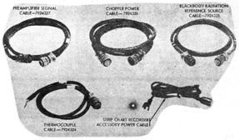

Figure 9. Signal and Power Cables.

(4) Chopper Power Cable, APN 7924326. The chopper power cable, Figure 9, supplies power from the control unit to the heaters and the chopper drive motor in the radiometer optical unit. It also routes the magnetic pickup phase signals from the chopper assembly to the control unit. The cable is stored in the equipment storage drawer.

(5) Blackbody Radiation Reference Source Cable, APN 7924325. The blackbody radiation reference source cable, Figure 9, routes input voltages from the temperature controller to the radiometer optical unit blackbody power receptacle. The cable is stored in the equipment storage drawer.

(6) Thermocouple Cable, APN 7924324. The thermocouple cable, Figure 9, is used to measure the temperature of the reference source. The cable connects to the radiometer optical unit thermocouple receptacle. The cable is stored in the equipment storage drawer.

(7) Strip chart recorder, power cable. The strip chart recorder power cable, Figure 9, is an accessory cable supplied with the Model 680 strip chart recorder unit. The cable may be used for operating the recorder separately from the combination case and the radiometer electronics unit. It is stored inside the combination case cover.

(8) Thermocouple Accessory APN 7924320. The chromel-alumel thermocouple accessory, Figure 9, is for general use on the direct measurement of blackbody cavity temperatures, including the GMTS blackbody. It is used in conjunction with an electronic ice bath. The accessory is stored in the equipment storage drawer.

(9) Maintenance Tool Kit, APN 7924394-3. The maintenance tool kit, Figure 10, is used to service the Model 680 strip chart recorder. It is stored in the equipment storage drawer. The kit consists of the following:

(a) Spare fuse

(b) Slidewire cleaner

(c) Lubricant

(d) Bristol wrench set

(e) Manufacturer's handbook

(f) 3/16" Allen wrench

The Allen wrench fits the mounting bolts supplied with the radiometer optical unit.

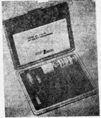

Figure 10. Maintenance Tool Kit--7924395-3.

(10) Recorder Chart Paper, APN 7924395-2. A 100-foot roll of recorder chart paper is kept in the equipment storage drawer to be used with the Model 680 strip chart recorder. The recorder chart paper must be removed for high temperature storage (above 67° C).

d. Case Assembly No. 2 Test Set Components. Case assembly No. 2 contains the following test set components:

(1) Autocollimator Illuminator, Model FF2. The autocollimator illuminator, Figure 11, is the light source for the AN/TSM-54 and AN/TSM-82 GMTS autocollimators. It is also the light source for the autocollimating telescope of the Infrared (Secondary Transfer) Test Set, 4931-00-895-3894, during calibration testing. The instrument consists of a low-voltage filament lamp and an electrical cable that connects the lamp to a variable transformer for control of lamp intensity. The transformer converts 117 V 50-60 Hz input from a standard convenience outlet to a 4 V output for use by the lamp. The autocollimator illuminator is stored in the top drawer of the case assembly.

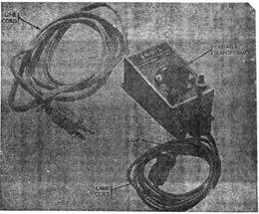

Figure 11. Autocollimator Illuminator--Model FF2.

(2) Adapter Tube Assembly, APN 7924034. The adapter tube assembly, Figure 12, when used in conjunction with alignment tube APN 7924035, adapts the radiometer optical unit for mounting in the AN/TSM-54 and AN/TSM-82 GMTS during calibration testing of the GMTS. It is also used for test set calibration with the Infrared (Secondary Reference) Test Set, 4931-00-895-3894. The assembly mounts on the forward end of the radiometer optical unit and consists of an adapter tube, an alignment sighting mirror, and a removable end cap which protects the radiometer optics The cap is removed for test set operation. The adapter tube is stored in the top drawer of the case assembly.

(3) Alignment Tube, APN 7924035. The alignment tube, Figure 12, if mounted on the aft end of the radiometer optical unit and is used with Adapter Tube Assembly, APN 7924034. The unit is stored in the top drawer of the case assembly.

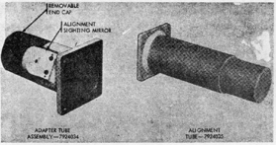

Figure 12. Adapter Tube Assembly APN 7924034 and Alignment Tube APN 7924035.

(4) Resistance Insert Adapter, APN 10214952. The resistance insert adapter is a component of related material. It is stored in the top drawer of case assembly No. 2, Figure 7. It is not used in operating the test set.

(5) Radiometer Optical Unit, APN 7924205. The radiometer optical unit, Figure 13, consists of a machined aluminum housing which contains all optical elements, a chopper and chopper motor assembly, a detector and preamplifier assembly. Attached externally to the main housing are the chopper and preamplifier housing covers which seal the access to internal components. Detachable forward and rear storage caps protect the instrument optics and blackbody during storage. The instrument is stored in the bottom drawer of the case assembly. The optical housing assembly contains:

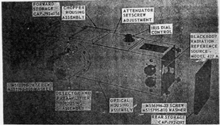

Figure 13. Radiometer Optical Unit APN 7924205.

(a) The optical system which transmits radiant energy input to the detector from the source under test.

(b) The optical system which transmits radiant energy from the internal blackbody reference source to the detector.

(c) The calibrated blackbody radiation reference source.

Receptacles at the rear of the housing receive the blockbody interconnecting power cable from the temperature controller and the thermocouple cable. A dial control knob located on the top side of the optical housing is for iris adjustment and readout. The iris is adjustable to attenuate the energy from the blackbody standard to match the energy level of the GMTS F filter assembly attenuator. A recessed setscrew is used to adjust the attenuator which controls the internal reference energy and normalizes source attenuation so the range full scale can be set. Threaded hole patterns at each end of the optical housing provide for attachment of the forward and aft adapter and alignment tubes when mounting the unit on the GMTS under test, or for attachment of storage caps. Threaded holes in the two housing legs provide for attachment of the radiometer to the infrared secondary reference test set alignment stand.

(d) The Model 427A blackbody radiation reference source, Figure 14, is mounted internally in the optical housing assembly. Access to the Model 427A is at the rear of the housing. An attached power cable ends at the optical housing receptacle that receives the interconnecting cable from the temperature controller.

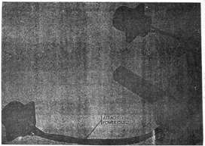

Figure 14. Blackbody Radiation Reference Source--Model 427A.

An attached chromel-alumel thermocouple cable ends at the optical housing receptacle for the thermocouple cable. This cable is used during operational checks to determine source temperature. Because it is factory calibrated with a specific temperature controller, accuracy of the blackbody unit depends on operation of the particular temperature control unit issued with it. The two units form a calibrated set and can be replaced only with another calibrated set.

(e) The chopper housing assembly, Figure 13, is installed on the radiometer main housing. The assembly includes a 117 V 50-60 Hz chopper drive motor, motor capacitor, phase disc, two magnetic pickups, chopper, terminal strips and associated circuitry, and radiometer heater circuitry. A receptacle on the chopper housing accepts the chopper interconnecting power cable from the control unit in case assembly No. 1.

(f) The detector and preamplifier housing assembly, Figure 13, mounts on the radiometer main housing and contains a detector and relay optics mounted on a support structure, magnetic shield, and a preamplifier circuit board for processing the detector output signal. Connecting wires are routed to a receptacle on the housing which accepts the preamplifier interconnecting signal cable from the control unit.

(6) The Portable Aneroid Barometer, APN-7912405 is a component of related material. It is stored in the bottom drawer of case assembly No. 2 and is not used in operating the test set.

(7) The Sound Level Meter, APN 7909005 is a component of related material. It is stored in the bottom drawer of case assembly No. 2, Figure 8, and is not used in operating the test set.

3. Tabulated Data. The test set characteristics and data are listed in Table 1.

Table 1. Characteristics and Data
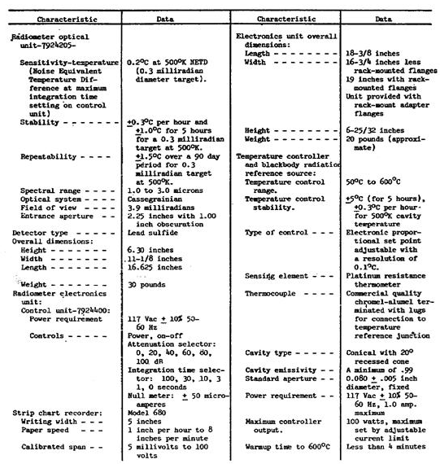

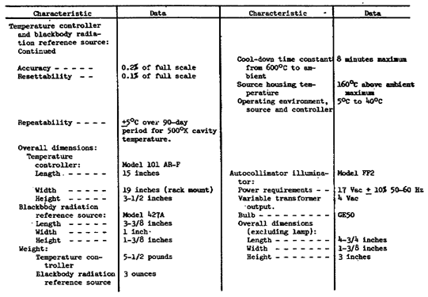

4. THEORY OF OPERATION.

a. Fundamental Principles. The test set compares the radiant energy from an external source with the radiant energy from an internal blackbody source of calibrated intensity. A lead sulfide detector converts the received radiant energy from the opposing sources to voltages. These voltages are processed by the preamplifier and control unit and are monitored by a null meter in the control unit. A meter deflection to either side of null indicates which of the two opposing sources has the greater intensity. Output signals from the control unit may be permanently recorded on a strip chart recorder. The block diagram, Figure 15, illustrates the fundamental principle.

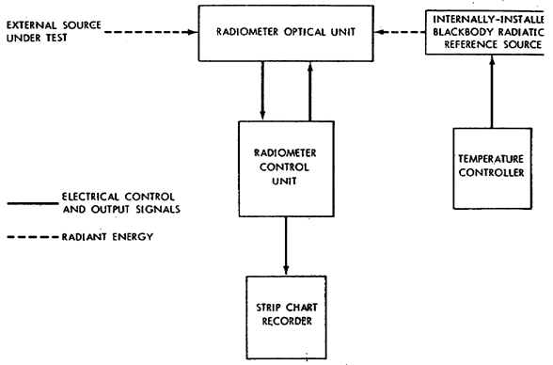
Figure 15. Test Set Block Diagram.

b. Radiometer Optical Unit, Figure 16.

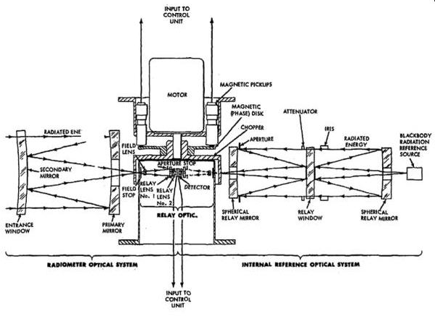
Figure 16. Radiometer Optical Unit Functional Diagram.

(1) Optics. Radiant energy from both an external source and an internal blackbody radiation reference source enter the opposing optical systems of the radiometer through viewing apertures which limit the acceptance angle of irradiance of each source.

(a) External source. Energy from the external source enters the optical system through the entrance window to a primary mirror, and is reflected back to the secondary mirror (inner aluminized surface of the entrance window. It then converges through the light baffle and openings in the chopper to the relay optical system which limits the acceptance angle of the incident radiant energy and relays the incoming radiation to the lead sulfide detector. The light baffle excludes light other than that from the secondary mirror.

(b) Reference source. Energy from the internal blackbody radiation reference source enters the opposing reference source optical system and is relayed through an optical system as illustrated by Figure 16. There it converges through openings in the chopper to the detector relay optics and in turn to the detector. The internal source optical system iris attenuates the energy input in a continuous calibrated adjustment.

The iris is adjusted to attenuate the energy from the blackbody standard to match the energy level of the GMTS F filter assembly attenuator. The attenuator is another adjustable attenuator which controls the internal reference energy input and normalizes source attenuation to set the range full scale. Total internal source attenuation is a product of the settings of the iris and the attenuator.

(2) Chopper System.

(a) The optical paths of radiated energy from the test and internal source optical systems, converging through the openings in the chopper blade to the detector relay optics and detector, are alternately blocked by the rotating chopper. Eleven holes equally spaced over one-half of the chopper blade circumference alternately expose opposing faces of the detector to the energy input. The chopper is powered by a synchronous 1800 RPM drive motor.

(b) The phase disk and magnetic pickups develop an output signal which is used for signal processing in the control unit Figure 16. The phase disk, driven by the chopper drive motor, induces keying pulses in the magnetic pickups. These output pulses are locked to the chopper speed and identify the detector signal output phase. The magnetic pickup signals are routed directly to the phase switch driver portion of the control unit circuitry.

(3) Radiant energy converging on the lead sulfide detector from the opposing external and reference sources is alternately modulated by the rotating chopper. As the chopper turns, the eleven holes drilled in one-half of its circumference first modulates the energy from one side, then when the chopper completes that one-half revolution, the holes modulate the energy coming from the other side. The resulting detector output signals are adjacent groups of eleven carrier cycles approximating square waves. Peak-to-peak amplitude of each group is related to the energy incident on the detector from the corresponding optical path. When energies in the two paths are balanced, the amplitudes of the two groups of waveforms are identical. The detector is coupled to a low-noise preamplifier which raises the signal level for transmission to the control unit.

c. Radiometer Control Unit. The control unit has a power supply, signal processing circuits, manual function controls, and outlets for the radiometer optical unit interconnecting signal and power cables. Power for the optical unit and the strip chart recorder is distributed by this assembly and controlled by front panel ON-OFF switches.

(1) The signal from the radiometer optical unit preamplified is amplified by a band-pass amplifier with its center frequency at the carrier fundamental. The AC signal from the amplifier is rectified by two sets of diodes which alternately develop positive and negative outputs. These are summed in an integrator network which drives a meter circuit and strip chart recorder (Figure 17).

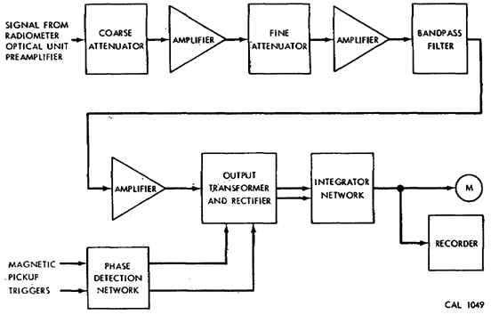
Figure 17. Radiometer Control Unit Block Diagram.

(2) Magnetic pickup outputs from the optical unit chopper actuate a flip-flop in the phase detection network. The flip-flop sets and resets to correspond with the phase of the incoming signal. Flip-flop output drives transistor switches which cause the signals from the two phases to have opposite polarity. The DC level which results from the integration process is the difference between these two opposing signals.

d. Temperature Controller.

(1) The temperature controller accurately controls the temperature of the blackbody radiation reference source at the selected set point. This ensures spectral distribution and total radiation stability of the reference source during system operation. The instrument maintains a preselected temperature by comparing the temperature of the reference source, measured by a platinum resistance thermometer, with the desired temperature as preset by a COARSE SELECTOR dial-setting. A slight difference between the measured temperature and the desired temperature causes more or less power to be delivered to the heating element of the reference source to maintain a nearly constant temperature.

(2) The basic system operation, as shown in block diagram Figure 18, is as follows:
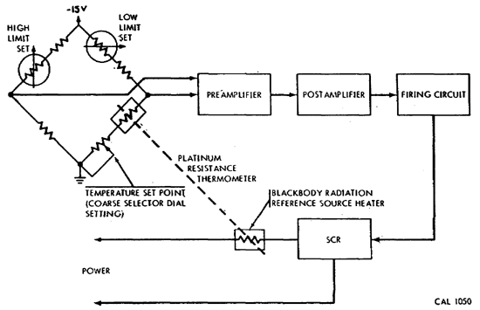
Figure 18. Temperature Controller Block Diagram.

(a) The DC signal voltage from the bridge is fed to a preamplifier which amplifies and routes the signal to a postamplifier.

(b) The preamplifier compares the bridge signal, as determined by the thermometer and the COARSE SELECTOR, with a reference signal, amplifies the difference, and feeds this amplified difference signal to the meter and the postamplifier.

(c) The postamplifier adds current limit capability, and feeds the amplified difference signal to the firing circuit.

(d) The firing circuit changes the amount of power going to the blackbody radiation reference source heater by changing the time of firing of the silicon controlled rectifier (SCR) within each half-cycle of power frequency.

(e) The SCR performs the firing function and delivers the power to the blackbody radiation reference source heater.

e. Blackbody radiation reference source.

(1) The blackbody radiation reference source is an accurate, stable infrared radiation standard with known spectral distribution and radiant intensity. It produces a divergent beam of radiated energy which is directed into the radiometer internal reference optical system.

(2) The major functional components of the blackbody unit are the radiator, aperture, baffle assembly, and the thermocouple, Figure 19.

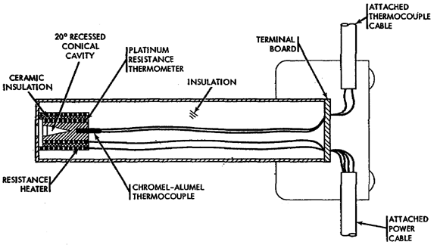
Figure 19. Blackbody Radiation Reference Source Functional Diagram.

(a) Radiator. The radiator is a cylinder with a 20° recessed conical cavity surface treated to produce a uniform layer of oxidation. The high emissivity of the oxidized surface and the geometrical form of the cavity produce an effective cavity emissivity which approaches unity. The cylinder is heated by a resistance heating element with power supplied by the temperature controller. The platinum resistance thermometer sensing element for the temperature controller is located between the cylinder and the resistance heater. Its placement is designed to produce optimum temperature control and warmup time.

(b) Thermocouple. A chromel-alumel thermocouple monitors the actual temperature of the cavity during operational checks of the system. A reference cold junction is used for the checks with the thermocouple output monitored with a millivolt potentiometer.

5. CONTROLS. This section describes, locates, and illustrates the various controls needed to operate the test set.

a. Control unit controls, Figure 20.

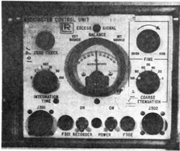

Figure 20. Control Unit Controls.

(1) The COARSE ATTENUATION selector knob is used for major adjustments to system sensitivity. An indexing scale is graduated from 0 to 100 dB in 5 counterclockwise steps of 20 dB each.

(2) The FINE ATTENUATION selector knob is used for continuous adjustment of 0 to 20 dB per each step of the course control.

(3) The BALANCE meter monitors the control unit DC output signals processed for readout from the opposing external source under test and the radiometer internal blackbody reference source. A meter reading counterclockwise from null indicates that the external source has the greater intensity and the adjustment required for the source under test. A meter reading clockwise indicates the internal source has the greater intensity. A null reading indicates the external source radiation is equal to the internal source radiation.

(4) The INTEGRATION TIME selector knob gives a choice of signal integration time prior to display on the null meter and chart recorder. Six switch positions select the time constants which give integration times from 0 to 100 seconds.

(5) The push button ZERO CHECK switch shorts the null meter circuit and the recorder input to ground which checks the zero settings.

(6) The POWER toggle switch applies line voltage which energizes the control unit.

(7) The RECORDER toggle switch in the ON position routes AC power to the recorder, connects the output circuit to the recorder, and disconnects the meter. In the OFF position, AC power to the recorder is off, the null meter is connected, and a loading resistor is substituted for the recorder.

(8) Fuse F301 protects the chopper motor and heater. Fuse F302 protects the control unit power supply from circuit overload.

(9) The neon pilot light is a visual indication that the control unit is or is not energized.

(10) An amber neon indicator light, recessed in the front panel and located above the null meter, indicates if signal clipping is occurring (excessively high amplifier gain). For maximum instrument sensitivity, the attenuation controls must be set at a signal level which causes the EXCESS SIGNAL indicator to flicker dimly or go out. If the indicator does not light, more amplifier gain may be applied to get higher output signal resolution. A brightly lit indicator shows that the signal comparator is being saturated and gain must be reduced to restore meaningful signal display.

b. Blackbody temperature controller controls, Figure 21.

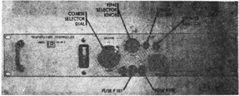

Figure 21. Temperature Controller, Model 101AR-f Controls.

(1) The COARSE SELECTOR dial is a 10-turn counting dial used to select the desired temperature setting at which the blackbody radiation source is to be controlled. The scale is graduated from 0 to 100 in 10 major divisions. Each major division has 10 minor divisions. A total of 1000 divisions are obtainable over 10 dial turns.

(2) The FINE SELECTOR knob is used to change the temperature about 1 degree on each side of the COARSE SELECTOR setting. A clockwise indexing scale from 0 to 5 provides temperature increase and a counterclockwise scale from 0 to 5 decreases temperature. It is not necessary to use this knob to operate the test set because the provided calibration data is for the COARSE SELECTOR dial with the fine SELECTOR dial centered.

(3) The indicator meter is a visual indication of the controlling circuit. Values above null indicate the reference source temperature is above specified operating temperature; values below null indicate the temperature is below specified operating temperature. A near null reading indicates the proper operating temperature. The scale is graduated from 0 to 100 in 2 major divisions on either side of null. Each major division has 50 minor divisions. No calibration for these scales is provided so numerical significance is not assigned.

(4) The POWER toggle switch applies line voltage to energize the instrument.

(5) The neon pilot light is a visual indication that the unit is in operation.

(6) Two overload fuses, F101 and F102, protect the temperature controller and the blackbody reference source from circuit overload.

6. NORMAL. This section describes the procedure for normal operation of the test set, and assumes that the set is free from maintenance problems. The sequence of operation given in this section is necessary for the test set to function correctly.

a. Prepare test set for use. Refer to Figure 22 while reading the sequence of operation given in this paragraph.

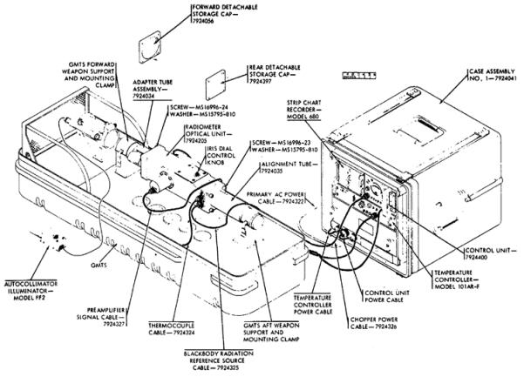
Figure 22. Test Set Operational Setup.

(1) Unlatch and remove test set combination case covers.

(2) Remove primary AC power cable from the storage mount on the cover of case assembly No. 1. Connect the cable to the primary power receptacle of case assembly No. 1 and to a convenience outlet supplying 117 V ±10% 50-60 Hz power.

(3) Control Unit.

(a) Set POWER and RECORDER toggle switches to OFF position.

(b) Set COARSE and FINE ATTENUATION selector knobs to a setting.

(c) Set INTEGRATION TIME selector knob to 0 setting.

(d) Connect control unit attached power cable to combination case power outlet.

(4) Blackbody Temperature Controller.

(a) Set POWER toggle switch to OFF position.

(b) Set 10-turn COARSE SELECTOR dial to 0 setting.

(c) Set FINE SELECTOR knob to 0 setting.

(d) Connect temperature controller attached power cable to combination case power outlet.

(5) Radiometer Optical Unit.

(a) Remove MS16996-23 screws and MS16795-810 washers which secure the rear storage cap, APN 7924397, to the radiometer housing in four places. Remove the storage cap. When the rear storage cap is removed, verify that the manufacturer's serial number on the internal blackbody radiation reference source is identical with that of the temperature controller unit mounted in the combination case.

NOTE. | Do not operate the test set if the manufacturer's serial number is not identical on both the blackbody source and the temperature controller. Replace with a matched set before proceeding. Replace rear storage cap with aft alignment tube, APN 7924035, and secure in four places with the screws and washers supplied with the radiometer optical unit.

(b) Remove MS16996-24 screws and MS15795-810 washers which secure the forward storage cap, APN 7924056, to radiometer housing in four places. Remove the storage cap. Replace storage cap with forward adapter tube assembly, APN 7924034, and secure in four places with the screws and washers supplied with the radiometer optical unit.

(c) Release forward and aft weapon support mounting clamps on the GMTS unit to be calibrated. Mount the radiometer optical unit on the GMTS with the forward adapter tube assembly and aft alignment tube in the GMTS forward and aft weapon mount saddles. Tilt the optical unit down slightly to fit it into the saddles with jack J403, located under the microphone stand on the AN/TSM-54. On the AN/TSM-82, Block III GMTS, the microphone stand can be tilted out of the way. Set the GMTS mounting clamps to secure the radiometer optical unit in the GMTS.

(d) Connect preamplifier signal cable, APN 7924327, and chopper power cable, APN 7924326, to control unit connectors J301 and J302 and to mating connectors on the radiometer optical unit J401 and 5J02.

(e) Connect blackbody cable, APN 7924325, to temperature controller connector J101 and to mating connector on radiometer optical unit J403.

(f) Autocollimator illuminator. Make certain that the illuminator in the autocollimating telescope (on the GMTS) is operating. If not, attach the autocollimator illuminator lamp in case 2 to the GMTS autocollimator. Connect the lamp cord to the variable transformer, and connect the transformer line cord to a 117 V ±10% 50-60 Hz convenience outlet.

(g) Adjust the radiometer iris dial control knob to the dial setting which corresponds to the GMTS F filter factor. Use the iris calibration chart to relate scale readings to the desired factor. On Block III GMTS, unscrew F filter from optical attenuator on the front of the GMTS collimator.

b. Operating Procedures

(1) Temperature controller

(a) Set the temperature controller 10-turn COARSE SELECTOR dial to the desired temperature, use block III temperature for the blackbody III GMTS or the temperature specified on the calibration chart for Block 1 GMTS. Use the blackbody calibration chart to find the dial setting that corresponds to the desired temperature.

(b) Make sure that the FINE SELECTOR knob is set to 0.

(c) Switch the toggle POWER switch to ON position.

(d) Set the GMTS IR TEMPERATURE ADJ at the nominal value shown on the set. Switch GMTS master POWER SWITCH and appropriate circuit breaker switch to the ON position.

(e) Allow blackbody radiation reference source sufficient time to reach stable operating temperature. A reading of approximately 0 on the indicator meter indicates stable operating temperature. Proceed to next step while a stable operating temperature is being reached.

(2) Control Unit.

(a) Switch power toggle switch to ON position.

(b) Set INTEGRATION TIME selector to 3 seconds.

(c) Set the COARSE ATTENUATION and FINE ATTENUATION knobs so that the EXCESS SIGNAL indicator just stops flickering and goes out.

(d) Set the strip chart recorder MV/V switch to 5 volts and the ON/OFF switch to ON.

(e) Set the control unit RECORDER switch to the ON position, depress and hold ZERO CHECK switch and adjust recorder ZERO dial to center pen carriage on paper.

(f) Set control unit RECORDER switch to the OFF position, adjust chart paper speed to 1 inch per minute, and set PEN in the DOWN position.

(g) Set GMTS IR TEMPERATURE ADJ to 600 and allow it to remain for 3 or 4 minutes. Reset IR TEMPERATURE ADJ to its previous setting and wait until GMTS IR CURRENT meter indicates some stable value other than zero.

(h) Proceed with GMTS adjustments for a null indication on the BALANCE meter. Adjust IR temperature dial for Block I GMTS or optical attenuator on front of collimator for Block III GMTS.

(i) Adjust the setting of COARSE and FINE ATTENUATION knobs until the EXCESS SIGNAL indicator just stops flickering. If necessary, repeat step (h) until the correct indication is obtained.

(j) Set the control unit RECORDER switch to ON and allow the unit to warmup for about 10 minutes. Note that the pen line does not drift more than 5 minor divisions from null.

(k) Place the RECORDER switch in the OFF position.

(l) Repeat steps (g) through (k) three times for comparison. Repeat the alinement procedure if any run requires a different GMTS adjustment in step (h). Place a new identification label on the panel below the dial to identify GMTS Block I or III, and show which filter is presently in use.

c. Iris calibration chart, Figure 23. The iris calibration chart defines the correct iris control dial reading needed to obtain a desired iris setting. The iris calibration chart applies only to the radiometer optical unit with which it is issued. The calibration curve differs for each particular instrument.

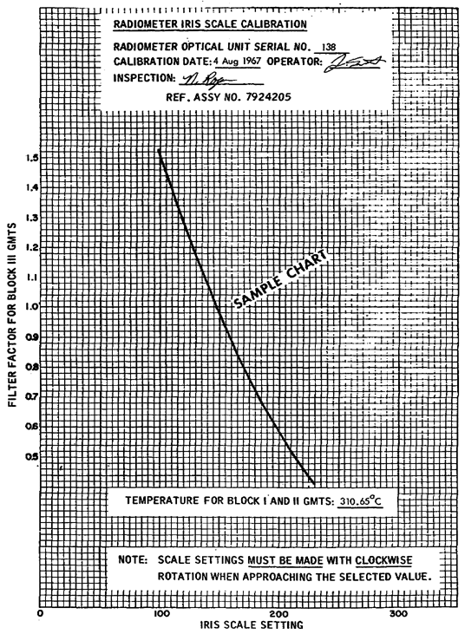
Figure 23. Sample Iris Control Calibration Chart.

(1) The iris calibration chart plots the values of dial numbers against the GMTS filter factor. Values of dial numbers are found at the bottom of the chart, and values of the GMTS filter factor at the left of the chart. To convert the desired iris opening into the proper dial setting; take the following steps:

(a) Find the desired filter factor at the left of the charts.

(b) Follow a horizontal line until it intersects the calibration curve.

(c) Then follow the vertical line down to read the value to which the iris control dial should be set.

(2) Obtain the correct GMTS filter factor with the internal reference source at Block III temperature and the iris dial set to the value obtained. Obtain the calibrated Block I energy level with the iris dial set to 170 and the internal reference source at the temperature specified for Blocks I and II on the calibration chart.

d. Blackbody calibration chart, Figure 24.

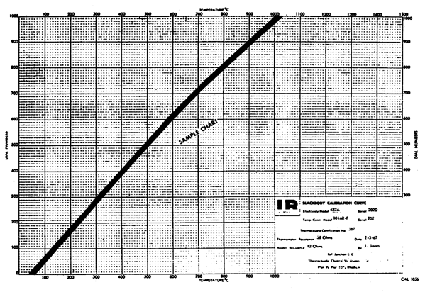
Figure 24. Sample Blackbody Calibration Chart.

(1) The blackbody calibration chart applies only to the precalibrated blackbody reference source and temperature controller set with which it is issued. The calibration curve differs for each particular set of instruments.

(2) As illustrated by Figure 24, the blackbody calibration chart plots the values of dial numbers against temperature. Values of temperature are found at the top and bottom of the chart, and values of dial numbers are found at the left and right of the chart. To convert the desired operating temperature into the proper COARSE SELECTOR dial setting, take the following steps:

(a) Find the desired temperature at the top of bottom of the chart.

(b) Follow a vertical line until it intersects the calibration curve.

(c) Then follow a horizontal line left or right to read the value to which the COARSE SELECTOR dial should be set.

7. GMTS, Figures 2 and 3.

a. Power sources. There are three circuit breakers on the GMTS. Only one is in the ON position when AC power is used to energize the test set. The other two circuit breakers are DC. The one that is put into the ON position is determined by the power source used. Use one of three different power sources to energize the GMTS. 104 to 120 V 60 and 400 Hz can be used. This power source would most likely be used in a shop or calibration van. For field use energize the GMTS by using either 21.6 or 24 VDC at 14 amperes or -21.6 to -24 VDC at 14 amperes. When the master power switch is put in the ON position, power is applied to the power supply of the GMTS, which in turn supplies 24 V and 40 V to the system. The ON-OFF indicator indicates ON when the 24 V is present from the power supply. The weapon power meter, which has a range of 0 to 50 V, indicates 40 V when it is present from the power supply.

b. Types of GMTS and their differences. There are two GMTS models. The earlier AN/TSM-54 is called the Blocks I and II, and the AN/TSM-82 is called Block III. The microphone on the Blocks I and II must be removed to mount the radiometer. The microphone on the Block III can be tilted back without being removed. There is no attenuator filter assembly on the Blocks I and II, so the source output is controlled by varying the temperature. The temperature for the Blocks I and II GMTS is 227° C and the Block III is 527° C.

c. GMTS Blackbody. The blackbody is the IR source of the GMTS. It is located on the target assembly. If you studied this and previous lessons you should be familiar with the principles of how a blackbody operates. The IR TEMPERATURE ADJ controls the temperature of the blackbody. This is a 10-turn micro-pot with a micrometer dial. The dial settings are not direct temperature readings. This is the same type of dial used on the secondary transfer radiometer and serves the same purpose on the GMTS. The number setting on this GMTS dial is given to the using unit by the calibration team if it is necessary to change the original setting to obtain the proper operating temperature for that particular GMTS. The indicator associated with the blackbody is the IR control meter. This meter indicates the current to the power element of the IR source, also the average deflection is proportional to the current flowing in the IR source. But the primary purpose of the IR CONTROL meter is to indicate the temperature stability, not current output.

8. SUMMARY. During this lesson, you studied the purpose, characteristics and operation of the infrared (secondary transfer) test set, including relevant portions of the GMTS. You now have a good background for the next lesson on the infrared (secondary reference) test set.

SUBCOURSE MM0487, INFRARED CALIBRATION

EXERCISES FOR LESSON

1. What is the purpose of the blackbody thermocouple?

a. Supply bias voltage to the blackbody

b. Determine the source temperature

c. Supply the source a reference of the unit under test

2. What is the purpose of the radiometer iris control?

a. Attenuate the energy from the test set blackbody to match the energy of the GMTS

b. Attenuate the energy from the GMTS to match the energy of the test set blackbody

c. Adjust the alignment of the tubes when mounting the unit

3. What is the peak-to-peak amplitude of the chopper signal from the detector dependent on?

a. Signal level of the control unit

b. Signal processing circuits

c. Infrared energy from corresponding optical path

4. The radiometer iris dial control knob should be adjusted to the dial setting which corresponds to

a. the GMTS F filter factor.

b. a null indication on the balance meter.

c. the temperature specified on the calibration chart.

5. What is the blackbody calibration chart used for?

a. The dial setting that corresponds to the desired temperature

b. Determine the source temperature

c. To find out which blackbody should be used in a test procedure

6. When can you tell that the GMTS blackbody has stabilized?

a. The ON light illuminates

b. The IR control meter reads a steady low current

c. The IR control meter read a high current

7. What steps should be performed on the temperature controller prior to switching the TOGGLE power switch to the ON position?

a. Verify that the FINE SELECTOR knob is set to 0 and the 10-turn COARSE SELECTOR dial to 0

b. Set the 10-turn COARSE SELECTOR dial to the desired temperature and verify that the FINE SELECTOR knob is set to midrange

c. Set the 10-turn COARSE SELECTOR dial to the desired temperature and verify that the FINE SELECTOR knob is set to 0

8. How are the openings in the chopper blade arranged?

a. Eleven holes are equally spaced over 180 degrees of the chopper blade.

b. Six holes are equally spaced over 180 degrees of the chopper blade.

c. Eleven holes are equally spaced over 360 degrees of the chopper blade.

9. The chopper power cable supplies power to which items?

a. The heaters and the control unit

b. The heaters and the chopper drive motor

c. The chopper drive motor and the control unit

10. What is the purpose of the adapter tube assembly?

a. It adapts the radiometer optical unit for mounting in the AN/TSM-54 and AN/TSM-82 GMTS during calibration tests of the GMTS.

b. It adapts the thermocouple for mounting in the AN/TSM-54 and AN/TSM-82 GMTS during normal operation of the GMTS.

c. It adapts the autocollimator illuminator for mounting in the AN/TSM-54 and AN/TSM-82 GMTS during calibration test of the GETS.

11. The sensing unit of the secondary transfer set temperature controller is

a. A platinum resistance thermometer:

b. A bridge circuit.

c. A chromel-alumel thermocouple.

12. Which instrument is used to obtain a permanent visible record of the secondary transfer set operation?

a. Differential voltmeter

b. Strip chart recorder

c. Oscilloscope

13. The blackbody unit is dependent upon which unit for accurate operation?

a. Temperature controller unit

b. Radiometer control unit

c. Optical housing assembly

14. Received radiant energy from opposing sources is converted to voltage by which item?

a. Lead sulfide detector

b. Chromel-alumel thermocouple

c. Platinum resistor

15. The temperature controller unit and the blackbody reference source are protected from circuit overload by

a. F101

b. F101 and F103

c. F101 and F102

16. The iris calibration chart plots

a. The values of dial numbers against the GMTS filter factor.

b. The values of dial numbers against the desired operating temperature.

c. The GMTS filter factor against the desired operating temperature.

17. The COARSE ATTENUATION and FINE ATTENUATION knobs should be set so that the EXCESS SIGNAL indicator

a. Just comes on and stops flickering

b. Flickers brightly

c. Stops flickering and just goes out

18. When the EXCESS SIGNAL indicator is brightly lit it shows

a. That the signal comparator is being saturated

b. That there is no signal going into the signal comparator

c. That the signal is not being clipped

19. The INTEGRATION TIME selector knob does what?

a. It provides a choice of signal integration time prior to display on the null meter and chart recorder

b. It provides a choice of signal integration time prior to display on the oscilloscope and strip chart recorder

c. It provides a choice of signal integration time after display on the null meter and chart recorder

20. The radiator consists of a cylinder containing a 20-degree recessed conical cavity with a surface treated to

a. Produce a non-uniform layer of oxidation

b. Produce a uniform layer of oxidation

c. Reduce oxidation.

SUBCOURSE NUMBER MM0487, INFRARED CALIBRATION.

APPROVED SOLUTION

Lesson 3 Infrared Transfer Set

1. b para 2d(5) 11. a para 4d(1)
2. a para 2d(5)(c) 12. b para 2c(1)
3. c para 4b(3) 13. a para 2d(5)(d)
4. a para 6a(5)(g) 14. a para 4a
5. a para 6d(1) 15. c para 5b(6)
6. b para 6b(2)(g) 16. a para 6c(1)
7. c para 6b(1) 17. c para 6b(2)(c)
8. a para 4b(2) 18. a para 5a(10)
9. b para 2c(4) 19. a para 5a(4)
10. a para 2d(2) 20. b para 4e(2)(a)

LESSON 4. INFRARED REFERENCE SET

Lesson Objective: | After studying this lesson you should be able to explain the purpose, characteristics, operation and circuit analysis of the reference infrared test set.
Credit Hours: | Two
1. INTRODUCTION

In the previous lesson you studied the secondary transfer infrared set and the IR portion of the guided missile test set (GMTS). In this lesson the equipment needed to calibrate the secondary transfer set will be discussed. After studying this lesson, you should be able to explain the purpose, characteristics, operation and circuit analysis of the secondary reference infrared test set.

2. DESCRIPTION

a. General. The infrared secondary reference test set in this lesson will be called the test set. It is a standard for calibrating the infrared secondary transfer set. The secondary reference test set and the secondary transfer test set comprise the infrared calibration system for calibration of the AN/TSM-54 and AN/TSM-82 GMTS. Designed for operation in a laboratory-type environment at an Army secondary reference calibration laboratory, the test set consists of the following (Figure 1): a precision alignment stand; a matched calibrated unit consisting of the temperature controller (Model 101A-F) and blackbody radiation reference source (Model 463); a matched calibrated unit consisting of the off-axis collimator (Model 230A) and radiant energy attenuator; an autocollimating telescope (Minnidekkor Model TA 60); and manufacturer's handbooks for the temperature controller, blackbody radiation reference source, and collimator. A general description of each test set component is presented below.

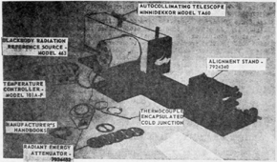

Figure 1. Infrared Secondary Reference Test Set, 4931-00-895-3894

b. Alignment Stand. The alignment stand (Figure 2) provides a means for precise optical alignment positioning of the instrument under calibration test with the test set off-axis collimator. A machined aluminum base plate includes three legs for mounting on an optical bench.

Three removable recessed foot pads located on the top surface of the base plate ensure proper positioning of the collimator during pre-operational setup. The alignment stand adjustment mechanism includes adapters for mounting the infrared secondary transfer test set radiometer optical unit during calibration testing. It is capable of four degrees of freedom, lateral and vertical translation, and rotation about the lateral and vertical axes. A 4-inch circular handle at the side of the stand provides major vertical translation; and a 2-inch circular handle on the front of the stand provides major lateral translation. Precise calibration alignment of the mounted instrument under test with the collimator is done by dial settings of two micrometers.

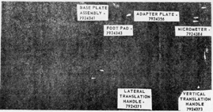

Figure 2. Alignment Stand - 7924340 - Front View

c. Temperature Controller Model 101A-F. The temperature controller (Figure 3) is a portable unit designed for bench operation with a specific blackbody radiation reference source. It accurately controls and maintains the blackbody operating temperature to a preselected value. A front panel contains the necessary controls for system operation. A receptacle at the rear of the unit receives the connecting cable from the blackbody radiation reference source. The power cord for plug-in to an electric outlet supplying 117 VAC ±10% 50-60 Hz is also located at the rear of the set.

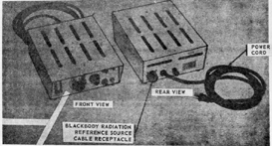

Figure 3. Temperature Controller - Model 101A-F - Front and Rear Views

d. Blackbody Radiation Reference Source-Model 463. The blackbody radiation reference source (Figure 4) mounts on the off-axis collimator base plate 90 degrees clockwise form the collimator optical axis (Figure 1). An attached connecting cable routes input voltages from the temperature controller. An attached thermocouple containing an encapsulated cold junction provides a means to determine source temperature. Because it is factory-calibrated with a specific temperature controller, accuracy of the blackbody unit is dependent on operation with the particular temperature controller unit issued with it. The two units form a calibrated system and are replaceable only with another calibrated system. For operation of the test set, the aperture and baffle assembly issued with the unit are removed and stored.

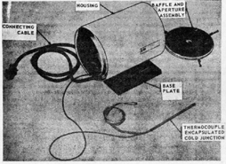

Figure 4. Blackbody Radiation Reference Source - Model 463 with Aperture and Baffle Assembly Removed.

e. Off-axis Collimator-Model 230A. The off-axis collimator mounts on the alignment stand base plate by means of three adjustable legs tapered to fit the alignment stand foot pad receptacles (Figures 1 and 5). The instrument includes a support post which provides for attachment of the autocollimating telescope; a tubular mirror housing which directs the line of sight from the mounted telescope to the test instrument alignment mirror during alignment sighting; an aperture wheel which contains indexed opening of varying degrees and is adjustable to a preselected setting by means of a spring detent; and an adjustable iris and iris control scale. A base plate provides the support for the blackbody radiation reference source and properly aligns it with the collimator optical axis.

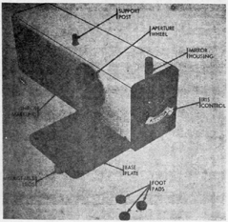

Figure 5. Off-Axis Collimator - Model 230A

f. Radiant Energy Attenuator. The radiant energy attenuator (Figure 6) is a test set instrument calibrated for operation with a specific off-axis collimator. The unit is mounted on the forward adapter tube of the test instrument under calibration with a spring tension cast mounting cap. The attenuators are driven by pulley friction. Two idler pulley's secured by a mounting plate, maintain positioning of the rotating attenuator. One GMTS Block I and five GMTS Block II attenuator. One GMTS Block I and five GMTS Block II attenuators are supplied with the instrument. A power toggle switch is located at the rear of the motor cover.

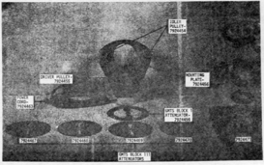

Figure 6. Radiant Energy Attenuator - 7924452 - Front View

g. Autocollimating Telescope - Minnidekkor Model TA 60. The autocollimating telescope (Figure 7) is a small, lightweight, autocollimator used during precalibration test setup for precise optical alignment of the test instrument with the off-axis collimator. It measures horizontal and vertical angular displacement simultaneously by means of a graticule scale with divisions of one minute of arc. The eyepiece is placed at a 90 degree angle to the tube. Rotation of the tube about its horizontal axis allows for proper positioning of the eyepiece for operator alignment sighting. Vertical line-of-sight adjustments are secured with a clamp. The telescope is secured to the collimator support post by a locking clamp. A light source at the rear of the tube illuminates the telescope during alignment sighting. The light source is supplied with the secondary transfer test set.

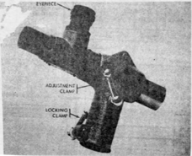

Figure 7. Autocollimating Telescope - Minnidekkor Model TA 60

3. THEORY OF OPERATION

a. Fundamental Principle. The test set is a standard for known energy emission to which infrared systems designed to measure energy radiation may be calibrated. The test set collimates radiant energy emitted from a known temperature source into a beam. It then directs the radiant energy beam through a preselected attenuator (which defines the energy flux corresponding to the GMTS requirements) into the entrance optics of an infrared instrument, optically aligned to receive the beam. Figure 8 illustrates the fundamental principle.

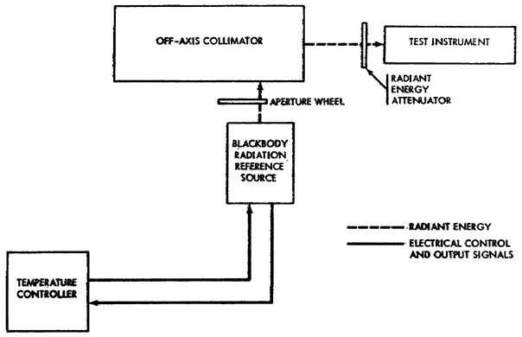
Figure 8. Infrared Secondary Reference Test Set 4931-895-8894 Functional Block Diagram

b. Temperature Controller - Model 101A-F.

(1) The temperature controller accurately controls the temperature of the blackbody radiation reference source at a selected point to ensure spectral distribution and total radiation stability of the reference source at a selected point to ensure spectral distribution and total radiation stability of the reference source during system operation. The instrument maintains a preselected temperature by comparing the temperature of the reference source, as measured by a platinum resistance thermometer, against the desired temperature as preset by a COARSE SELECTOR dial setting. The magnitude of the difference between the measured temperature and the desired temperature causes more or less power to be delivered to the heating element of the reference source to maintain a nearly constant temperature.

(2) Electrically, the platinum resistance thermometer and the COARSE SELECTOR temperature dial are in the same arm of a bridge, causing a need for more or less resistance in the platinum resistance thermometer to maintain the bridge in a near-balanced condition (Figure 9). This configuration causes the thermometer to be operated under constant current conditions which results in maximum thermometer sensitivity. When the temperature controller is maintaining a steady state temperature, the bridge is nearly balanced, but just enough out of balance to develop a significant input signal to the preamplifier. The extent of unbalance is sufficient to maintain the desired temperature of the reference source. If the source were to cool slightly, or if the temperature controller COARSE SELECTOR dial were set to a slightly higher temperature, the bridge would become more unbalanced. This increase in voltage causes an increase of output power from the temperature controller to heat the reference source and the platinum resistance thermometer until resistance of the platinum restores the bridge to a near-balanced condition. If the reference source becomes too hot, or if the temperature dial is set to a lower temperature, the bridge voltage decreases, passes through a null, and again increases with a 180° phase change. The decrease in voltage causes the controller to reduce the power to the heater; the out-of-phase voltage, regardless of its magnitude, causes the controller to turn off the power to the heater. An open circuit condition in the thermometer circuit also causes the preamplifier to shut off the heater power.

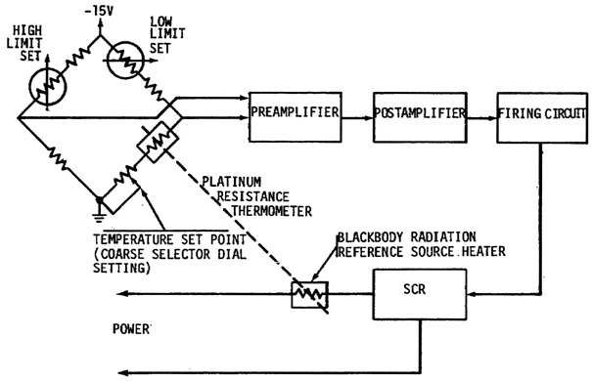

Figure 9. Temperature Controller - Model 101A-F Functional Block Diagram

(3) The basic system operation, as illustrated by Figure 9. DC signal voltage from the bridge is fed to a preamplifier which amplifies and routes the signal to a postamplifier. The preamplifier compares the bridge signal, as determined by the thermometer and the COARSE SELECTOR, against a reference signal, amplifies the difference, and feeds this amplified difference signal to the meter and the postamplifier. The postamplifier adds current limit capability, and feeds the amplified difference signal to the firing circuit. The firing circuit changes the amount of power into the blackbody radiation reference source heater by changing the time of firing of the silicon controlled rectifier within each half-cycle of power frequency. The SCR performs the firing function and delivers the power to the blackbody radiation reference source heater.

c. Blackbody Radiation Reference Source Model 463.

(1) The blackbody radiation reference source is an accurate, stable infrared radiation standard of known spectral distribution and radiant intensity. It produces a divergent beam of radiated energy which is directed into the off-axis collimator through the collimator aperture wheel.

(2) The major functional components of the Model 463 blackbody unit are the radiator, the aperture and baffle assembly, and the thermocouple (Figure 10). For operation with the test set, the aperture and baffle assembly are removed from the unit before the unit is mounted on the collimator base plate.

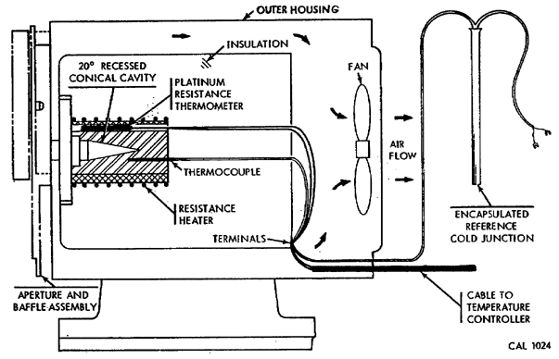
Figure 10. Functional Diagram of Radiation Reference Source Model 463

(a) Radiator. The radiator consists of a cylinder containing a 20-degree recessed conical cavity (Figure 10) with a surface treated to produce a uniform layer of oxidation. The high emissivity of the oxidized surface and the geometrical form of the cavity produce an effective cavity emissivity approaching unity. The cylinder is heated by a resistance heating element with power supplied by the temperature controller. The platinum resistance thermometer sensing element of the temperature controller is located between the cylinder and the resistance heater. Its placement is adjusted to produce optimum temperature control and warm-up time. The heater is wound in a pattern which produces a uniform temperature across the cavity with no apparent temperature gradients.

(b) Thermocouple. Thermocouple is used to monitor the actual temperature of the cavity during operational checks of the system. An encapsulated reference cold junction is employed and thermocouple output is read on a millivolt potentiometer.

(3) The blackbody outer housing contains a fan which draws air from the front, between the inner and outer cases (Figure 10), and exhausts it to the rear. This air circulation keeps the outer case within 10° C above ambient, even at the maximum cavity temperature.

d. Off-Axis Collimator and Radiant Energy Attenuator.

(1) The collimator represents an infrared radiation source at infinity. The radiation from this source consists of essentially parallel rays. For laboratory use the collimator provides a convenient source of parallel radiation from a known temperature source. The Model 230A collimator issued with test set employs an off-axis parabolic reflective optical system which focuses radiant energy, emanating from a blackbody radiant reference source located at the focal point, into a parallel, or collimated beam, which is required for the calibration and testing of radiometric instruments.

(2) Functionally, the Model 230A collimator uses an off-axis parabola system with an accurately selected set of apertures placed at the focus of the parabola, a secondary front surface mirror, a primary mirror, and an exit aperture iris diaphragm. The exit iris is adjusted by an iris control located at the front of the collimator. The iris control allows stepping down on the beam cross section emanating from the collimator. However, adjustment of this iris is not required for proper test set operation. The collimator iris control is set for maximum iris opening at all times during test set operation. A radiant energy attenuator is used with the test set to limit radiating energy from the collimator to values corresponding to GMTS requirements. This attenuator is factory-calibrated for use with the specific collimator which is issued with it.

(3) A functional schematic diagram of the off-axis collimator and radiant energy attenuator system is shown in Figure 11. System operation is as follows:

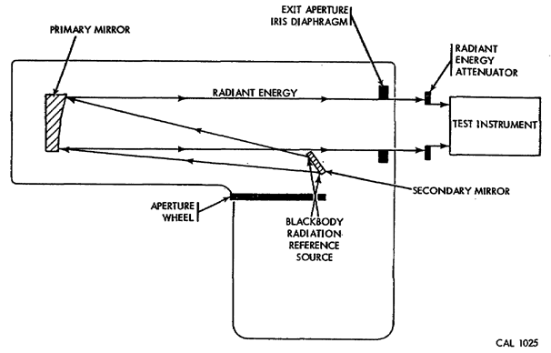

Figure 11. Off-Axis Collimator Model 230A and Radiant Energy Attenuator 7924452 Functional Schematic Diagram

(a) Radiant energy emitted from the blackbody radiation reference source illuminates an entrance aperture of preselected size as defined by the setting of the collimator aperture wheel at the focus of the parabola.

(b) The radiant energy is directed through the entrance aperture to an off-axis secondary mirror, reflected to a primary mirror, and projected out through the exit aperture. This off-axis reflective system presents a clear exit aperture with no intervening obstruction.

(c) The parallel radiation projected from the collimator is directed through a radiant energy attenuator and into the entrance optics of the test instrument. The attenuator defines the energy flux for various F values of the GMTS by limiting the collimated beam. Basically, since emitted collimator flux density is greater than required for the GMTS, the attenuator serves to step down the beam to nominal values equivalent to GMTS attenuator settings. Attenuator disks of various blockages corresponding to both the Block I and Block III requirements. The attenuator disks are rotated during calibration testing to average out variations in the energy beam emanating from the collimator before they enter the test instrument's optical system.

4. OPERATING INSTRUCTIONS

a. Service Upon Receipt of a Test Set. The following items should be checked as shown prior to putting a set into service:

(1) Temperature Controller.

(a) The manufacturer's serial number on the temperature controller must be identical to the serial number on the blackbody radiation reference source.

(b) The power switch and pilot light must function normally.

(c) The coarse and fine temperature selector knobs must operate smoothly without binding or rough motion.

(d) Indicator meter movement must not stick at any point.

(e) Proper value overload fuses must be correctly installed.

(2) Blackbody Radiation Reference Source.

(a) The manufacturer's serial number on the blackbody radiation reference source must be identical to the serial number on the temperature controller.

(b) The blackbody aperture plate, aperture mounting plate, and associated hardware, supplied with the blackbody unit, but not needed to operate the test set, must be properly stored.

(3) Off-Axis Collimator.

(a) Alignment sighting mirrors and the iris aperture window must be free from scratches, pits, dirt, chips, and breaks that interfere with or affect the optical performance of the instrument.

(b) The aperture plate must rotate without binding and provide proper indexing with the spring detent.

(4) Radiant Energy Attenuator.

(a) The manufacturer's serial number on the radiant energy attenuator must be identical to the serial number on the off-axis collimator.

(b) All Block III attenuators must be inspected for proper cement bonding of attenuator overlays to carrier disks.

(5) Autocollimating Telescope.

(a) The eyepiece lens and front window must be inspected for scratches, pits, dirt, chips, and breaks which interfere with or affect the optical performance of the instrument.

(b) The eyepiece focus adjustment must operate so as to produce a well-defined scale reading.

(c) With the instrument lamp energized, illumination must be sufficient for the scale numerals and markings to be clearly distinguishable, and for proper projection of the cross hair target.

(6) The condition of the test set may be determined by using the operational check procedure and the test set operating procedures.

b. Temperature Controller Controls. This section describes, locates, and illustrates the various controls needed to operate the test set.

(1) COARSE SELECTOR Dial. The COARSE SELECTOR dial (Figure 12) is a 10-turn counting dial used to select the temperature setting at which the blackbody radiation reference source is to be controlled. The scale is to be graduated from 0 to 100 in 10 major divisions.

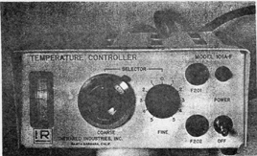

Figure 12. Temperature Controller Model 101A-F Controls

(2) FINE SELECTOR Knob. The FINE SELECTOR knob (Figure 12) provides a change in temperature of about 1 degree each side of the COARSE SELECTOR setting. An indexing scale from 0 to 5 clockwise increases temperature; from 0 to 5 counterclockwise decreases temperature.

(3) Indicator Meter. The indicator meter (Figure 12) provides a visual indication of the controlling circuit. Values above null (0) shows that the reference source temperature is above specified operating temperature. An approximate null reading indicates proper operating temperature. The scale is graduated from 0 to 100 in 2 major divisions on either side of null. Each major division has 5 minor divisions.

(4) POWER Switch. The power toggle switch (Figure 12) applies line voltage to energize the instrument.

(5) Pilot Light. The neon pilot light (Figure 12) is a visual indication that the test set is energized.

(6) Overload Fuses. Two overload fuses, F201 and F202, protect the temperature controller unit and the blackbody radiation reference source.

c. Operation Under Usual Conditions. This section describes the procedures for normal operation of the test set. It is assumed that the set is free from maintenance problems, and has passed the inspection requirements.

(1) Preparations for Use.

(a) Place the alignment stand on a flat, level surface which has minimum vibration. The surface must be clean and free of obstacles to ensure a firm footing for the stand.

(b) Install the threaded adjustable legs of the collimator into the collimator base legs (Figure 13). Adjust the height of the legs to level the collimator and lock by tightening the leg lock nuts. Mount the collimator on the alignment stand base plate with the tapered adjustable legs firmly seated in the base plate recessed foot pads. Set the iris control, located at front of collimator, for maximum iris opening.

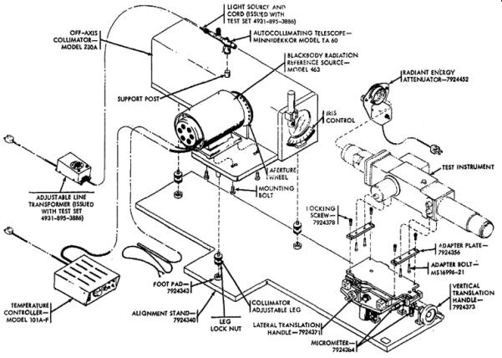
Figure 13. Test Set Operational Setup.

(c) Clamp the autocollimating telescope on the collimator support post (Figure 13). Connect the telescope light source to the telescope, connect the light source cord to the adjustable line transformer, and plug the transformer cord into an electrical outlet that supplies 117 VAC ±10% 50-60 Hz.

(d) The autocollimator telescope is aligned by placing an optical flat mirror so that it intercepts the collimator and autocollimator beams. Sight through an open aperture wheel position with a microscope (in the position normally occupied by the blackbody). Adjust the optical flat mirror for the best image (mirror perpendicular to the collimator axis).

(e) Now, sight through the autocollimator eyepiece and adjust the telescope position until the cross hair target is superimposed on the graduated scale. Secure the telescope locking clamps and seal these clamp positions. Then, remove the flat mirror and microscope.

(f) Mount the blackbody radiation reference source on the collimator base and secure it with mounting bolts in four places (Figure 13).

(g) Place the temperature controller on a flat, level working surface and connect the cable from the blackbody radiation reference source to the temperature controller (Figure 13). Plug the temperature controller line cord at the rear of the instrument into an electrical outlet that supplies 117 VAC ±10% 50-60 Hz.

(h) Attach the alignment stand adapter plates to the test instrument housing adapter legs with adapter bolts in four places. Mount the test instrument on the alignment stand before installing the test instrument and aft GMTS adapter tubes. The forward adapter tube contains the sighting mirror used in alignment procedures; the aft adapter tube provides a balance weight to ensure proper spring tension on the alignment stand tilt translation mechanism. Install the test instrument on the alignment stand rotating table with locking screws in four places (Figure 13).

(2) Operating Procedure.

(a) Set the temperature controller 10-turn COARSE SELECTOR dial (Figure 12) to the desired operating temperature setting. This setting is determined by the blackbody calibration chart (Figure 14).
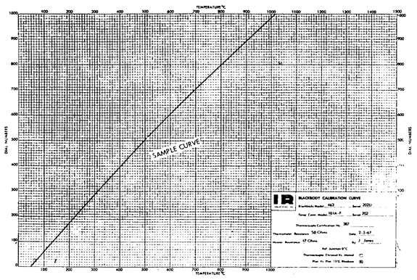
Figure 14. Sample Blackbody Calibration Chart

(b) The FINE SELECTOR know should be turned to 0 (Figure 12).

(c) Switch the toggle POWER switch to ON position.

(d) Allow time for the blackbody radiation reference source to reach a stable operating temperature. A reading of approximately 0 on the indicator meter (Figure 12) indicates a stable operating temperature. Under normal conditions, proceed as follows while a stable operating temperature is being reached.

(e) Set the collimator aperture wheel to the opened spring detent setting by aligning the selected value on the aperture wheel with the index marking (Figure 5) on the collimator housing.

(f) Actuate the line transformer to illuminate the autocollimating telescope. With the lamp lit, the internal cross hair target of the autocollimating telescope is projected on the autocollimating mirror of the test instrument and reflected back to the eyepiece.

(g) Mount the radiant energy attenuator on the forward end of the test instrument forward adapter tube (Figure 13): The manufacturer's serial number on the radiant energy attenuator must be identical with the serial number on the collimator. Plug the attenuator line cord into an electrical outlet that supplies 117 VAC ±10% 50-60 Hz.

d. Blackbody Calibration Charts

(1) The blackbody calibration chart defines the correct COARSE SELECTOR dial setting required to obtain a desired operating temperature. A sample chart is shown in Figure 14.

(2) The blackbody calibration chart applies only to the calibrated blackbody radiation reference source and temperature controller with which it is issued. The calibration curve differs for each particular set of instruments.

(3) The blackbody calibration chart plots the values of dial numbers against temperature. Values of temperature are found at the top and bottom of the chart and values of dial numbers are found at the left and right of the chart. To convert the desired operating temperature at the top or bottom of the chart, follow a vertical line until it intersects the calibration curve, then follow a horizontal line left or right to read the value to which the COARSE SELECTOR dial must be set.

5. SUMMARY. During this lesson you studied the purpose characteristics, operation and circuit analysis of the secondary reference infrared test set. This lesson combined with the previous lesson (secondary transfer set) should have given you a good working knowledge of the infrared test sets. These lessons should also help you understand the next lesson (Irradiance and Light Meter Test Sets).

SUBCOURSE NUMBER MM 087 INFRARED CALIBRATION

EXERCISE FOR LESSON 4

1. The secondary reference infrared set is designed for operation in a:

a. Direct support field maintenance shop.

b. Laboratory-type environment on an Army area transfer team.

c. Laboratory-type environment at an Army area calibration laboratory.

2. The alignment stand provides a means for precise optical alignment positioning of the test instrument with the test set

a. Off-axis collimator

b. Blackbody radiation reference source

c. Temperature controller

3. What other unit is the blackbody dependent upon?

a. Off-axis collimator

b. Temperature controller

c. Radiant energy attenuator

4. What is the purpose of the base plate?

a. It supports the blackbody radiation reference source and properly aligns it with the collimator optical axis

b. It supports the off-axis collimator and properly aligns it with the collimator optical axis

c. It supports the autocollimator optical axis

5. How many attenuators are supplied with the test instrument?

a. One GMTS Block I and five GMTS Block III

b. Five GMTS Block I and one GMTS Block III

c. Three GMTS Block I and three GMTS Block II

6. The infrared reference set converts radiant energy emitted from known temperature source into:

a. Energy flux

b. Reflected energy

c. A collimated beam.

7. How does the temperature controller maintain a preselected temperature for the reference source?

a. It is measured by a platinum resistance thermometer and compared against the desired temperature as preset by a COARSE SELECTOR dial setting

b. It is measure by a chromel-alumel thermocouple and compared against the desired temperature as preset by a COARSE SELECTOR dial setting

c. It is measured by a bridge circuit and compared against the desired temperature as preset by a FINE SELECTOR dial setting

8. What would happen to the output power from the temperature controller if the source were to cool slightly?

a. Increase

b. The same

c. Decrease

9. How does the firing circuit change the amount of power into the blackbody radiation reference source heater?

a. Changes the time of firing of the SCR within each quarter-cycle of the power frequency

b. Reverses the current into the SCR each quarter-cycle of the power frequency

c. Changes the time of firing of the SCR within each half-cycle of the power frequency

10. What operation is performed on the blackbody unit before it is mounted on the collimator base plate?

a. Aperture is removed

b. Aperture and baffle assembly are removed

c. Baffle assembly is removed

11. During a measurement, the IR controller output acts as a:

a. Source of perpendicular radiation

b. Source of parallel radiation

c. Source of parabolic radiation

12. When is the iris control set for maximum iris opening?

a. At all times during test set operation

b. Never

c. Only during GMTS calibration

13. The manufacturer's serial number on the blackbody radiation reference source must be identical to that of the:

a. Temperature controller

b. Radiant energy attenuator

c. Thermocouple encapsulated cold junction

14. The blackbody calibration chart plots the values of dial numbers against

a. Time

b. Temperature

c. Reflected energy

SUBCOURSE NUMBER MM0487, INFRARED CALIBRATION.

APPROVED SOLUTION

Lesson 4 Infrared Reference Set

1. c para 2a 8. a para 3b(2)
2. a para 2b 9. c para 3b(3)
3. b para 2d 10. b para 3c(2)
4. a para 2e 11. b para 3d(1)
5. a para 2f 12. a para 3d(2)
6. c para 3a 13. a para 4a(2)
7. a para 3b(1) 14. b para 4c(3)

LESSON 5. IRRADIANCE AND LIGHT METER TEST SETS

Lesson Objective: | After studying this lesson you will be able to state the purpose, characteristics and operation of the irradiance test set and light meter tester. You should be able to state the schematic functions of major circuits in the irradiance test set. You should also be able to answer all review questions pertaining to the irradiance test set and light meter tester.
Credit Hours: | Two
1. INTRODUCTION

a. In previous lessons you studied the fundamental principles of infrared, the purpose, characteristics and principles of the infrared transfer and reference test sets. As a calibration technician you will be required to use two other components in calibrating infrared test sets.

b. During this lesson we will cover the purpose, characteristics, operation and circuit analysis of the irradiance test set and the light meter tester.

2. IRRADIANCE TEST SET MODEL 921.

a. Purpose and description (Figure 1).

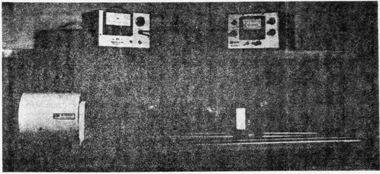

Figure 1. Irradiance Set

(1) The Model 921 Irradiance Set is used to calibrate the radiant energy output of the Infrared Secondary Reference Set. It can be adapted to measure the radiation flux density of other infrared sources and optical systems.

(2) The irradiance set uses a comparative measurement technique which minimizes long term and absolute errors. A large detector is used to sense a large area of a collimated beam. No optics other than a spectral filter are used, thus eliminating transmission and aberration factors of refractive elements. Use of source modulation (rather than detector modulation) and synchronous detection, using the modulation signal as the sync signal, minimizes the interference of extraneous radiation. The system consists of five assemblies which can be grouped into two functional units.

(a) Modulation system. These units form a complete mechanical modulating system which can be used for any optical radiation application.

1 Model 827 Modulator consists of a motor driven disk, aperture wheel and speed sensors (Figure 2). It will mount directly on the 460 series blackbody.

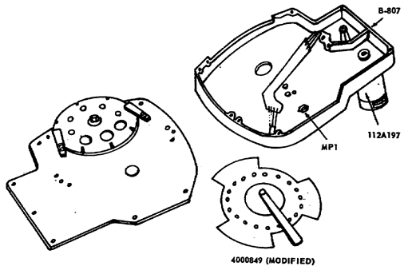

Figure 2. Model 827 Modulator Assembly

2 Model 828 Modulation Control contains all electronic control circuitry for the Model 827 Modulator. The unit utilizes a ten turn speed selection control with both meter readout and an electronic output signal to indicate modulation frequency.

(b) MS-1 measurement stand - 1005120 (Figure 7). A measurement stand is provided which consists of two sets of rods joined together to form a two meter bench for placement of the detector/preamplifier. A scale is provided for measurement of the distance from an aperture to the detector.

b. Specifications

(1) Spectral range: 1.7 to 2.7 microns

(2) Detector: Lead sulfide, 0.4 in x 0.4 in.

(3) Stability: 0.5% full scale signal over 1 hour.

(4) Meter readout: ±2% full scale accuracy.

(5) Recorder output: 0 to 1.0 volt full scale with output impedance less than 1 K.

(6) Measurement stand: Scale length - 200 cm.
Resolution - 1 mm.

(7) Modulation frequencies: 50 Hz to 5,000 Hz with 40 slot blade.

c. Theory of operation.

(1) System description. The Irradiance Set is a calibration instrument used for measuring radiation flux density. The final measurement is obtain by comparing the detected signal through a test system with the signal obtained without the test system. A measurement of flux density is normally carried out by first obtaining a measured signal from the detector which is irradiated by a blackbody source through a test system. The same detector and source are then used to obtain an identical measured value as a function of the distance from a known aperture. Irradiance calculated from the latter measurement will be the same as that sensed through the test system. Flux density for a detector irradiated by a blackbody source through an aperture is obtained by using the formula:

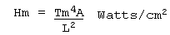

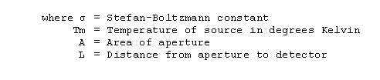
Determination of flux density with this equipment is obtained for any temperature by using the above equation after measurement of distance L.

(2) Functional description. A block diagram of the system is shown in figure 3. The Irradiance Set can be divided into two functional units, the modulation system and the detector signal processing system.

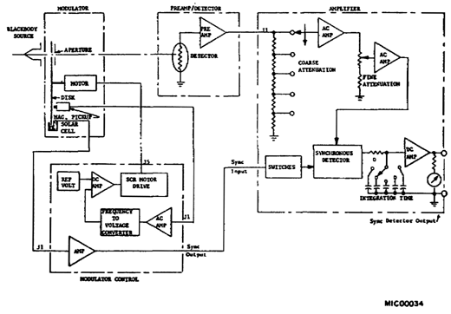

Figure 3. Irradiance Set Block Diagram

(a) Modulation system. The modulation system consists of a closed loop servo system which controls motor speed. An error signal is developed by comparing a reference voltage with a signal proportional to motor speed. The error signal changes the motor voltage by varying the firing time of silicon controlled rectifiers (SCR's). The SCR's are connected in a bridge circuit to provide a 120 cycle full wave output which is filtered and applied to the motor. The speed signal is developed by a magnetic pickup located in the modulator. Another signal developed by a solar cell and lamp is used to monitor the modulation frequency developed by the 3 slot blade. The frequency signal is amplified, squared and provided as an external output.

(b) Detector signal processing system. The detector signal is first amplified by a low noise preamplifier and then fed to a separate amplifier. The amplifier provides gain control and AC amplification. The amplified signal is provided to a synchronous detector system and filtered. The resulting DC signal is read on a meter and a recorder output is provided.

(3) Circuit analysis.

(a) Modulator Speed Control Circuitry (Figure 4). The magnetic pickup input to the Modulator Control is shunted with a network so that the amplitude of the signal fed to Ql is approximately constant with respect to frequency above 100 Hz. The signal is amplified by Ql and Q2. Q3 and Q4 form a Schmitt trigger with a square wave output of approximately 1 volt peak-to-peak. The square wave is fed to the control amplifier differentiator and the meter circuit differentiator, both of which rectify on the negative going portion of the square wave. For the meter circuit, the rectified signal is filtered and fed to the meter and associated calibration network. The output of the control network is filtered and added to the reference signal from the ten turn frequency control. Q6 is a DC amplifier which amplifies the algebraic sum of the signal and the reference. The sum of a fixed bias and the output of Q6 is fed to Q7 through the gain control. Q7 serves the dual purpose of being a second stage DC amplifier and the variable control resistor in the RC charging network for the relaxation oscillator, Q8. The oscillator generates pulse of about two volts amplitude and about 30 microseconds in duration and is synchronized with the line voltage via a supply from CR19. For a fixed modulation frequency, the first pulse always occurs at a fixed time after positive anode voltage has been applied to one or the other of the silicon controlled rectifiers. The output from Q8 is coupled to the gates of the controller rectifiers in the proper phase so that the gate pulse is positive with respect to the cathode. The 120 cycle full wave output from the output bridge is capacitor coupled to a transformer and rectified. The resultant DC signal is fed back to the emitter of Q6 for feedback stabilization.

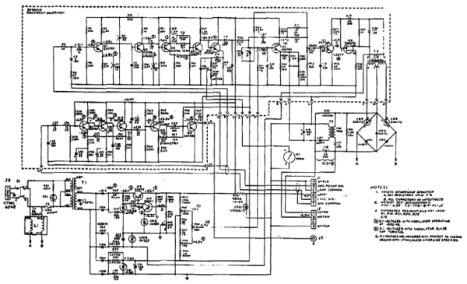

Figure 4. Modulator Control Schematic

1 Modulator SYNC/FREQ output circuitry. The SYNC/FREQ output is generated separately by a solar cell in the modulator. The cell output is amplified by Q11 through Q14. This signal drives switching circuit Q15 through potentiometer R70 which acts as symmetry control. The output of Q15 is a square wave between ground and approximately -24 volts.

2 Modulator power supply circuitry. Transistors Q9 and Q10 form a voltage regulator which provides -25 volts to the amplifier circuitry. A positive voltage (approximately 7 volts) is developed by Zener diode CR1 and associated circuitry. The line SYNC circuit consists of diode CR19 and associated components. The lamp voltage (for generating the solar cell signal) is provided by Zener diode CR21.

(b) Preamplifier (Figure 5). The preamplifier is a low noise, high impedance amplifier for the detector with a gain of approximately 675. Transistors Q1 through Q3 with associated circuitry form the first stage of the preamplifier with an AC gain of approximately 15. High input impedance and stability is provided by feedback Resistor R9. Resistor R9 is the detector load resistor which controls the bias current to the detector. The detector bias voltage is filtered by R2, R3, C1 and C2. The second stage, which is DC coupled with AC feedback through R20 and C14, consists of Q4, Q5 and Q6. Emitter follower output is provided by Q6 and C14. The gain of this stage is approximately 45.

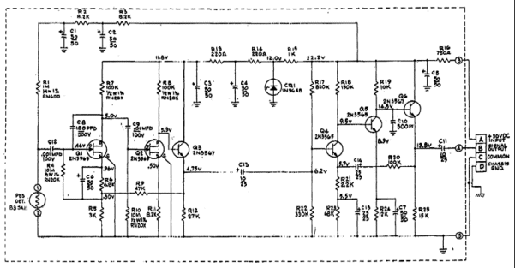

Figure 5. Preamplifier and Detector Schematic

(c) Amplifier (Figure 6). Signal input to the amplifier is connected to the coarse attenuator consisting of resistors R101 through R105, R116 and R117. Each position of the attenuator switch reduces the signal by a factor of 10. The signal is amplified by the amplifier consisting of Q101, Q102 and Q103. Signal gain is approximately 30. The first stage is a DC coupled audio amplifier with emitter follower output. Gain stability is provided by the feedback path of R113 and C102. Signal output from Q103 is coupled to the fine attenuator (potentiometer R1). This attenuator step. The signal is then fed into an amplifier consisting of Q204, Q205, and Q206 which has a gain of 30. This amplifier is identical to the first.
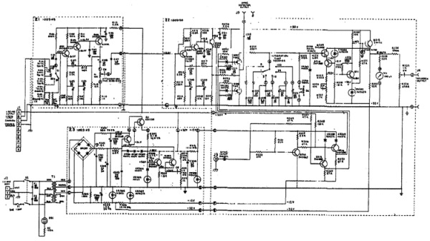

Figure 6. Signal Amplifier

1 Q207 and Q208 are junction field effect transistors which act as switches in the synchronous demodulator. The gate drive is arranged so that Q207 and Q208 are alternately turned on and off. When the phase of the SYNC input signal is properly adjusted, Q207 is turned on during the positive half cycle of the signal which is fed to the R-C network consisting of resistor R222 and capacitors C216 through C223. During the negative half-cycle, Q207 is turned off and Q208 is turned on to establish signal ground reference for the next half cycle. Specific RC filters are selected by the integration time switch on the front panel. A more stable signal is obtained with longer integration times but response time to a change in signal is slower.

2 The next stage is a unity gain DC amplifier with high input impedance. It acts as an operational amplifier with direct feedback. Q209 is a field effect transistor (FET) which provides high input impedance. Transistor Q210 and Zener diode CR204 provide constant operating voltage for Q210. Q211 is a second gain stage and provides emitter follower output. Resistors R234 through R236 provide recorder output which is adjustable by R235 to 1 volt.

3 Gate drive for Q207 and Q208 is provided by the circuitry consisting of transistors Q214, Q215, Q216 and associated components. The input at J3 is a -20 volt square wave at-the same frequency as the signal. The square wave drives switch Q215 directly and Q216 is driven through inverter Q214. Collectors for Q215 and Q216 are square waves between +12 volts and -12 volts with opposite phases.

4 The power-supply consists of bridge BR301, transistors Q1, Q301 through Q303 and associated components. The +30 volts is provided by a voltage regulator with CR305 as reference, Q302 and Q303 as error amplifiers, as the pass transistor driven by Q301. Diodes CR301 through CR303 limit overload currents by limiting the voltage across the base emitter junctions of Q1 and Q301 and resistor R307. Diodes CR301 through CR303 do not conduct until an overload current increases the drop from Q301 base to +30 volts output to approximately 1.7 volts. Zener diodes CR306, CR307 and CR308 provide the other voltages required.

d. Operating instructions. (See Figure 7 for a typical setup.)

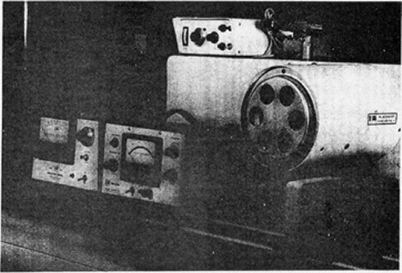

Figure 7. Irradiance Set Model 921 (P/N 1005116)

(1) Preparation for use.

(a) The measurement stand (MS-1) should be assembled and used on a flat, level surface at a point of minimum vibration.

(b) After assembly the measurement stand can be leveled by adjusting the legs.

(c) The modulator should now be mounted to the face of the blackbody. The modulator control unit should be placed in a convenient location to the modulator and the motor, signal and power cables connected in that order.

(d) Place the amplifier in a convenient location; using the SYNC signal cable, connect it to the modulator control unit.

(e) The preamp detector should be placed on the MS-1 and the detector signal cable connected between it and the amplifier. Connect the power cable.

(f) After setting the blackbody temperature control to the desired temperature and applying power, time must be allowed for temperature stabilization of the blackbody. After stabilization this temperature should be monitored throughout the measurement using a precision potentiometer and ice/water bath reference.

(g) The aperture wheel should be set to position two. The frequency control on the modulator control unit should be set to the maximum CCW position before applying power; apply power and then set desired speed. Thirty minutes should be allowed for warm-up. For optimum detector response the frequency should be kept below 1,000 Hz.

(h) After applying power to the amplifier a 20 minute warm-up should be allowed. The amplifier gain controls and SYNC control level on the modulator should be adjusted for maximum meter deflection on the amplifier.

(2) Modulation frequency. The modulation frequency can be determined by using either the meter readout or an external electronic counter. The meter reads a signal proportional to the blade rotation rate; therefore, the actual chopper frequency depends on the number of slots in the blade being used. At maximum speed, the motor rotates at 125 revolutions per second (7,500 revolutions per minute); therefore, the modulation frequency is 125 x 3 (bladespeed x number of slots) or 375 Hz. Since the meter full scale value is 10 (125 revolutions per second), 1 on the scale equals 12.5 revolutions per second. Therefore, frequency (F) = 12.5 x (meter reading) x (number of slots).

Example: A meter reading of 2.0 is obtained using a 3 slot blade.

F = (12.5) (2) (3) = 75 Hz

The ratio of the motor pulley to the blade is 1:1.

(3) Collimator checking. The following procedure is normally used when the collimator of the Infrared Secondary Reference Set is the system under test. All systems should be turned ON and stabilized. Sync phasing must be accomplished prior to performing the following:

(a) With the coarse attenuator control turned to 80 dB, and the modulator aperture wheel in position 2 (open). The blackbody (with modulator attached) should be mounted on the collimator in the normal operating position. The potentiometer reading should again be checked as in (1)(f) above.

(b) With the collimator aperture wheel turned to 0.025 inch position and the reference set alinement stand controls (azimuth and elevation) centered, the detector assembly should be placed on the alinement stand facing the collimated beam with the rear of the detector assembly touching the back of the alinement stand.

(c) The integration time should be set to 1 second and the attenuation control should be adjusted for an on scale indication. The meter can be peaked for a maximum indication by positioning of the blackbody on the collimator and adjusting the horizontal and vertical alinement micrometers on the alignment stand.

(d) Turn collimator aperture to GMTS position and adjust the amplifier attenuator controls to place meter indicator on any major increment on or above-three-fourths full scale. Set integration time to 10 seconds. Record resultant meter signal.
NOTE. Do not readjust attenuator controls.

(e) At this time the potentiometer reading should be the same as in (a) above and should remain the same after removing the blackbody from the collimator and mounting it on the MS-1 measuring stand.

(f) Set modulator aperture wheel to position 1 (calibration aperture).

NOTE. Do not readjust attenuator controls.

(g) With the above accomplished, remove detector assembly from the reference set alinement stand and place it on the rail of the MS-1. Position the detector assembly along the rails until the same meter reading is obtained as in (d) above.

(h) Read the distance from the scale on the measurement stand at the position indicated by the pointer on the detector assembly. This distance "L" is used in the irradiance computation. Record this reading.

(4) Determination of flux density.

(a) A constant (C) that will be required for this computation can be determined using the formula below:

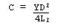

where 5Y | = 5.6686 x 16⁻¹²
D | = Aperture diameter in centimeters (cm) (0.0366)
L | = Distance measured in cm (taken from measurement stand scale)

(b) The flux density can then be computed as

H = CT⁴ watts/cm²

for any desired source temperature T (in degrees Kelvin).

(5) Periodically new F factors must be computed on the radiant energy attenuator set. This can be accomplished by obtaining the proper value of the constants, K, for each of the attenuators from calibration records. The constant K is defined as:

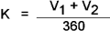

where V₁ + V₂ = the sum of the angular opening in degrees of the attenuator.

The new F-factor for a radiant energy attenuator Block III can be computed using the appropriate K-values and the formula:

F = 0.8641 x 10²⁰ x C x K

where C is the constant in paragraph (4), compute a new F factor for the GMTS Block I Attenuator, APN 7924459, using the appropriate K value and the formula, F = 1.1 x 10¹⁹ x C x K

3. LIGHT METER TESTER.

a. The optical spectrum includes those radiations, commonly called light, that are capable of visual detection. Light may be defined as the aspect of radiant energy of which a human observer is aware of through the visual sense. There are two general sources of light, natural and artificial. Nearly all the natural light we receive comes from the sun; moonlight is really reflected sunlight. Distant stars furnish us with an extremely small amount of light. There are several ways of producing artificial light. Materials may be heated until they glow, or become incandescent, as in the case of the filament of an electric lamp. Molecules of a gas at reduced pressure may be bombarded with electrons to produce the light we see in a neon sign. Visible light from fluorescent tubes or panels results from the action of ultraviolet radiations on phosphorus with which the glass is coated. (Refer to the glossary, Appendix A in this subcourse for definitions of key words and terms used in light measurement.)

b. The Light Meter Tester Model 2311 shown in figure 8 is a source of artificial light, and has the purpose of providing a variable light source, for use in calibration of a wide variety of light meters.

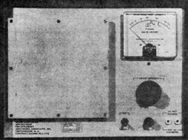

Figure 8. Light Meter Tester

c. Description. The light meter tester consists simply of a variable auto transformer to control the voltage to a bank of four 15W/115V incandescent bulbs which, together with a diffusing screen, provides a variable and evenly diffused light source. A voltmeter is also provided on the instrument which is calibrated to read directly in units of foot-lamberts. (See table in the glossary for light measurement conversion units.) This model has an output light brightness level of 900 foot-lamberts minimum, over a range from 20 to 1,250 foot-lamberts. Accessories supplied with each tester are:

1 each black photographer's cloth 18" x 18" nominal

3 each spare diffusing screens 8" x 8" x 1/4"

d. Operation.

(1) No warmup period is required for the tester; therefore, it is recommended that the operator wait until the unit is to be used before turning the power on. After turning power on a reference level is obtained by rotating the adjust intensity control for 800 foot-lamberts.

(2) The sensors of the light meter to be calibrated should be placed within 1-1/2 inches of the center portion of the light diffusing screen of the Model 2311. The light meter sensor and diffusing screen should be covered with the black photographer's cloth to eliminate any effect of background lighting.

(3) In the position stated above, the light meter should indicate 560 foot-candles, plus or minus 3 percent; if not, the meter should be adjusted to obtain this indication.

(4) Other levels of light brightness may be checked with the light meter tester, using the procedure outlined in the manufacture's manual.

e. Below the scale of the meter on the tester are three special purpose marks. The first of these points, marked 100^{c}/sq ft, is the normal low range calibration point for the tester. This calibration mark is based on the relationship:

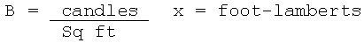

The other two points, marked f8 and f11, are for convenience when checking a camera with an internally coupled exposure meter. These points provide an equivalent aperture setting for a shutter operation at 1/50 of a second with a film having an ASA film speed rating of 32.

f. When the tester is not in actual use, the power switch should be turned off to prolong the life of the lamps as much as possible. If the tester is not in use for prolonged periods, it is recommended that the diffusing screen be covered to protect it from damage and accumulation of dust.

g. An object is luminous if it is visible because of the light it emits; it is illuminated if it is visible because of the light it reflects. An object may reflect, absorb, or transmit the light which it receives. Three quantities generally are used when dealing with the measurement of light. These quantities are luminous intensity, luminous flux, and illumination. Intensity is measured in candles, luminous flux is measured in lumens, and illumination is measured in lumens per square foot or lumens per square meter.

4. SUMMARY. Now that you have completed this lesson you should be able to state the purpose, characteristics, and operation of the irradiance test set and the light meter tester. The irradiance set is used to calibrate the radiant energy output from the secondary reference set and the light meter tester serves as a source for calibrating light meters. The information presented in this lesson will be beneficial to you when performing calibration on infrared equipment.

SUBCOURSE NUMBER 1 MM0487, INFRARED CALIBRATION

EXERCISE FOR LESSON 5

1. What is the purpose of the Model 921 irradiance test set?

a. Used in calibrating the IR secondary transfer set

b. To calibrate the radiant energy output of the secondary reference set

c. Used in conjunction with the radiometer test set for field service use

2. The irradiance test set can be divided into two functional units. What are they?

a. Modulation system and the detector processing system

b. Control system and the modulation system

c. Detector system and the control system

3. What develops the modulation frequency used to control the motor speed in the modulation system of the irradiance test set?

a. 3 slot blade

b. Silicon controlled rectifiers

c. A magnetic pickup

4. If the modulation frequency is monitored by an external electronic counter, what will be the readout if a 10 slot chopper blade is rotating at 100 revolutions per second and meter full scale is reading 8.0?

a. 400 Hz

b. 1,600 Hz

c. 1 Hz

5. In the irradiance test set, what is the ratio of pulley motor to blade?

a. 10:1

b. 1:4

c. 1:1

6. In the modulator SYNC/FREQ output circuitry, what is the output of Q15?

a. A square wave

b. A negative DC voltage

c. A continuous wave

7. (Refer to Figure 6.) The signal output form Q103 is coupled to the fine attenuator (potentiometer R1). What is the signal change between the coarse attenuator steps?

a. 2:1

b. 5:1

c. 10:1

8. The calibrated voltmeter provided on the light meter tester is graduated to read directly

a. Volts

b. Foot-lamberts

c. Candela

9. To calibrate a light meter using the light meter tester, what distance should the sensors be placed from the source at the center portion of diffusion screen?

a. Within 1 foot

b. Within 1-1/2 inches

c. At least 1-1/2 inches

10. What is the purpose of the two marks, f8 and f11, below the scale of the meter on the light meter tester?

a. Low and high range calibration points

b. Used when checking a camera

c. Used as a self-check for the tester

11. The black photographer's cloth used with the light meter test set is used to

a. Eliminate background lighting

b. Clean the light diffusing screen

c. Control the level of brightness.

12. What is the minimum output light brightness level of the light meter tester?

a. 20 foot-lamberts

b. 1,250 foot-lamberts

c. 900 foot-lamberts

13. What is the spectral range of the irradiance test set?

a. 0.72 to 1,000 microns

b. 1.7 to 2.7 microns

c. 1.72 to 3 microns

14. (Refer to Figure 4.) In the modulation power supply circuit the lamp voltage is provided by

a. DS-1

b. CR21

c. T3.

15. The MS-1 measurement stand contains a scale which is provided for measurement of the distance from a calibrated aperture to the detector. What is the length of this scale?

a. 200 cm

b. 120 cm

c. 120 inches

SUBCOURSE NUMBER MM0487, INFRARED CALIBRATION.

APPROVED SOLUTION

Lesson 5 Irradiance and Light Meter Test Sets

1. b para 2a 9. b para 3d(2)
2. a para 2c(2) 10. b para 3e
3. a para 2c(2) 11. a para 3d
4. c para 2d(2) 12. c para 3c
5. c para 2d(2) 13. b para 2b
6. a para 2c(3) 14. b para 2c(3)
7. c para 2c(3) 15. a para 2b
8. b para 3c

LESSON 6. INFRARED CALIBRATION

Lesson Objective: | When you finish this lesson you should know the techniques and procedures for operating the infrared (IR) reference standard, irradiance test set, IR transfer standards, and light meter tester to measure infrared and light irradiance devices.
Credit Hours: | Three
1. INTRODUCTION

During the previous lessons on the infrared (IR) you studied fundamentals of IR, the secondary transfer IR test set, guided missile test set (GMTS), secondary reference IR test set, irradiance and light meter test sets. Now study the techniques and procedures needed to operate these test sets.

2. SAFETY REQUIREMENTS FOR PERSONNEL AND EQUIPMENT.

a. DO NOT look into an infrared source directly or through its optics, because the eyes can be dangerously burned.

b. DO NOT put your fingers or hands into or directly in front of an infrared source; because these sources may be as hot as 1,000°C and you could be seriously burned.

c. DO NOT touch optic surfaces as your body acid will etch them or tamper with optic alinements.

d. Make sure that the manufacturer's serial number on the internal blackbody source is the same as the serial number of the temperature controller.

e. Take all necessary safety precautions so you can avoid electrical shock from high voltage.

3. CALIBRATION OF SECONDARY TRANSFER INFRARED.

a. In this section you will learn to calibrate the secondary transfer infrared test set.

b. You need a:

(1) Secondary reference infrared test set (see Lesson 4, Figure 1).

(2) Secondary transfer infrared test set (Lesson 3, Figure 1).

(3) Ice point reference standard (Figure 1).

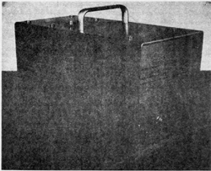

Figure 1. Thermoelectric Ice Point (MIS-10314).

(4) Potentiometer, a detector galvanometer, and batteries (Figures 2, 3, 4, and 5).

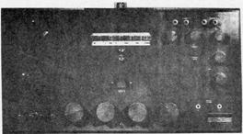

Figure 2. Potentiometer 2802 (7910298).

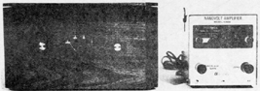

Figure 3. Detector Galvanometer (7907452).

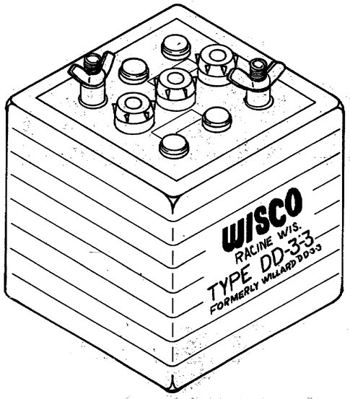

Figure 4. Storage Battery.

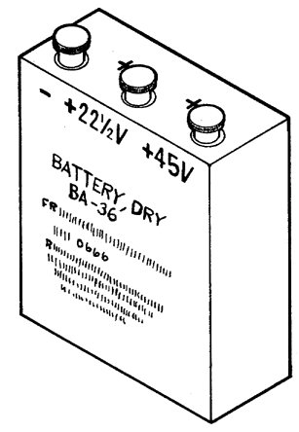

Figure 5. BA 36 Battery.

(5) DC voltage reference bank (730A - Type 2) to be used (Figure 6).

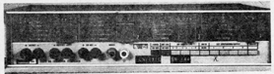

Figure 6. Model 730A, Standard Cell Bank.

c. If needed equipment is not available, equivalent items may be substituted if they meet the minimum specifications needed to calibrate the secondary transfer infrared test set.

d. Preliminary procedure:

(1) Take the radiometer optical unit from its storage case and remove the cover from the other case.

(2) Remove the forward storage cap from the radiometer optical unit. Now install the adapter tube assembly from the secondary transfer test set.

(3) Mount the radiometer optical unit on the reference test set alignment stand (Figure 7).

(4) Remove the rear storage cap from the radiometer optical unit and install the alignment tube.

(5) Connect the equipment as shown in Figure 7. Use the cable connections listed below.

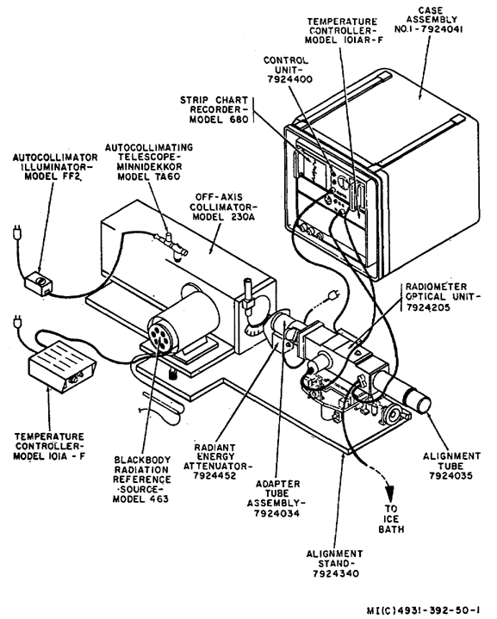

Figure 7. Equipment Setup.

(a) Cable 7924324 - connect P404 to J404 and connect two 24-inch No. 10 untinned bus wire, copper leads to the opposite end of cable.

(b) Cable 7924325 - connect P403 to J403 and P101 to J101.

(c) Cable 7924326 - connect P401 to J401 and P301 to J301.

(d) Cable 7924327 - connect P402 to J402 and P302 to J302.

(6) Insert the junction point of the copper wire leads, end of cable 7924324, and the reference test set blackbody encapsulated cold-junction thermocouple into the well of the ice-point reference standard (0° Celsius).

(7) Insert the attenuator disk (7924469) into the radiant energy attenuator.

(8) You are now ready to energize the reference test set temperature controller, autocollimator, and radiant energy attenuator.

(9) Determine the value corresponding to Block III Temperature in the Army Standards Laboratory report, and set the reference test set temperature controller COARSE dial to this value.

(10) Position the transfer test set controls as shown below.

(a) Set the control unit INTEGRATION TIME SWITCH TO 3 seconds.

(b) Set the control unit RECORDER switch to off.

(c) Set the control unit ATTENUATION COARSE and FINE controls to zero.

(d) Set the temperature controller SELECTOR COARSE control to the setting for Block III Temperature (527°C) and the SELECTOR FINE control to zero. If the transfer test set has not been calibrated, set the temperature controller SELECTOR COARSE dial at 530 as a starting point.

(e) Set the radiometer optical unit IRIS CONTROL to 170 (midscale).

(11) Energize all equipment and allow it to warm up and stabilize for at least 30 minutes.

(12) Next, turn both micrometer handles on the reference test set alinement stand to .500.

(13) Use the vertical and horizontal translation handles to adjust the transfer test set to a point of approximate center alinement with the autocollimator.

(14) Turn the reference test set APERTURE WHEEL to .250.

(15) Now adjust the transfer test set radiometer control unit ATTENUATION FINE and COARSE controls until the EXCESS SIGNAL indicator lamp just ceases to flicker and goes out. Maintain this condition throughout the performance checks.

(16) Use the reference test set alignment stand micrometers to adjust the transfer test set for maximum left deflection as indicated by the transfer test set control unit BALANCE meter. When you adjust the micrometers, find the point of maximum left deflection and note the micrometer indication. Adjust the micrometer clockwise until the BALANCE meter needle begins a right deflection and note micrometer indication. Set the micrometer midway between these two indications.

(17) Turn the reference test set APERTURE WHEEL to .0250, and repeat steps (15) and (16).

(18) Set the reference test set APERTURE WHEEL to GMTS and repeat steps (15) and (16).

e. Do a performance check for Blackbody Block III Temperature.

(1) Connect the free ends of the copper leads on the transfer test set cable to the potentiometer EMF 1 terminals.

(2) Use the potentiometer and thermocouple temperature EMF tables (Table 1) to determine the transfer test set blackbody temperature. The blackbody temperature should be between 525° C and 529° C. National Bureau of Standards Circular 561 and tables supplied in the potentiometer manual are reference sources for determining temperature versus millivolt relationships for specific types of thermocouples.

Table 1. Thermocouple Temperature - EMF Table.

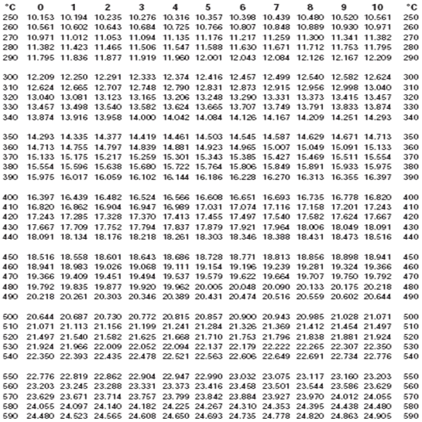

f. Do a performance check of the radiometer iris scale.

(1) Connect the leads from the reference test set encapsulated cold junction to the potentiometer EMF 2 terminals.

(2) Use the potentiometer and the calibration report of the reference test set thermocouple to determine the reference test set blackbody temperature. Adjust the reference test set temperature controller controls necessary to bring the reference test set blackbody to Block III temperature (527° C).

(3) Alternately, compare the temperatures of reference test set and the transfer test set blackbodies. The temperature of the transfer test set blackbody should be within .5° C of the reference test set blackbody temperature.

(4) Next, position the transfer test set strip chart recorder controls as shown below.

(a) Set RANGE switch to 5.

(b) Set SPEED switch to 1.

(c) Set CLUTCH switch to N.

(d) Set PEN switch to UP.

(e) Set POWER switch to ON.

(5) Set the transfer test set control unit RECORDER switch to ON.

(6) Depress and hold the transfer test set control unit ZERO CHECK switch and adjust strip chart recorder ZERO control to center pen carriage on the paper. When finished release the ZERO CHECK switch.

(7) Adjust the transfer test set radiometer optical unit IRIS CONTROL until the strip chart recorder pen indicates a null. Always turn the IRIS CONTROL clockwise to minimize gear backlash as you approach null. Observe the null indication on the radiometer control unit null meter or on the strip chart. On the 1-volt/division range the strip chart recorder is more sensitive than the meter. There is no indication on the null meter if the chart drive is on.

(8) Turn the transfer test set strip chart recorder RANGE switch to 1.

(9) Repeat steps (6) and (7). If the transfer test set radiometer optical unit iris control indicates between 169 and 171, record the indication.

(10) Remove attenuator disk (7924469) from reference test set radiant energy attenuator and replace it with the attenuator disk (7921467).

(11) Now, repeat steps (3) through (9). If the transfer test set radiometer optical unit iris control indicates within + one division of the number corresponding to the filter factor as read from the transfer test set radiometer iris scale calibration chart, record this indication. Repeat this procedure for all attenuator disks (7924468, 7924470, and 7924471). When you have checked all disks set the transfer test set control unit RECORDER switch to OFF, and the strip chart recorder RANGE switch to 5.

g. Do a performance check for Blocks I and II temperature.

(1) Adjust the reference test set temperature controls for a blackbody temperature of 227° C. Get this setting from the reference test set blackbody calibration chart. Allow at least 1 hour for blackbody temperature to stabilize after you change the reference test set temperature controller controls.

(2) Determine the reference test set blackbody temperature. Use the potentiometer and calibration report of the reference test set thermocouple, to adjust the controller controls, as necessary, to bring the reference test set blackbody to Blocks I and II temperature (227°C).

(3) Remove attenuator disk (7924471) from reference test set radiant energy attenuator and replace it with attenuator disk (7924459).

(4) Turn the transfer test set radiometer optical unit iris control clockwise until the value corresponding to the filter factor as read from the radiometer iris scale calibration chart is reached.

(5) Set the transfer test set control unit RECORDER switch ON.

(6) Depress and hold the transfer test set control unit ZERO CHECK switch and adjust the strip chart recorder ZERO control to center pen carriage on the paper; then release the ZERO CHECK switch.

(7) Adjust the transfer test set temperature controller SELECTOR COARSE control until the strip chart recorder indicates a null.

(8) Turn the transfer test set strip chart recorder RANGE switch to 1.

(9) Repeat steps (6) and (7).

(10) Use the potentiometer and thermocouple temperature EMF tables to determine the transfer test set blackbody temperature. The transfer test set blackbody temperature should be within ±1.5° C of Blocks I and II GMTS temperature as shown on the previous radiometer iris scale calibration chart.

(11) Set the transfer test set control unit RECORDER switch to OFF. This step completes the procedure for calibrating the secondary transfer infrared test set using the reference infrared test set.

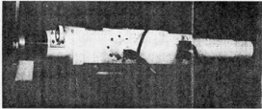

Figure 8. Radiometer Optical Unit (7924205).

4. CALIBRATION OF THE GUIDED MISSILE TEST SET (GMTS) AN/TSM-82, INFRARED TARGET ASSEMBLY.

a. You are now ready to study the basic method used to calibrate the infrared radiant energy level of the AN/TSM-82.

b. You need a:

(1) Secondary transfer infrared test set.

(2) Guided Missile Test Set AN/TSM-82.

c. Preliminary procedure:

(1) Preparation of GMTS AN/TSM-82 (Figure 9).

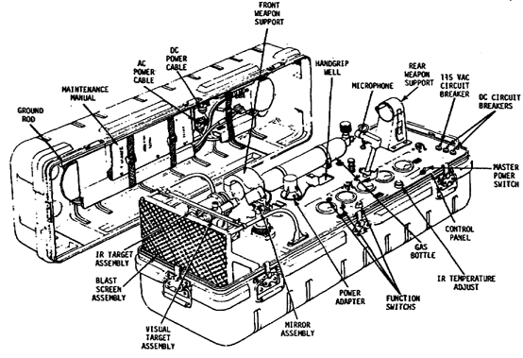

Figure 9. GMTS Front View.

(a) Set all circuit breakers to OFF.

(b) Set the master power and function switches to OFF.

(c) Lock the IR target assembly in place with the azimuth locking device.

(d) Connect AC power cable to test set.

(e) Loosen the microphone base screw and tilt the microphone base down. Release the microphone base and lift up the forward and aft support mounting clamps.

(f) Now connect the AC power cable to the 115 VAC.

(g) Loosen the large knurled knob on the IR target assembly and swing the attenuator/filter assembly up to remove the mirror assembly.

(2) Prepare secondary transfer equipment:

(a) Make sure that the power switch on the radiometer control unit and the recorder are set at OFF.

(b) Set the COARSE and fine ATTENUATION controls to zero.

(c) Set the INTEGRATION time selector to 3 seconds.

(d) Make sure that the temperature controller power switch is set at OFF. Remove the rear storage cap from the radiometer.

(e) Make sure that the manufacturer's serial number on the internal blackbody reference source is the same as the serial number on the temperature controller.

(f) Attach aft alinement tube to the radiometer.

(g) Remove the forward storage cap from the radiometer, and install the forward adapter tube.

(h) Now, remove the forward dust cover from the radiometer and install it in the GMTS with forward adapter and aft alinement tubes resting in the weapon support mounting clamps.

(i) Connect cable from J401 to J301.

(j) Connect cable from J402 to J302.

(k) Connect cable from J403 to J101.

(l) Connect-the transfer equipment to the 115 VAC.

(m) Set the iris dial on the radiometer at 170.

d. Temperature adjustments:

(1) Secondary transfer equipment (STS):

(a) Turn the radiometer control unit power switch to ON.

(b) Set the necessary transfer temperature controller coarse selector to the Block III GMTS temperature and set the fine selector to zero. Use the calibration chart for the STS blackbody.

(c) Turn temperature controller power switch to ON and wait for blackbody temperature to stabilize before proceeding.

(2) GMTS:

(a) Determine from the GMTS logbook what setting of the IR TEMPERATURE ADJUST is needed to maintain the correct temperature. Then, set the IR TEMPERATURE ADJUST control at that position. Record this setting and place it near the TEMPERATURE ADJUST dial.

(b) Set the AC circuit breaker and master power switch to ON. Allow the blackbody temperature to stabilize before proceeding.

e. Optical alinement.

(1) Make sure that the light in the GMTS autocollimating telescope is working by sighting down the telescope. If the light is not working, attach the autocollimator illuminator from the secondary transfer set.

(2) Sight through the autocollimating telescope to adjust the IR target assembly azimuth and elevation controls for optical alinement of radiometer and IR target assembly. There should be an indication of IR energy from the target assembly indicated on the radiometer control unit balance meter.

(3) Keep the COARSE and fine ATTENUATION controls adjusted on the radiometer control unit so the EXCESS SIGNAL indicator lamp just goes out.

(4) Readjust the IR target assembly azimuth and elevation controls for maximum left indication on the balance meter.

f. Calibration of IR energy level:

(1) Before proceeding make sure that the blackbodies are stabilized at the desired temperature.

(2) Swing the attenuator/filter assembly down and tighten large knurl knob on IR target assembly, then unscrew and remove filter from the attenuator/filter assembly. Handle only the edges and use pins to unscrew the filter. Do not put your fingers on the filter.

(3) Make sure that the radiometer iris is set to the dial setting which corresponds to the GMTS F-filter factor as shown on the iris calibration chart.

(4) Repeat steps e (3) and (4), as needed, for a peak indication.

(5) Adjust IR target assembly attenuator to get a null indication on the balance meter.

(6) Set strip chart recorder mV/V switch to 5 volts.

(7) Set power switch to ON.

(8) Adjust the chart paper speed 1 inch per minute.

(9) Depress zero check switch on the radiometer control unit and adjust recorder zero dial to center the pen carriage on the paper.

(10) Set the chart recorder pen in the down position, and allow the recorder to run for 5 minutes (5 inches).

(11) The pen line should not drift more than five minor divisions from null.

g. Disassembly:

(1) Remove power from the GMTS and secondary transfer test set and disconnect all cables.

(2) Remove the radiometer from the GMTS.

(3) Remove forward and aft adapter tubes from the radiometer and install all cover plates and dust caps.

(4) Install the filter on the GMTS IR target assembly. Be careful when installing the filter because the fine threads are easily damaged.

(5) Reposition microphone base and mounting clamps.

(6) Place all equipment in the appropriate cases.

5. CALIBRATION OF THE RADIANT ENERGY ATTENUATOR SET.

a. In this section, study how to calculate new F-factors for radiant energy attenuators in the secondary reference set.

b. You need a:

(1) Irradiance Test Set (Model 921).

(2) Secondary reference set.

(3) Temperature potentiometer.

(4) Electronic ice bath.

c. Preliminary procedure:

(1) Prepare secondary reference set for use.

(a) Use the thumb screws provided to assemble the measurement stand (MS-1). Assemble it on a flat level surface which has minimum vibration. Clean the surface and make sure it is free of obstacles so the stand will have a firm footing. Adjust the height of the legs to level the stand.

(b) Use the mounting screws provided to mount the modulator to the face of the blackbody. Position the blackbody in its proper place on the MS-1.

(c) Place the modulator control unit in a suitable location. Connect the motor cable and signal cable to the modulator control unit and the modulator.

(d) Connect the modulator control unit power cable to a 117 VAC power source.

(e) Place the preamp detector on the measurement stand at the 100 cm mark, and connect it to the amplifier using the detector signal cable.

(f) Connect the amplifier power cable to a 117 VAC 60 Hz power source.

(g) Set the blackbody temperature control to 750° C or higher. Turn on the temperature controller and wait for the blackbody temperature to stabilize. Use potentiometer and electronic ice bath to monitor the temperature.

(h) Select position 2 on the aperture wheel.

(i) Set the modulator control unit frequency control to maximum CCW position and turn the modulator control unit to ON.

(j) Set the modulator frequency control for an indication of 1 on the output meter and allow 10 minutes for warmup. The formula used to determine frequency is on the meter face. Remember this is a frequency of 167 Hz because the chopper blade has 3 slots.

(k) Turn on the amplifier and allow it to warmup for about 10 minutes.

(l) Set the amplifier integration time to 10, coarse attenuator to 40, and fine attenuator to 2.

(m) Adjust the modulator sync control lever for maximum output as shown on the amplifier meter. Adjust the attenuator controls as needed for an on scale indication. Tighten the sync control lever setscrew while maintaining maximum meter deflection.

(n) Next, turn the amplifier coarse attenuator control to 80 dB. Turn the modulator aperture wheel to position 1 (open). Mount the blackbody (with modulator attached) in the normal operating position on the collimator and secure it to the mount. Check the potentiometer reading to make sure it is the same as in (e) above.

(o) Turn the collimator aperture wheel to the 0.025-inch position.

(p) Center the reference set alinement stand controls (azimuth and elevation) and place the detector assembly on the alinement stand facing the collimated beam with the rear of the detector assembly touching the back of the alinement stand.

(q) Set the amplifier integration time to 1 second, and turn the collimator aperture to GMTS position and adjust the attenuator controls to obtain a meter indication of greater than three-fourths of full scale (above 75 on the scale). Now, adjust the horizontal and vertical alinement micrometers on the alinement stand for maximum meter deflections.

(r) Adjust the amplifier attenuator controls to place the meter indication at any major increment on or above three-fourths of full scale. Set the integration time to 10 seconds. Record the resultant reading.

(s) Check the potentiometer reading to make sure it is the same as in (n) above.

(t) Remove the blackbody from the collimator and mount it on the measuring stand. Check the potentiometer reading again.

(u) Set the modulator aperture wheel to position 2 (calibrated aperture). Do not readjust the attenuator controls.

1 Remove the detector assembly from the alinement stand and place on the rails.

2 Move the detector assembly along the rails until the same meter reading is obtained as in (r) above. There may be some lag in the meter response depending on the selected integration time.

3 Read the distance from the measurement stand scale at the position indicated by the pointer on the detector assembly. This distance L is used in the irradiance computation. Record the reading.

(2) Determination of the constant. Use the following formula to compute the constant:



where 5Y | = 5.6686 x 10⁻¹²
D | = Aperture diameter in cm
L | = Distance measured in cm
(3) Calculations for new F-factors of the radiant energy attenuator set.

(a) Obtain the proper value of the constant K for each of the attenuators from calibration records. The constant K is defined as:

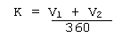

where: V₁ + V₂ = the sum of the angular opening in degrees of the attenuator.

(b) Compute the new F-factor for a GMTS Block III attenuator using the following formula:

F = 0.8641 x 10²⁰ x C x K

(c) Compute a new F-factor for the GMTS block I attenuator by using the following formula:

F = 1.1 x 10¹⁹ x C x K

6. CALIBRATION PROCEDURE FOR THE RADIOMETER, DBA SYSTEMS MODEL 302.

a. In this section, study the method used to calibrate the radiometer.

b. You need a:

(1) AC voltage standard Model 745A.

(2) DC voltage standard Model 332A.

(3) Differential voltmeter Model 887AB.

(4) Light meter tester Model 2311.

(5) Standard load 1 megohm ±0.1%.

(6) Test leads.

c. Prepare and set up equipment:

(1) Remove the radiometer protective cover only when it is needed to make adjustments.

(2) Use the DC voltage standard to connect the equipment (see Figure 10).

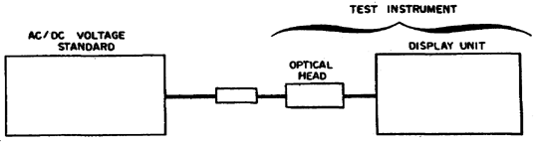

Figure 10. Optical Calibration - Equipment Setup.

(3) Position the radiometer controls as follows: (Lesson 2, Figure 7)

(a) RANGE switch to 1 x 10.

(b) Set MODE switch to DC.

(c) Set INTEGRATION TIME switch to MED.

(d) Set LOW PASS FILTER switch to OFF.

(e) Set SCALE control to 500.

(f) Set FUNCTION switch to CAL.

(4) All equipment is now energized, but wait 1 hour for it to warm up and stabilize.

d. DC calibration.

(1) Adjust the DC voltage standard for zero output. DO NOT use the offset position on the voltage standard.

(2) Use the CAL ADJUST control to zero the radiometer so that the digital panel meter (DPM) flickers between +000.0 and -000.0 (Lesson 2, Figure 7).

(3) Adjust the DC voltage standard for -1.99 volts, and the DPM should indicate between 198.5 and 199.5.

(4) Set the RANGE switch to 10³ and adjust the DC voltage standard for zero output. Repeat step (2).

(5) Adjust the DC voltage standard for -199 volts, and the DPM should indicate between 198.5 and 199.5.

e. AC calibration.

(1) Position the radiometer controls as shown below (figure 6).

(a) Set MODE switch to RMS FUND.

(b) Set BAND PASS FILTER controls to 2.000 Hz.

(c) Set RANGE switch to x0.1.

(d) Set FUNCTION switch to CAL.

(e) Set LOW PASS FILTER switch to OFF.

(f) Set scale switch to 500.

(2) Using the CAL ADJUST control short the standard load input and zero the radiometer DPM.

(3) Use the AC voltage standard to connect the equipment as shown in Figure 10.

(4) Adjust the AC voltage standard for 19.90 millivolts and 2,000 Hz.

(5) Tune carefully the BAND PASS FILTER for a maximum DPM indication. The DPM should indicate between 197.0 and 199.9.

(6) Disconnect the ground strap from the differential voltmeter. Now, connect the voltmeter to pins J and N of J1.

(7) Adjust the AC voltage standard to its lowest amplitude (0.1 millivolt) and frequency (2,000 Hz).

(8) Tune carefully the BAND PASS FILTER to get a peak reading on the differential voltmeter. The differential voltmeter should indicate between 0.94 and 1.06 millivolts.

(9) Observe the noise indicated on the differential voltmeter. It should be less than ±0.1 millivolt. If a slow negative transient deflects the voltmeter indication (0.2 millivolt) ignore the transient.

(10) Disconnect the differential voltmeter and the AC voltage standard.

(11) Set the RANGE switch to xl.0. Now, the input to the standard load is shorted and the DPM zeroed.

(12) Reconnect the AC voltage standard to the standard load and adjusted to 199.0 millivolts and 2,000 Hz. The DPM should indicate between 197.0 and 199.9.

(13) Set the AC voltage standard RANGE switch to x10, and adjust to its lowest output. Use the CAL ADJUST control and zero the radiometer.

(14) Adjust the AC voltage standard to 1.990 volts and 2,000 Hz. The DPM should indicate between 197.0 and 199.9.

(15) Adjust the AC voltage standard to 100 millivolts and 2,000 Hz. The DPM should indicate between 9.4 and 10.6.

(16) Set the RANGE switch to x102, and adjust the voltage standard to the lowest output. Use the CAL ADJUST control to zero the radiometer.

(17) Adjust the AC voltage standard to 19.90 volts and 2,000 Hz. The DPM should indicate between 198.0 and 199.9.

(18) Set the RANGE switch to x10³. Use the cal adjust control to zero the radiometer. Adjust the AC voltage standard to 100.0 volts and 2,000 Hz. The DPM should indicate between 99.0 and 101.0.

(19) Adjust the AC voltage standard to its lowest output.

(20) Set the radiometer RANGE switch to x10², the MODE switch to +PEAK, and use the CAL ADJUST control to zero.

(21) Adjust the AC voltage standard to 10.00 volts and 40 Hz. The DPM should indicate between 140.4 and 144.4.

(22) Set the MODE switch to -PEAK. Adjust the AC voltage standard to its lowest output. Use the CAL ADJUST control to zero the radiometer.

(23) Adjust the AC voltage standard to 10.00 volts and 40 Hz. The DPM should indicate between 140.4 and 144.4.

(24) Repeat Steps (19) through (23) at 5,000 Hz.

(25) Deenergize and disconnect all test equipment.

f. Optical calibration.

(1) Connect the equipment as shown in Figure 10. Do not ground the light meter tester. Disconnect the grounding strap on the differential voltmeter.

(2) Center the optical head flush against the light meter tester.

(3) Energize the light meter tester and adjust the intensity control until the differential voltmeter indicates between 99.8 and 100.2 volts AC. If possible, adjust it for 100.0 volts AC. Wait 1 hour for equipment to warm up and stabilize.

(4) Set the radiometer controls as shown below:(Lesson 2, Figure 7)

(a) Set MODE switch to DC.

(b) Set INTEGRATION TIME switch to MED.

(c) Set RANGE switch to x10.

(d) Set SCALE switch to 500.

(e) Set FIELD STOP ring (on the optical head) to position 5.

(f) Set FUNCTION switch to OP.

(g) Set REFLEX SIGHT control on the optical head to VIEW.

(5) Use the CAL ADJUST control to zero the radiometer so that the DPM flickers between +000.0 and -000.0.

(6) Place the REFLEX SIGHT control to OPER, and observe the DPM indication with the differential voltmeter to see if it indicates as close as possible to 100.0 volts. The DPM indication should be within +2% of the indication recorded with the original calibration material (reception of the radiometer) report.

g. Operational Check of DBA 302 Radiometer.

(1) The 302 Radiometer may pass the electronic alinement/optical check and yet fail to be operational in the AC Modes. This is because the sensor loads the preamplifier in the optical head in a different manner than the electronic standard (Hewlett-Packard 745) used in the electronic calibration. This different loading effect can cause the AC preamplifier to go into oscillation resulting in large indications on the DPM.

(2) Use the following procedure to do a quick operational check of the 302 with the optical head connected to the electronic portion.

(a) Set FUNC CONT switch to CAL position.

(b) Set MODE switch to +PEAK.

(c) Set RANGE switch to xl0.

(d) Use CAL ADJUST control to zero DPM.

(e) Switch FUNC CONT switch to OP position. The indication should be no greater than ±20. (See (3) below).

(f) Set MODE switch to -PEAK. The indication should be no greater than ±20 and it should still be possible to zero the DPM. (See (3) below).

(g) Set RANGE switch to 10^{3.}

(h) Repeat steps (1), (2), (4), (5), and (6).

(3) If the indication is greater than 20, or if the indication cannot be zeroed, the first preamplifier in the optical head is probably defective. Replace the AC preamp board in the optical head to solve the problem. If this fails to correct the problem, send the instrument back to the factory for repair.

7. SUMMARY.

During this lesson you studied the techniques and procedures used to operate the infrared reference standard, irradiance test set, IR transfer standards, and the light meter tester. Now, you should understand infrared calibration; because this subcourse was designed and developed to give you a general knowledge of the limited deployment infrared standards which pertain to calibration. If you retain this information it will help you do your job in calibration.
SUBCOURSE MM MM0487, INFRARED CALIBRATION

EXERCISES FOR LESSON 6

1. Which equipment is used to calibrate the secondary transfer infrared test set?

A. Model 302 radiometer, potentiometer and AC voltage standard

B. DC voltage reference bank, detector galvanometer, secondary reference infrared test set

C. Irradiance test set, light meter tester, ice point reference standard

2. The radiometer optical unit and the adapter tube assembly come with the:

A. Secondary transfer test set.

B. Secondary reference test set.

C. Light meter tester.

3. What do you use copper wire leads for when calibrating the secondary transfer infrared test set?

A. To reference the transfer blackbody temperature to the reference blackbody temperature

B. To determine the transfer test set blackbody temperature

C. To determine the EMF at the transfer blackbody encapsulated cold junction at zero degrees Celsius

4. If you do secondary transfer blackbody Block III temperature check which millivolt reading is within limits?

A. 21.78

B. 21.68

C. 21.87

5. What is the secondary transfer blackbody Block III temperature for a millivolt reading of 21.795?

A. 526° C

B. 527° C

C. 528°C

6. Which items do you use to determine the reference test set blackbody temperature?

A. The potentiometer and calibration report of the reference test set thermocouple

B. The ice point reference standard and the calibration report of the reference test set thermocouple

C. The encapsulated cold junction and the calibration report of the reference test set

7. In which direction do you turn the transfer test set radiometer optical unit iris control?

A. Clockwise and backed up counterclockwise

B. Counterclockwise to minimize gear backlash

C. Clockwise to minimize gear backlash

8. If you observe a null indication, which component item has the greater sensitivity?

A. The radiometer control unit null meter

B. The AC voltmeter

C. The strip chart recorder on the 1-volt/division range

9. When using the reference test set blackbody, what is the least amount of time that you are allowed for initial temperature stabilization?

A. Thirty minutes

B. One hour

C. Two hours

10. When you calibrate the GMTS, you set the secondary transfer temperature controller coarse selector to:

A. Block I GMTS temperature

B. Block II GMTS temperature

C. Block III GMTS temperature

11. If the light in the GMTS autocollimating telescope is not working, what do you use in its place?

A. The autocollimator illuminator from the secondary transfer set

B. No other item may be used

C. The autocollimator illuminator from the secondary reference set

12. What control or controls do you adjust for optical alignment of the radiometer and the IR target assembly when you sight through the autocollimating telescope?

A. Azimuth control and iris control

B. Elevation control

C. IR target assembly Azimuth and elevation controls

13. You adjust the coarse and fine attenuation controls on the radiometer control unit to obtain which excess signal indicator lamp indication?

A. The lamp barely come on

B. The lamp glows brightly

C. The lamp barely goes out

14. Why must you be careful if you install a filter on the GMTS IR target assembly?

A. The fine threads on the filter are easily damaged

B. The wavelength of the source may be changed if the filter is not screwed on tightly

C. The aperture may be damaged if the filter is screwed in too far

15. If you remove the blackbody from the collimator and mount it on the measuring stand to calibrate the radiant energy attenuator set, what must you check after the blackbody is mounted?

A. The distance "L" to make sure it has not changed

B. The potentiometer reading to make sure it has not changed

C. The aperture reading to make sure it has not changed

16. You must calibrate a radiant energy attenuator. What is the constant for this attenuator?

Given: Y = 5.6686 x 10-12
D = 0.04 cm
L = 100 cm

A. 1.3343 x 10-20

B. 5.6685 x 10-15

C. 2.2674 x 10-19

17. The filter factor (F) of an attenuator as determined by the calibration is the:

A. Diameter of the aperture (D)

B. Distance from the aperture to the detector (L)

C. Sum of the angular opening in degrees of an attenuator (V1 + V2)

18. This question refers to the calibration of the radiometer. You must adjust the band pass filter for what indication on the differential voltmeter?

A. Null indication

B. Peak indication

C. Mid-scale indication

19. When you do an optical calibration, the light meter tester

A. Must not be grounded

B. Must be grounded

C. Mid-scale indication

20. Which items do you use to calibrate the radiometer (Model 302)?

A. AC voltage standard, differential voltmeter, and a standard load

B. DC voltage standard, light meter tester, and an ice-point reference standard

C. AC voltage standard, potentiometer, and a light meter tester

SUBCOURSE NUMBER MM0487, INFRARED CALIBRATION.

APPROVED SOLUTION

Lesson 6 Infrared Calibration

1. b para 3b 11. a para 4e
2. a para 3d(2) 12. c para 4e(2)
3. c para 3e(2) 13. c para 4e(3)
4. a table 6-1 14. a para 4g(4)
5. b table 6-1 15. b para 5c(1)(s)
6. a para 3f(2) 16. b para 5c(2)
7. c para 3f(7) 17. c para 5c(2)
8. c para 3f(7) 18. b para 6e(8)
9. b para 3g 19. a para 6f(1)
10. c para 4d(1) 20. a para 6b

GLOSSARY
PART 1: INFRARED TERMS
ABSORPTION | The process whereby some or all of the energy of electromagnetic radiation is transferred to the material on which they are incident or through which they traverse.
ANGSTROM | A unit of length equal to 10⁻¹⁰ meters.
ATTENUATION | Generally, a reduction in concentration, density or effectiveness.
BLACKBODY | An ideal body that would, if it existed, absorb all and reflect none of the radiation incident upon it. When thermal equilibrium were reached, it would emit the same energy it absorbed.
CHOPPER | A device that imparts a pulsating characteristic to a beam of radiation by a regular and frequent interruption.
COLLIMATOR | An optical apparatus for producing parallel beams of radiation.
DETECTOR, IR | Any device that indicates the presence of infrared radiation.
EMISSIVITY | The ratio of the radiant infrared energy emitted by a surface to the infrared radiant energy emitted by an ideal radiator, or blackbody at the same temperature.
EMITTANCE | Power per unit is emitted (radiated) by an object.
FILTER | A device or substance that partially or completely absorbs specified wavelengths of infrared radiation.
FOCAL LENGTH | The distance from the optical center of a lens to the point where the light rays converge.
IMAGE | The optical counterpart of an object, produced by a lens, mirror, or other combination optical system.
LUMINESCENCE | The emission of light due to any cause other than high temperature.
MICROMETER (MICRON) | Is a unit of length equal to one millionth of a meter.
MIRROR | Any polished or smooth substance that forms images by the reflection of radiation.
NOISE EQUIVALENT POWER (NEP) | A way of defining a detector's useful sensitivity in terms of its response as well as its internal noise.
PHOTOELECTRIC EFFECT | Reaction of a device to radiation which causes emission of electrons, generation of voltage, or a change in resistance.
RADIATION | The emission and propagation of energy through space or through a material medium in the form of waves or rays.
REFLECTANCE | The ratio of the reflected radiation to the incident radiation.
REFLECTION | The throwing back of radiation by a surface.
REFRACTION | The change of direction that radiation experiences on passing from one medium to another in which its velocity of propagation is different.
RESPONSE | Ratio of input with respect to the output signal.
SCATTERING | The random distribution of infrared radiation caused by atmospheric particles.
SENSITIVITY | Generally, susceptibility to eternal action, as measured by speed of response or degree of responsiveness. This can be exemplified by sensitivity to light, infrared radiation, or electric current.
TIME CONSTANT | The measure of the time of response of a circuit or device.
TRANSMITTANCE | Ratio of the radiant power transmitted by a body to the total radiant power entering the body.
WINDOW | A region of little or no attenuation to infrared at that wavelength.
PART 2: VISIBLE LIGHT MEASUREMENT TERMS
LIGHT | Light is visually evaluated radiant energy. In a general non-specialized sense, light is the aspect of radiant energy of which a human observer is aware of through the stimulation of the retina of the eye.
CANDELA | The candela is the unit of luminous intensity. One candela is defined as the luminous intensity of one-sixtieth of one square centimeter of projected area of a blackbody radiator operating at the temperature of solidification of platinum.
CANDLEPOWER | Candlepower is luminous intensity expressed in candelas. The apparent candlepower of an extended source at a specified distance is the candlepower of a point source which would produce the same illumination at that distance.
LUMINANCE | The luminance of a surface in a specified direction may be expressed in luminous intensity per unit of projected area of surface or the number of lumens per unit area. A typical unit of the latter is the foot-lambert, equal to one lumen per square foot.
FOOT-LAMBERT | The foot-lambert is a unit of luminance equal to 1/candela per square foot, or to the uniform luminance of a perfectly diffusing surface emitting or reflecting light at the rate of one lumen per square foot, or to the average luminance of-any surface emitting or reflecting light at that rate.
FOOT-CANDLE | The foot-candle is the unit of illumination when the foot is taken as the unit of length. It is the illumination on a surface one square foot in area on which there is a uniformly distributed flux of one lumen, or the illumination produced on a surface all points of which are at a distance of one foot from a directionally uniform point source of one candela.
LUMINOUS INTENSITY | The luminous flux per unit solid angle in the direction in question (i.e., screen or aperture).
LUMINOUS FLUX | The time rate of flow of light.
LUX | The lux is the International System (SI) unit illumination.
PHOT | The phot is the unit of illumination when the centimeter is taken as the unit of length. It is equal to one lumen per square centimeter.
UNIT SOLID ANGLE | A ratio of area (A) on the surface of a sphere intercepted by a cone (of radiant energy) to the square of the sphere's radius (r). Unit solid angle = A/r². The vertex of the cone represents a point source and the base of the cone represents a surface area screen or aperture. Since A equals 4 r², the unit solid angle is a constant.

TABLE. ILLUMINATION CONVERSION FACTORS
 | 1 lumen | = 1/680 light-watt
 | 1 foot-candle | = 1 lumen/ft²
 | 1 watt-second | = 1 joule = 10⁷ ergs
 | 1 phot | = 1 lumen/cm²
 | 1 lux | = 1 lumen/m²
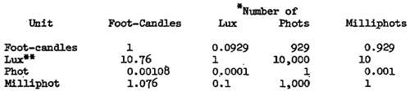
* Number of units multiplied by the factor equals to the number of units being converted to.
Example: To convert 2 units of lux into foot-candles, multiply 2 x 0.0929 = .1858 foot-candles.
** The Systems International (SI) Standard unit.

